

UCD-UAT Documentation

Post Upgrade



**Index**

**1] UCD-UAT Version 5**

**2] Dashboard** 5

**3] Components** 5

3.1] Component tab **6**

3.2] Templates tab 6

**4] Applications** 7

4.1] Application tab **7**

4.2] Templates tab 8

**5] Processes** 8

**5.1] Processes tab** 8

**5.2] External Approval Processes 9**

6] Resources **10**

6.1] Resource tree 10

6.2] Resource Template 10

6.3] Agents 11

6.4] Agents Configuration Templates **12**

6.5] Agent Relays 13

6.6] Agent Pools 13

**6.7] Cloud Connections** 14

**7] Calendar 14**

**8] Work Items** 15

9] Reports 15

9.1] Deployment 16

9.1.1] Deployment Total Duration 16

9.1.2] Deployment Average Duration **17**

9.1.3] Deployment Details 18

**9.1.4] Deployment Count** 19

9.2] Security 21

9.2.1] Component Security 21

9.2.2] User Security **21**

9.2.3] Application Security 22

9.2.4] Resource Security 23

**9.2.5] Environment Security** 24

**9.3] My Reports** 25

**10] Settings 25**

10.1] Automation 26

10.1.1] Automation Plugins 26

10.1.2] Source Configuration Plugins 27

10.1.3] Running Version Import 28

10.1.4] Locks **28**

10.1.5] Blueprint Designer Integration 29

10.1.6] Post Processing Script 29

**10.1.7] Statuses** 30

**10.1.7.1] Inventory Statuses** 30

**10.1.7.2] Version Statuses 30**

**10.1.7.3] Snapshot Statuses** 31

10.1.8] Tags 31

10.1.8.1] Agent Tags 31

**10.1.8.2] Application Tags** 32

10.1.8.3] Component Tags 32

10.1.8.4] Resource Tags 33

**10.2] Security 34**

10.2.1] API Keys And Certificates 34

10.2.2] Authentication (Users) 35

**10.2.2.1] Internal Security** 35

10.2.2.2] LDAP_Realm_YBL 36

10.2.2.3] LDAP2 **38**

**10.2.3] Authorization (Groups)** 39

10.2.3.1] Authorization Realms 39

10.2.3.2] Groups 40

**10.2.4] Teams** 40

10.2.4.1] Approval Manager 40

10.2.4.2] Appsec 42

**10.2.4.3] Automation Engineer 42**

10.2.4.4] Manager 43

10.2.4.5] OBDX Team 44

**10.2.4.6] Release Team** 44

10.2.4.7] System Team 45

10.2.5] Tokens **47**

10.2.6] Token Restrictions 47

10.2.7] Role Configuration 48

10.2.7.1] Administrator **48**

10.2.7.2]Approval Manager 48

10.2.7.3]Automation Engineer 49

10.2.7.4]Manager 49

**10.2.7.5]OBDX Team 50**

**10.2.7.6]Release Team 50**

10.2.7.7]UC Auto Configure 51

10.2.7.8]UC Auto Discovery 51

10.2.7.9]UC Version Import 52

10.2.8] Type Configuration 52

10.2.8.1]Agent 52

10.2.8.2]Agent Configuration Template 53

10.2.8.3]Agent Pool 53

10.2.8.4] Agent Relay **54**

10.2.8.5]Application 54

10.2.8.6]Application Template 55

10.2.8.7]Cloud Connection 55

10.2.8.8]Component 56

**10.2.8.9]Component Template 56**

10.2.8.10]Environment 57

10.2.8.11]Environment Template 57

10.2.8.12]External Approval 58

10.2.8.13]Post Processing Script 58

10.2.8.14]Process **59**

10.2.8.15]Resource 59

10.2.8.16]Resource Template 60

10.3] System 60

10.3.1] Logging **60**

10.3.2] Network 62

10.3.3] Notification Scheme 63

10.3.4] Audit Log 63

10.3.5] Diagnostics 65

10.3.5.1] Diagnostics Bundle **65**

**10.3.5.2] REST Call Log** 65

10.3.5.3] Metadata Indexing 66

10.3.6] Patches 66

10.3.7] Properties 67

10.3.8] CodeStation **67**

10.3.9] License Management 68

10.3.10] System Settings 69

**1] UCD-UAT Version :**

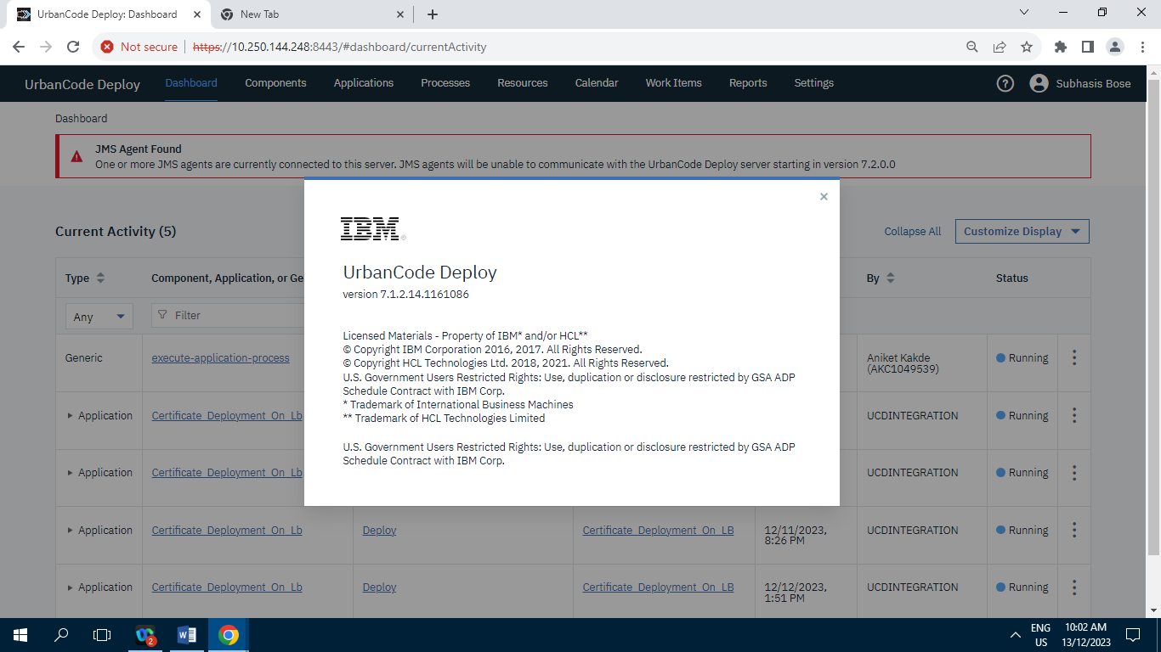

**Version 7.1.2.14.1161086**

**2] Dashboard :**

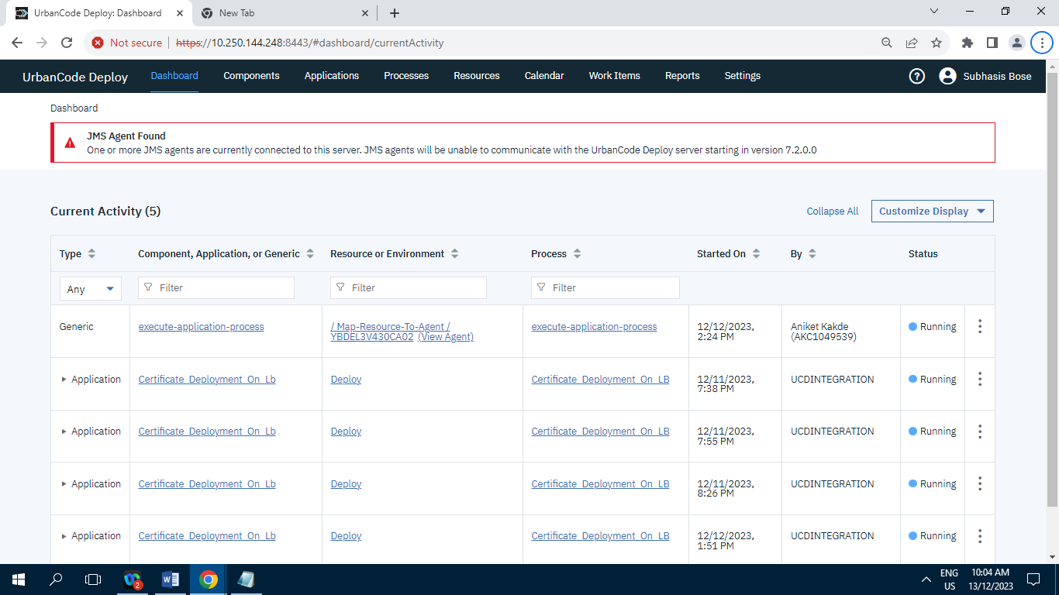

**3] Components :**

**3.1] Component tab :**

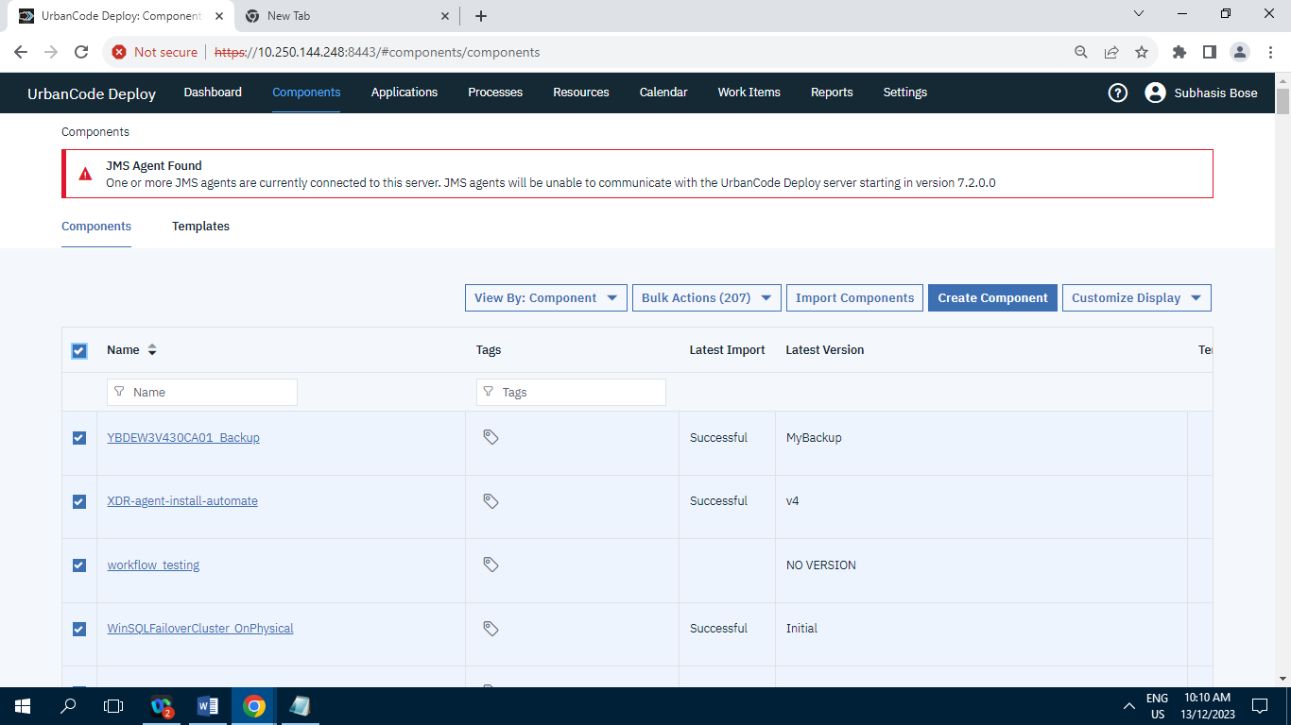

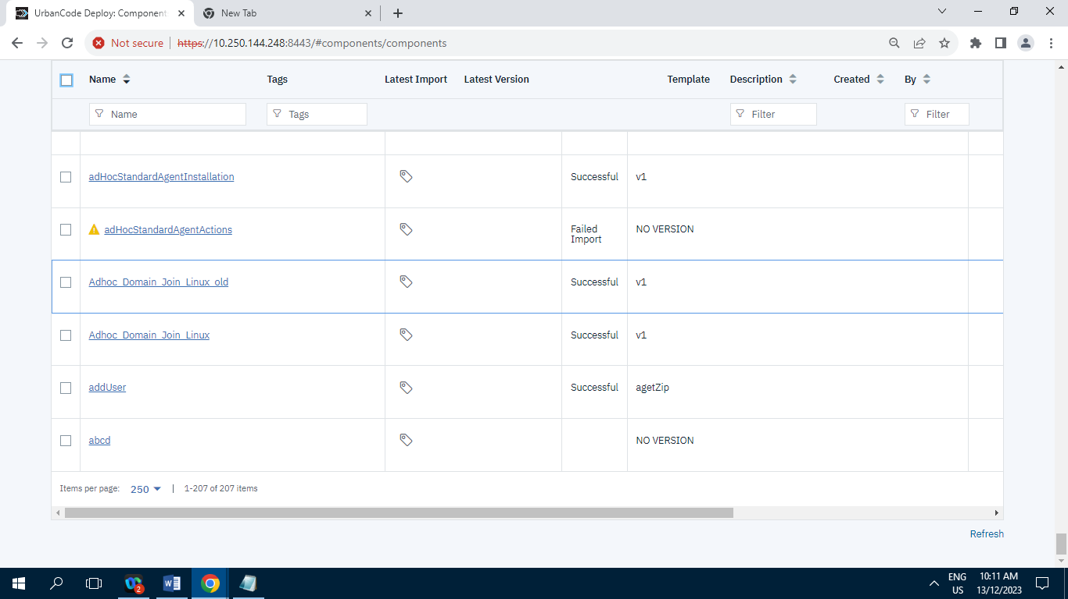

Screenshot of Component tab having 207 Records/Items.

**3.2] Templates tab :**

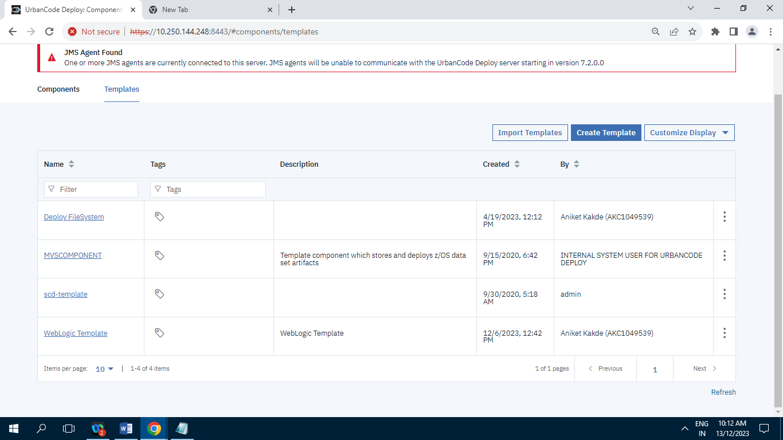

Screenshot of Templates tab having 4 Records/Items.

**4] Applications :**

**4.1] Application tab :**

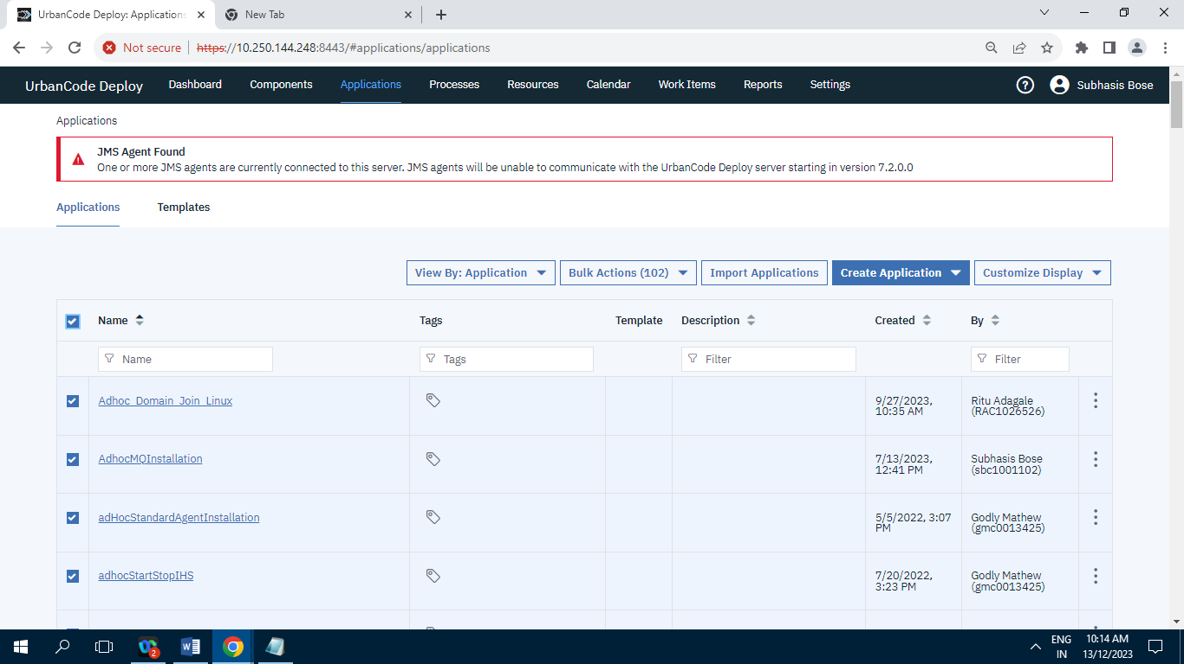

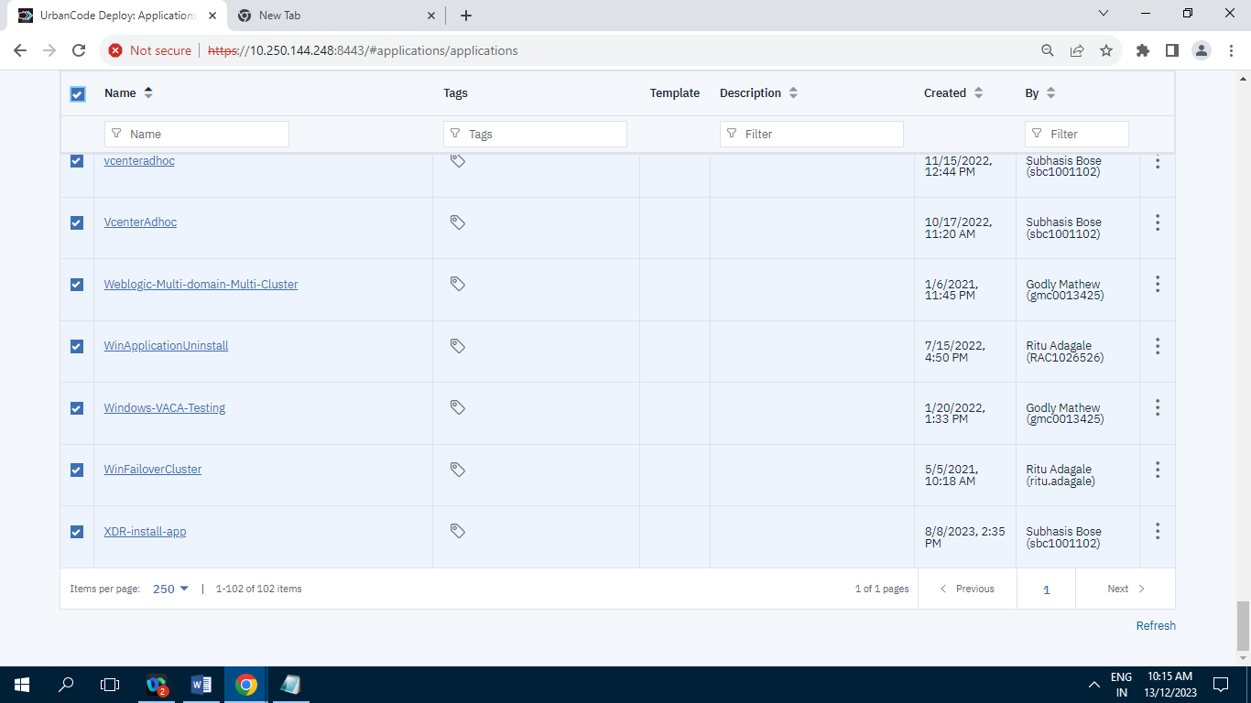

Screenshot of Application tab having 102 Records/ Items.

**4.2] Templates tab :**

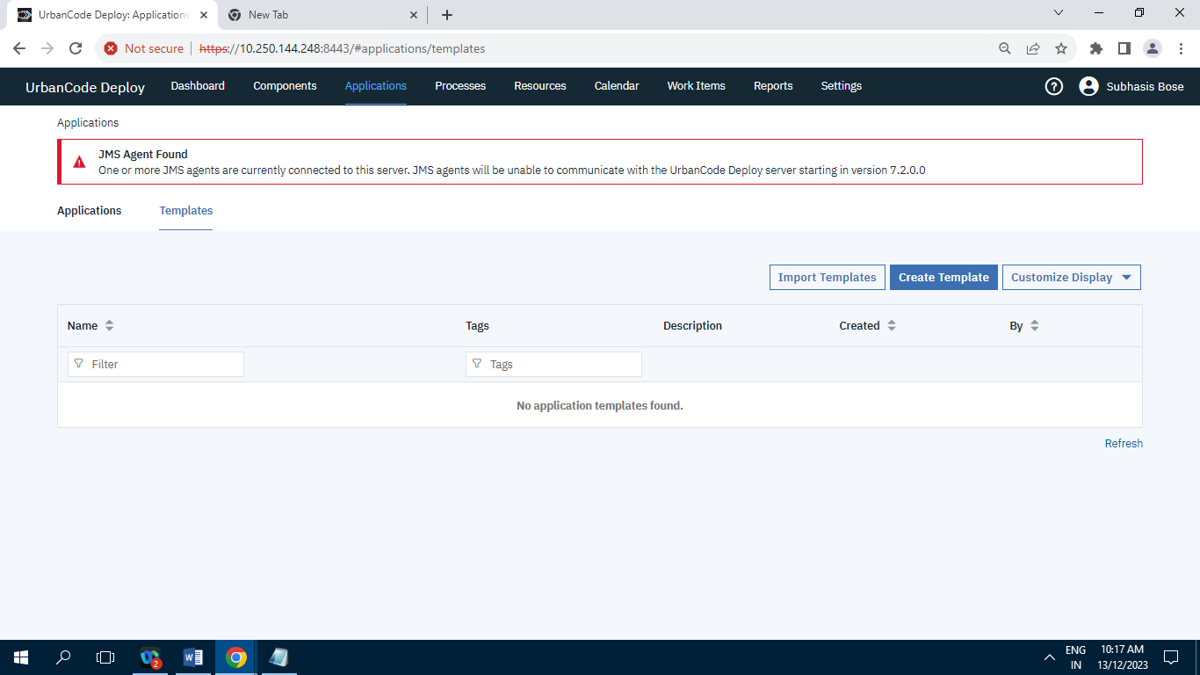

Screenshot of Template tab having zero Records.

**5] Processes :**

**5.1] Processes tab :**

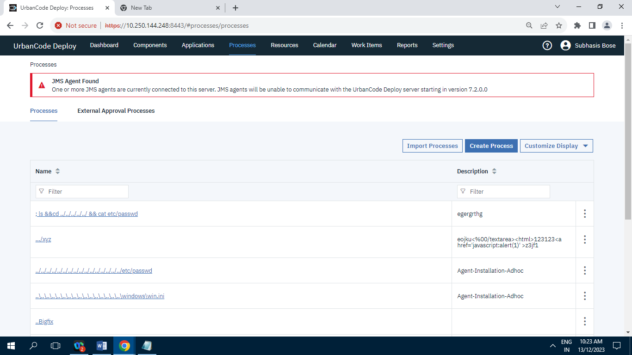

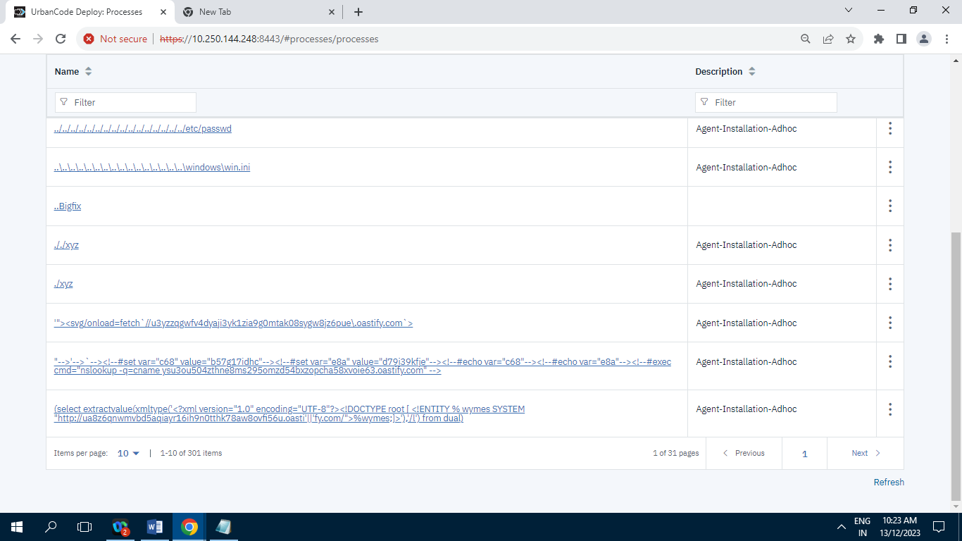

Screenshot of Processes tab having 301 Records/Items.

**5.2] External Approval Processes :**

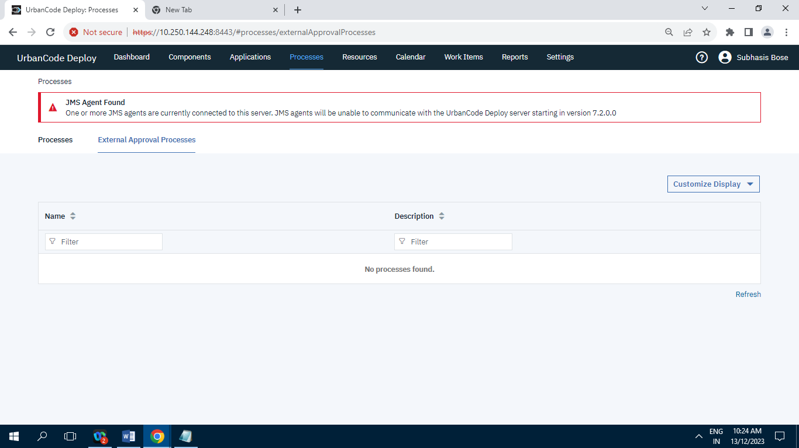

Screenshot of External Approval Processes having zero Record.

**6] Resources :**

**6.1] Resource tree:**

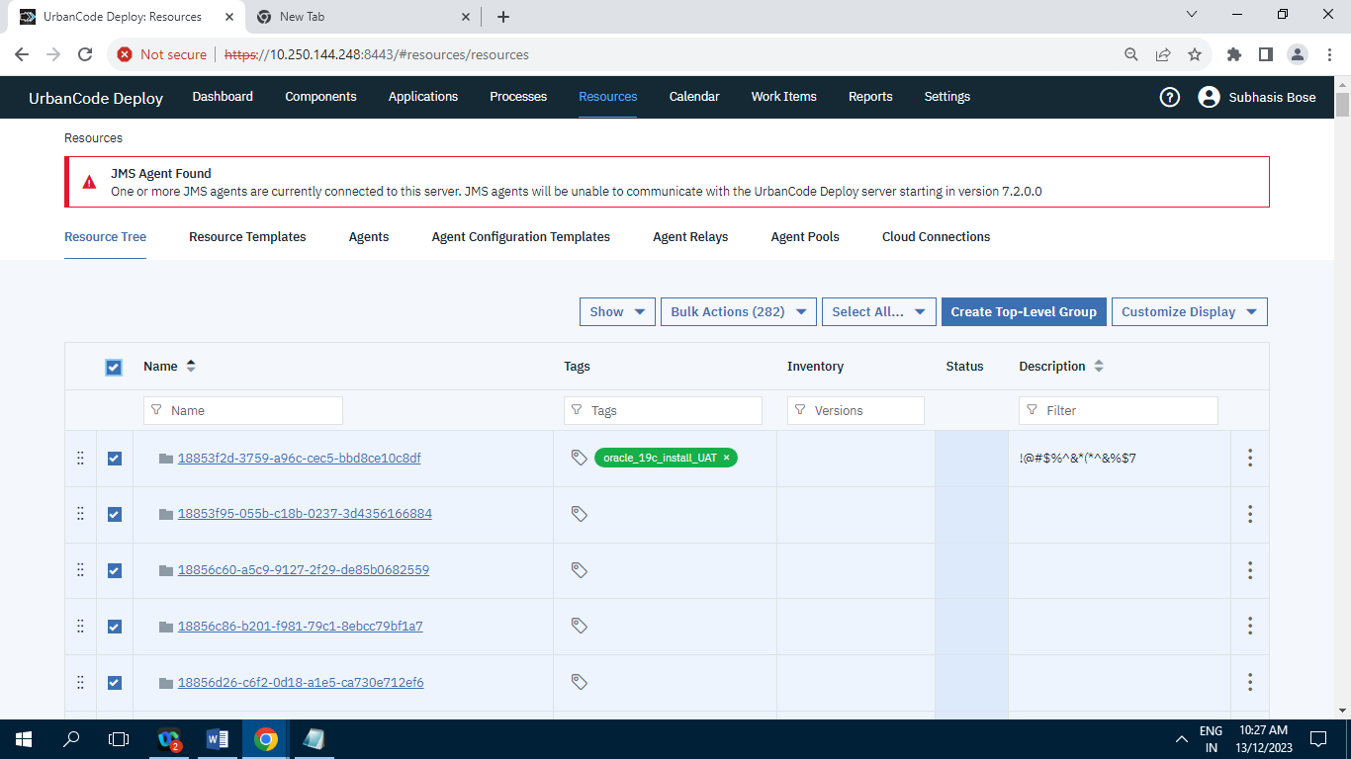

Screenshot of Resource tree tab having 282 Records.

**6.2] Resource Template :**

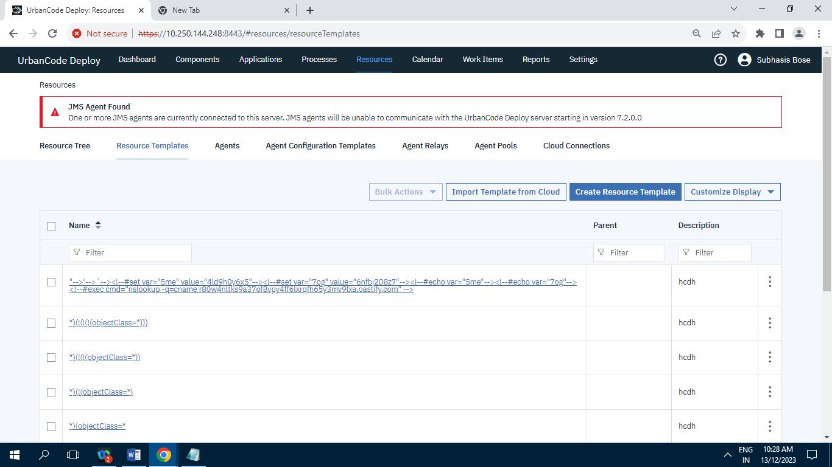

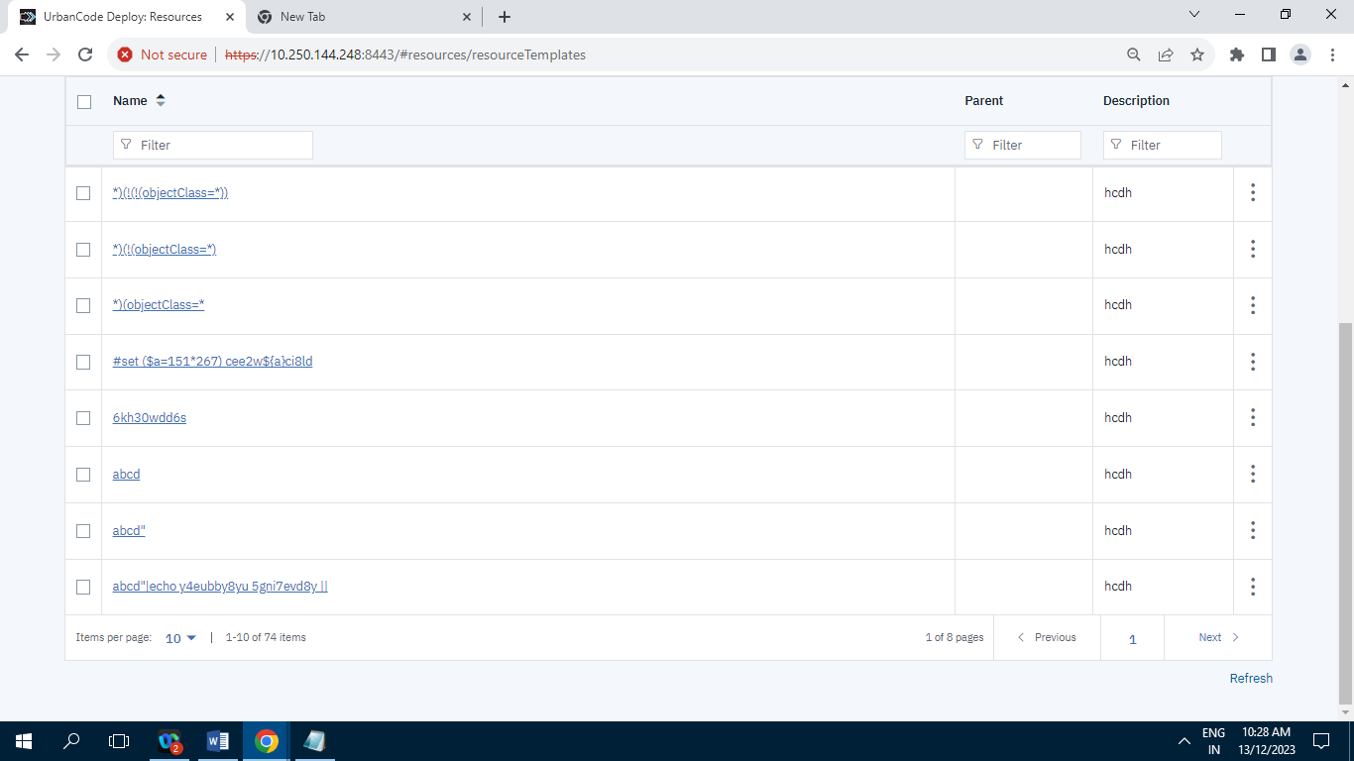

Screenshot of Resource Template tab having 74 Records/Items.

**6.3] Agents :**

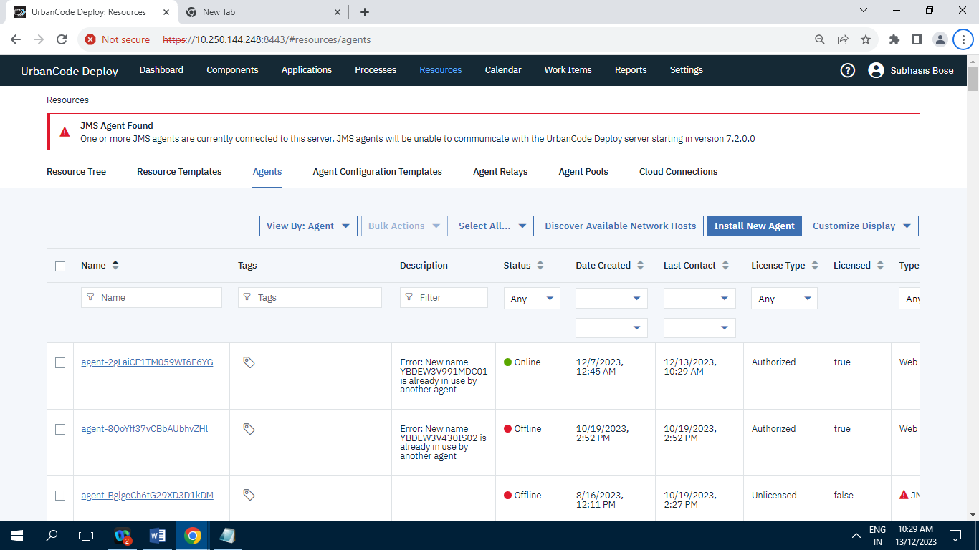

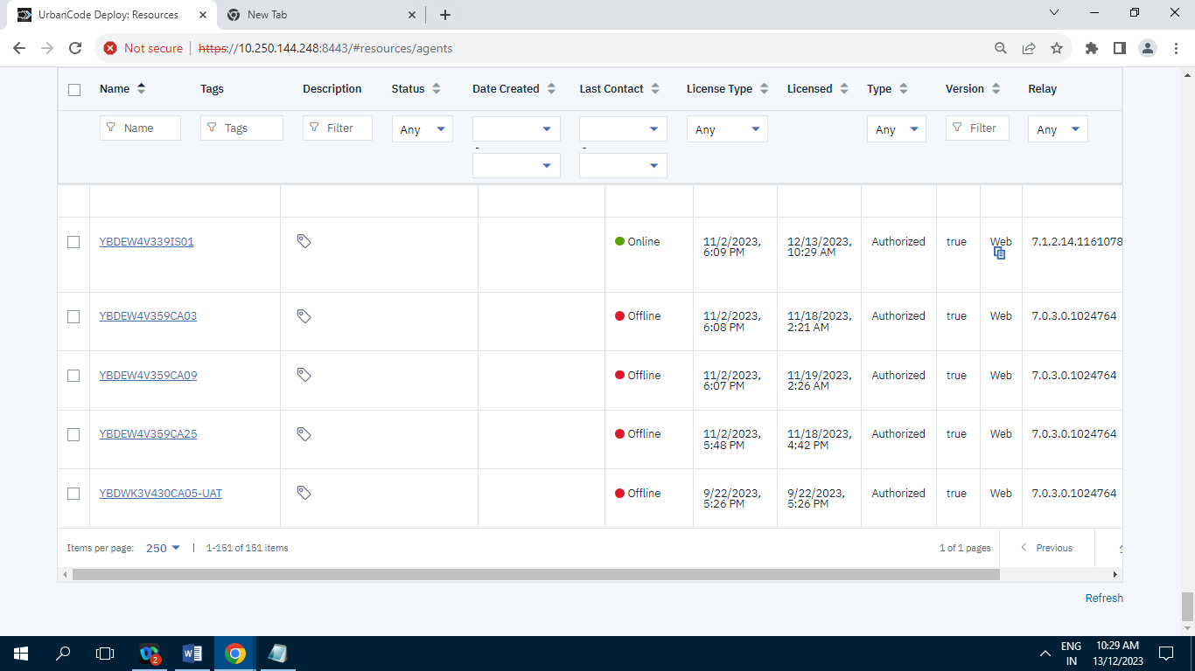

Screenshot of Agents tab having 151 Records/Items.

**6.4] Agents Configuration Templates :**

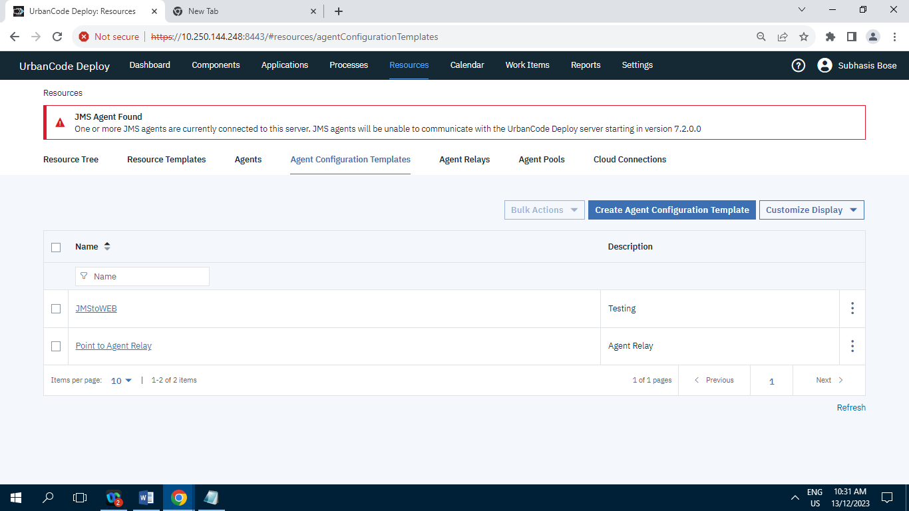

Screenshot of Agents Configuration Templates having 2 Records/Items.

**6.5] Agent Relays :**

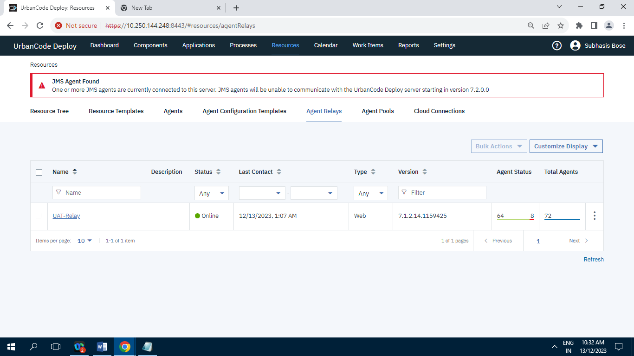

Screenshot of Agent Relays having 1 Record/Item.

**6.6] Agent Pools :**

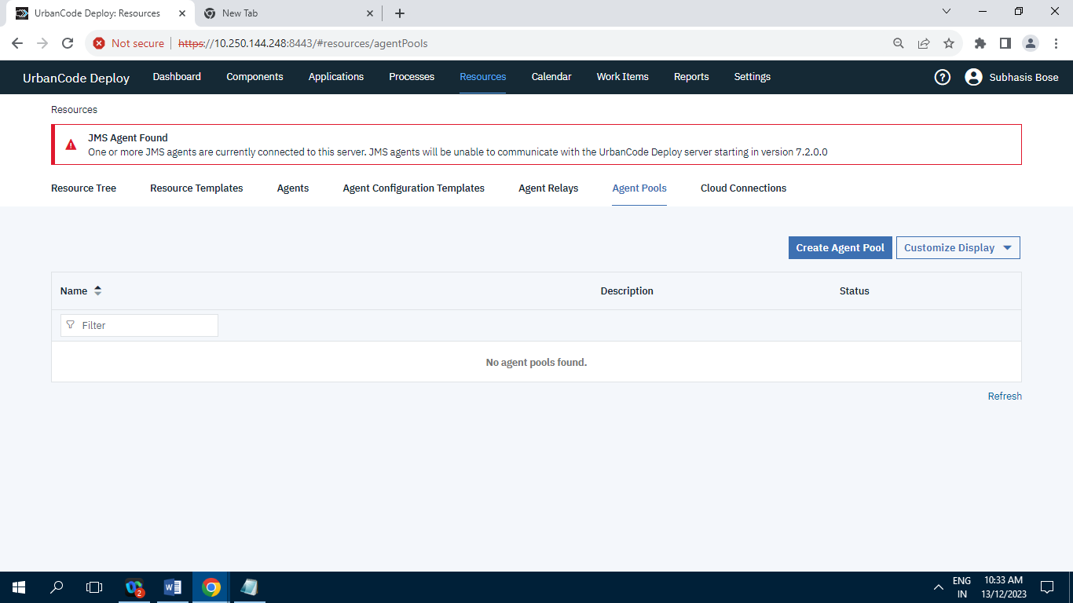

Screenshot of Agent Pools having zeroi Record.

**6.7] Cloud Connections :**

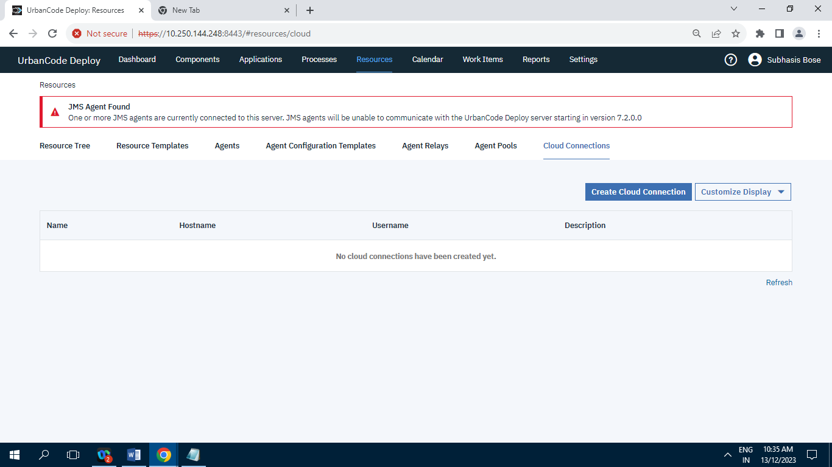

Screenshot of Cloud Connection having Zero Record.

**7] Calendar :**

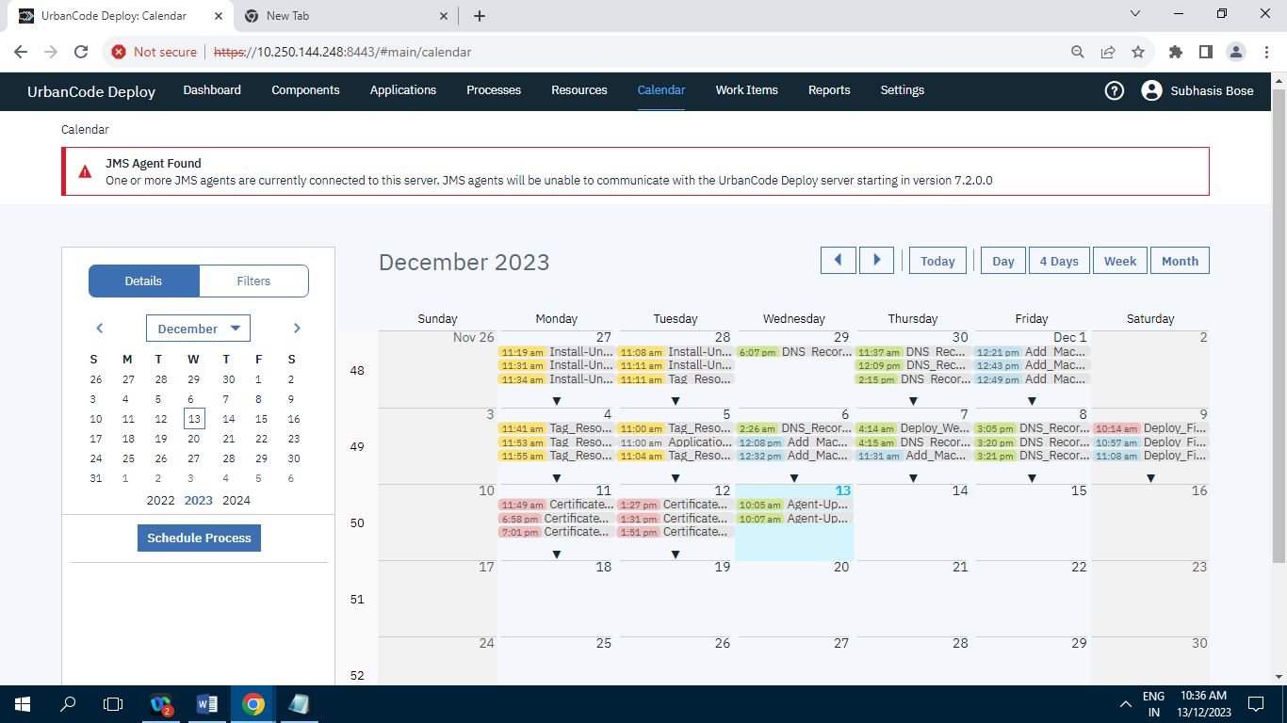

Screenshot of Calendar.

**8] Work Items :**

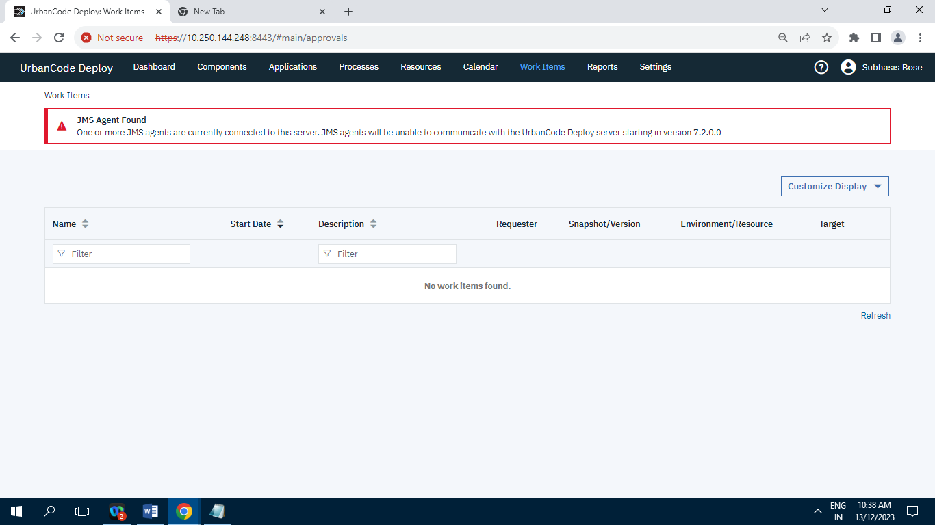

Screenshot of Work Item having zero Record.

**9] Reports :**

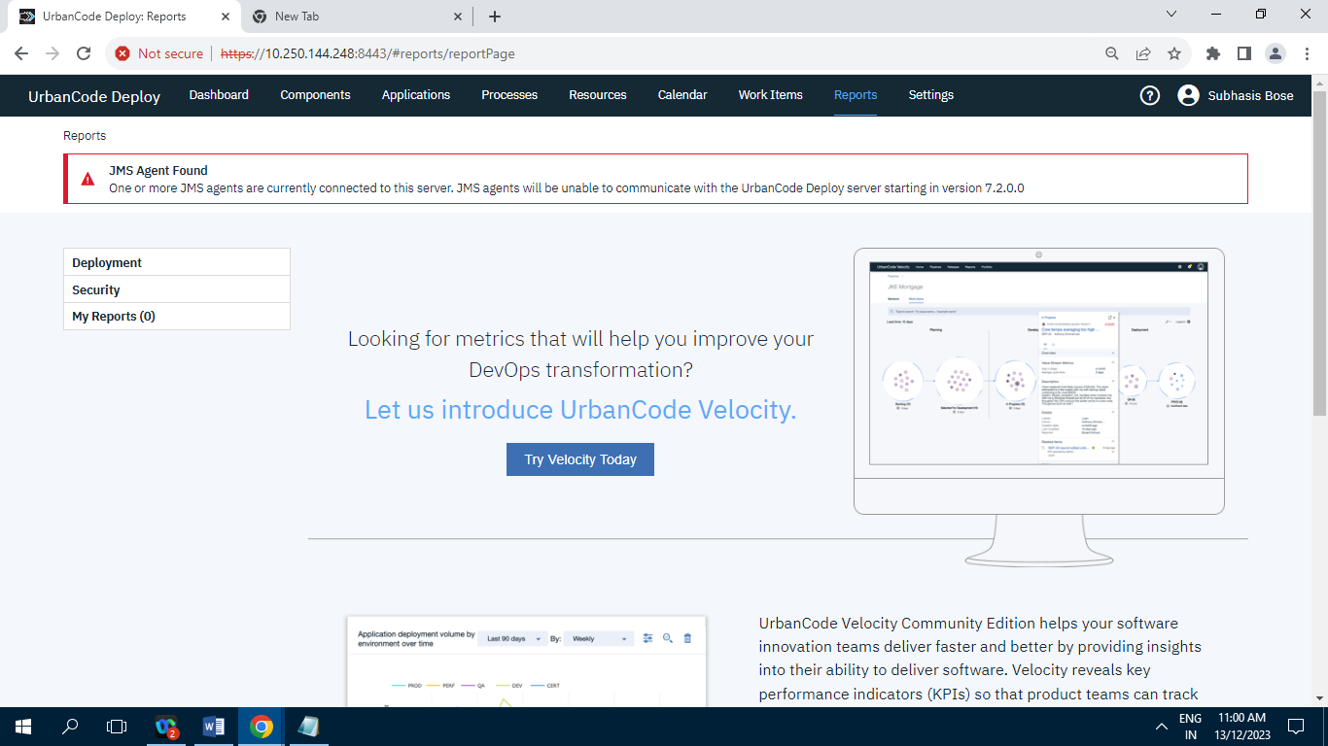

**9.1] Deployment:**

**9.1.1] Deployment Total Duration :**

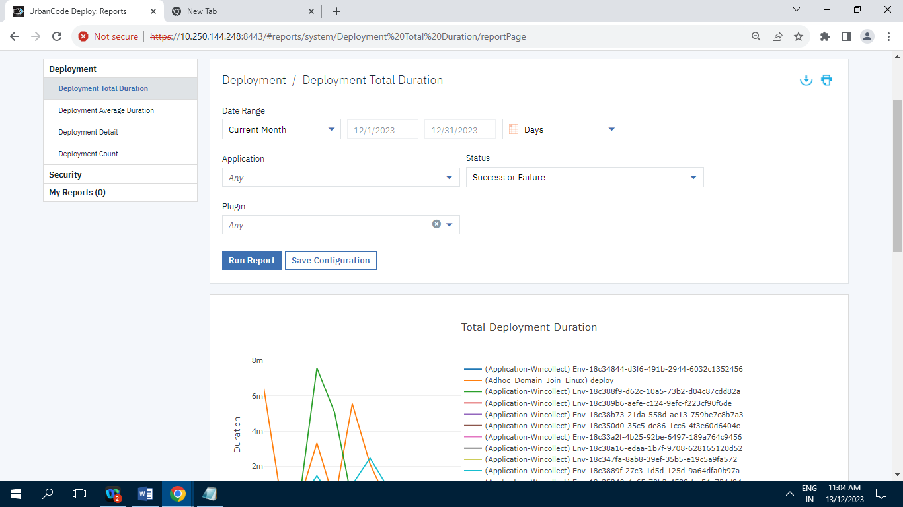

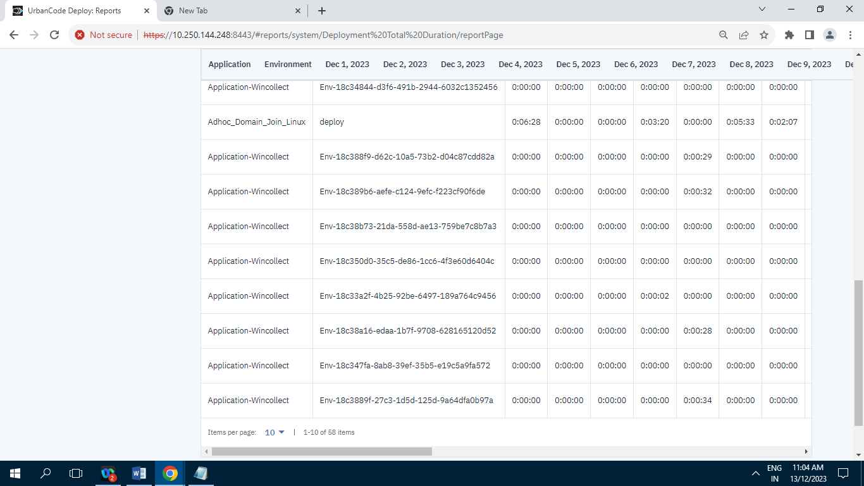

Screenshot of Deployment Total Duration having 58 Records/Items.

**9.1.2] Deployment Average Duration :**

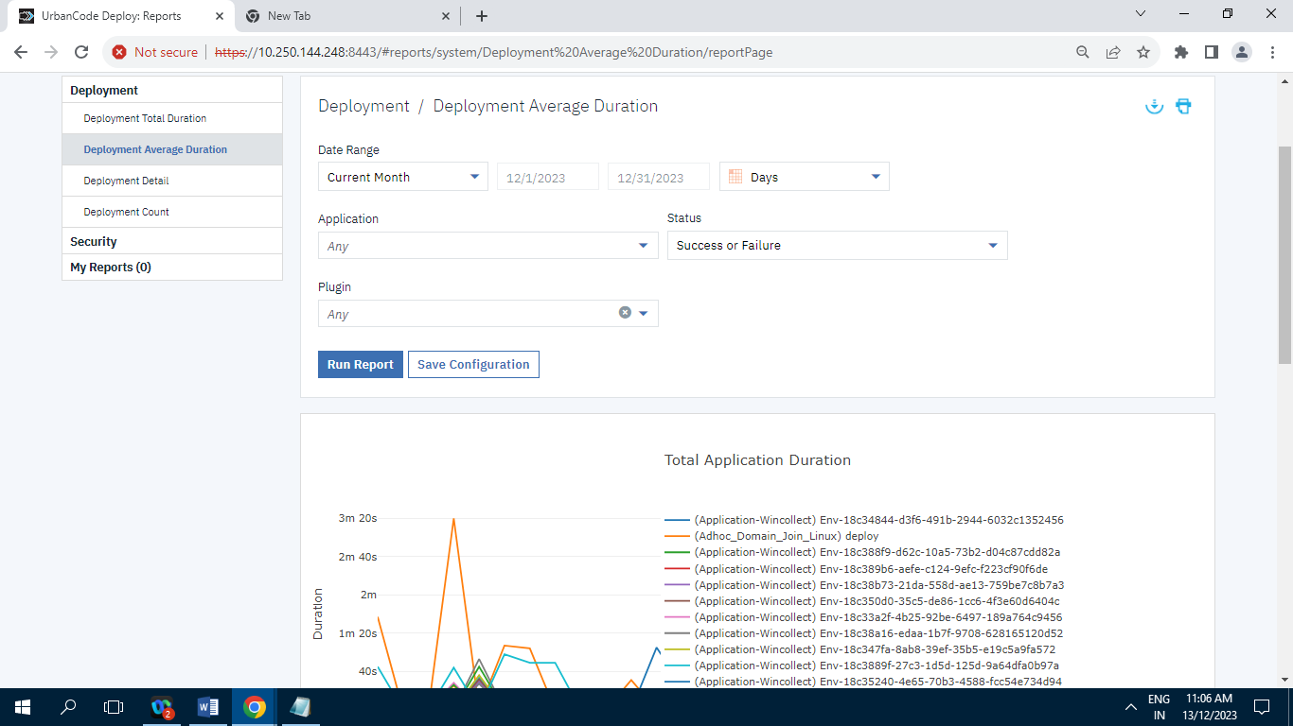

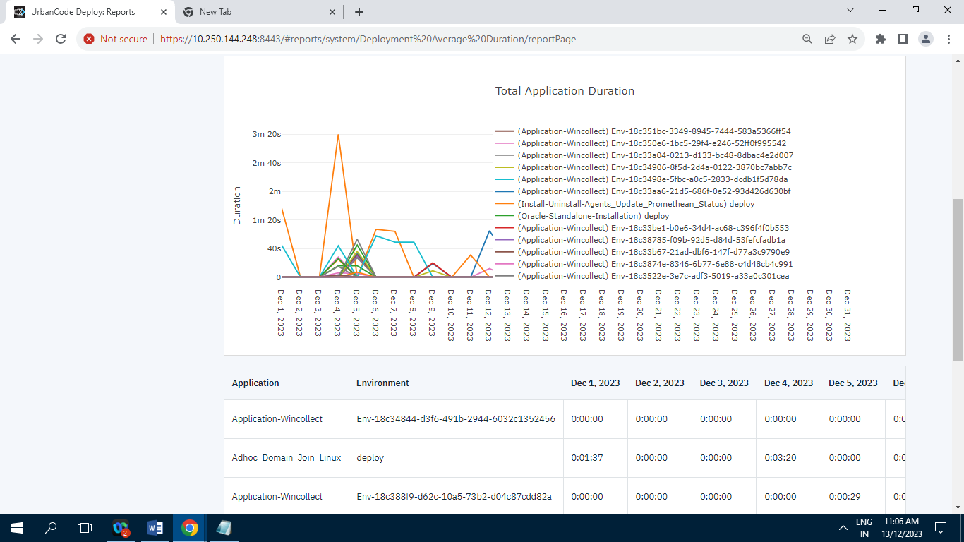

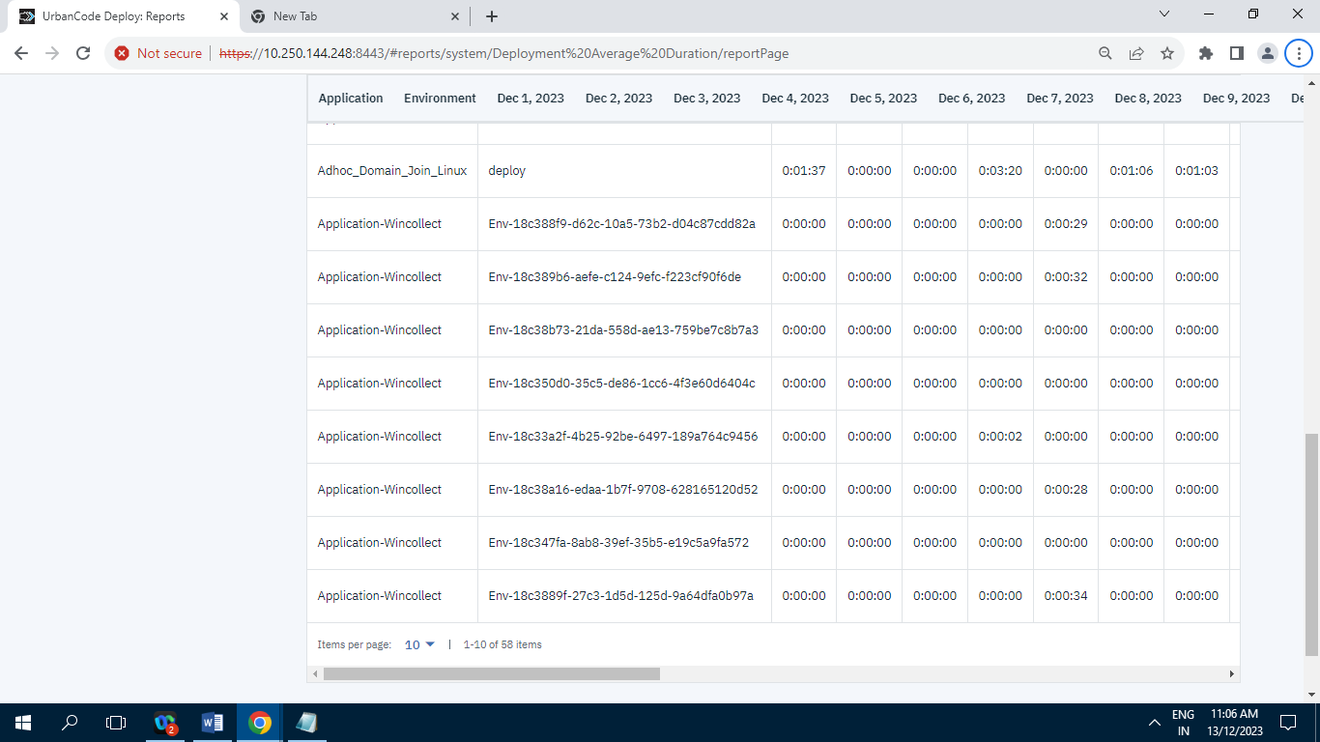

Screenshot of Deployment Average Duration having 58 Records/Items.

**9.1.3] Deployment Details :**

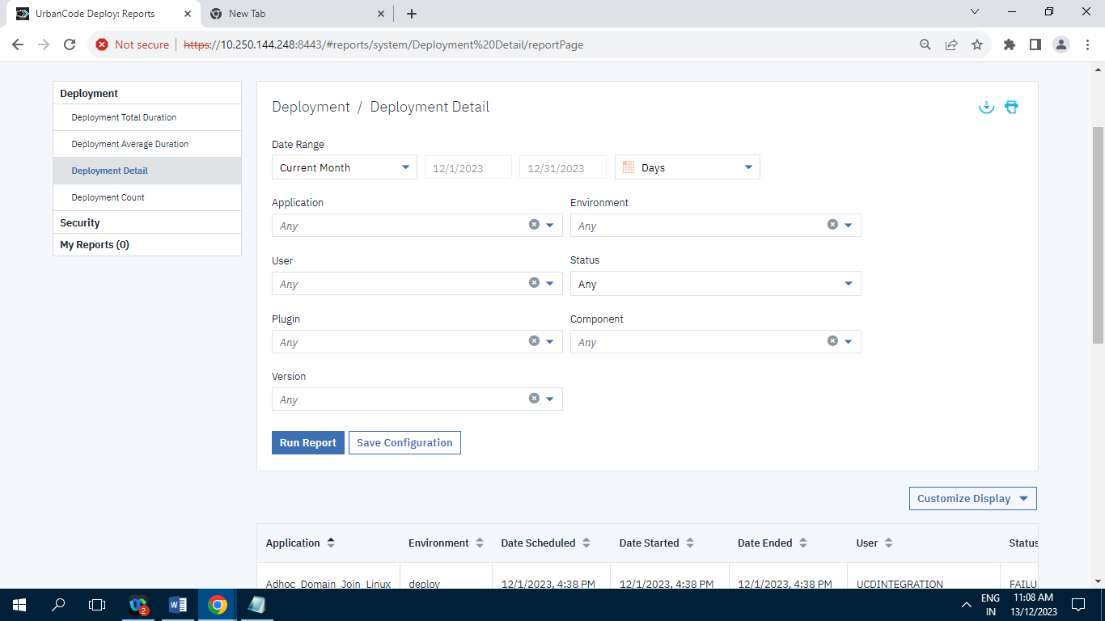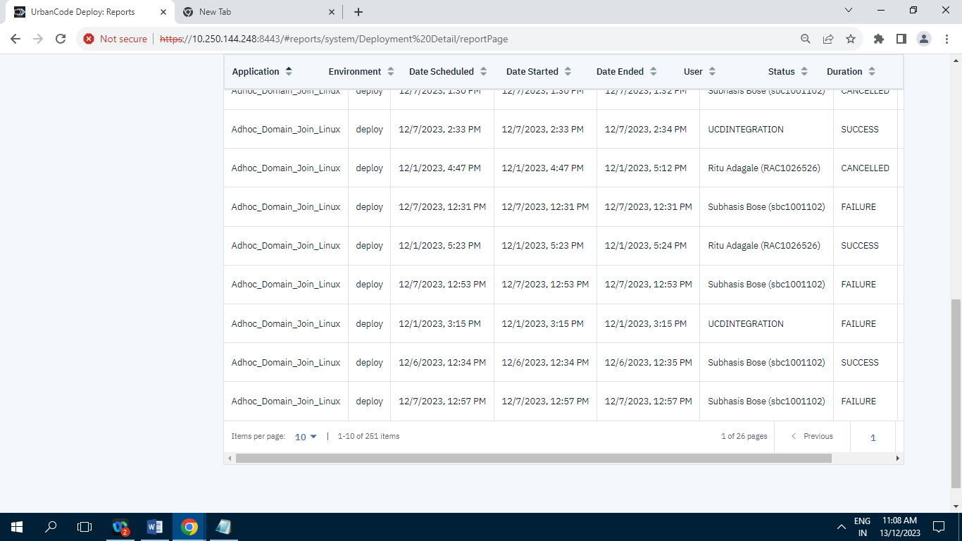

Screenshot of Deployment Detail having 251 Records/Items.

**9.1.4] Deployment Count :**

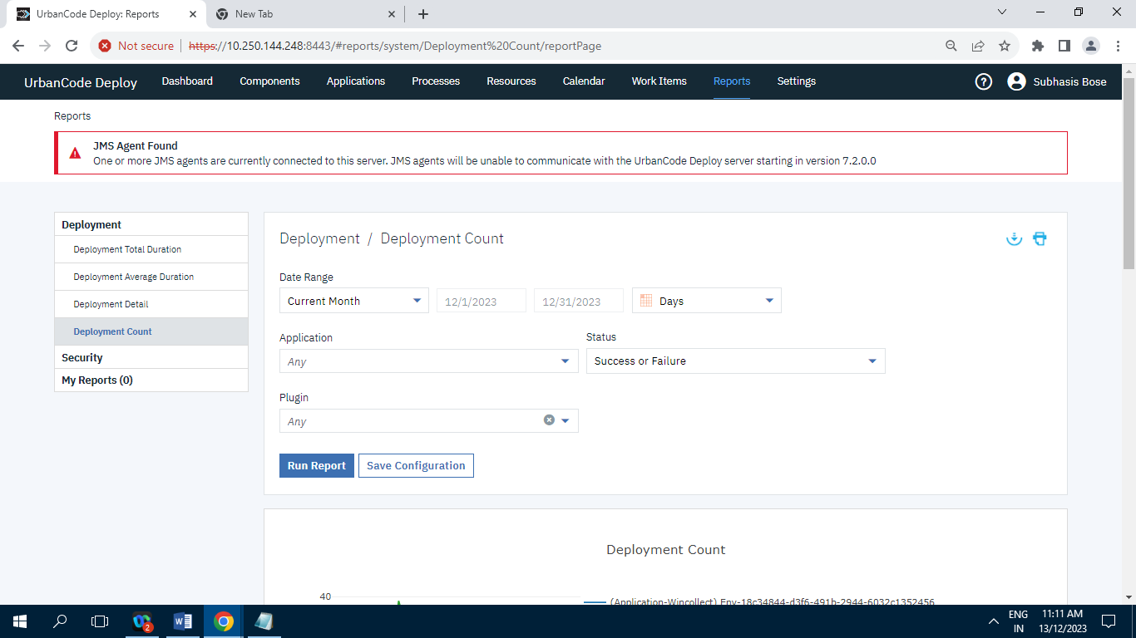

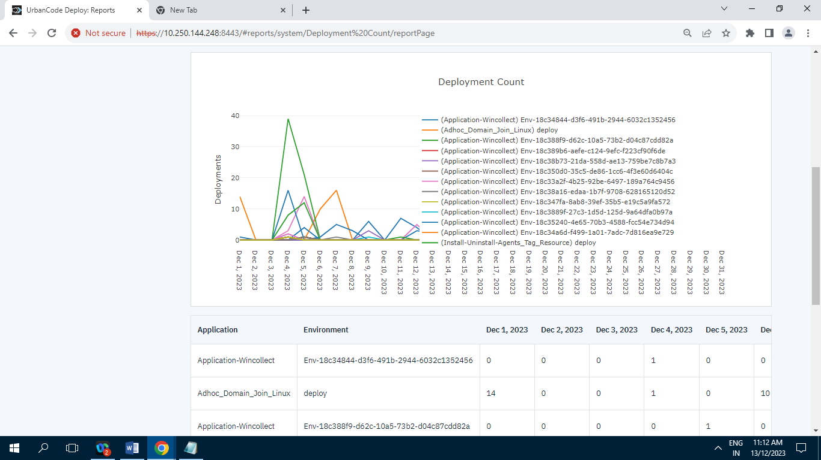

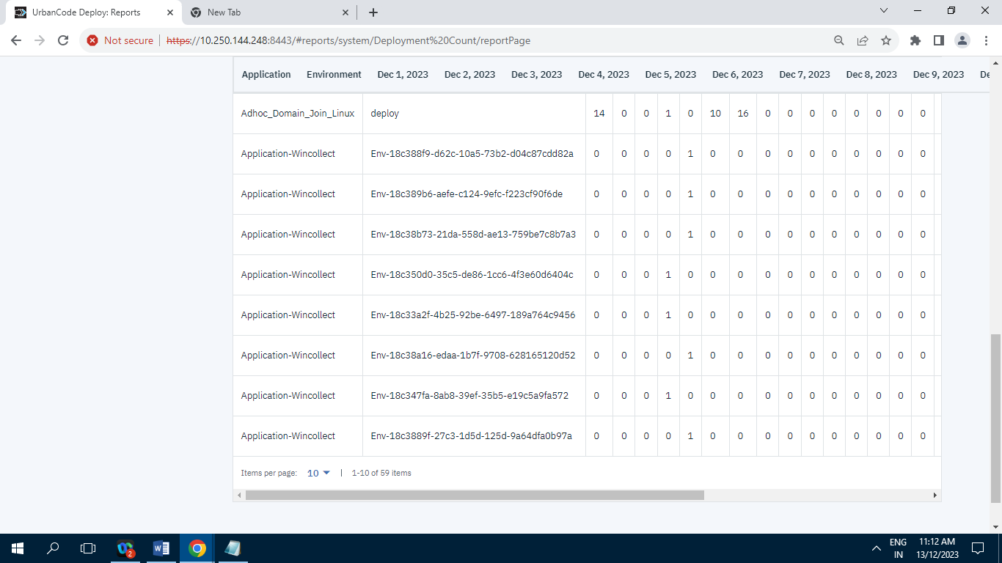

Screenshot of Deployment Count having 59 Records/Items.

**9.2] Security :**

**9.2.1] Component Security :**

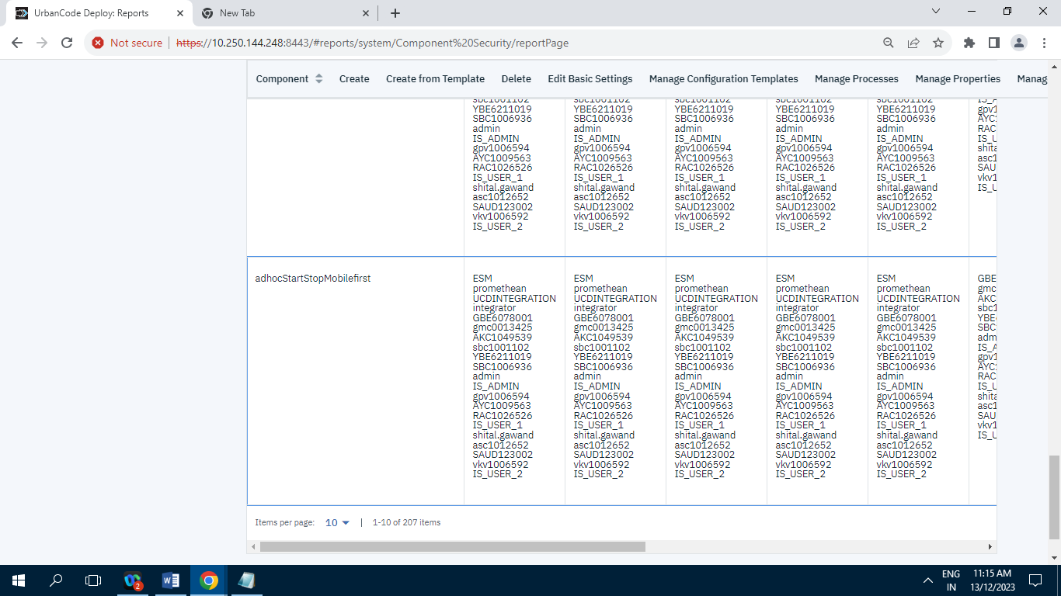

Screenshot of Component Security having 207 Records/Items.

**9.2.2] User Security :**

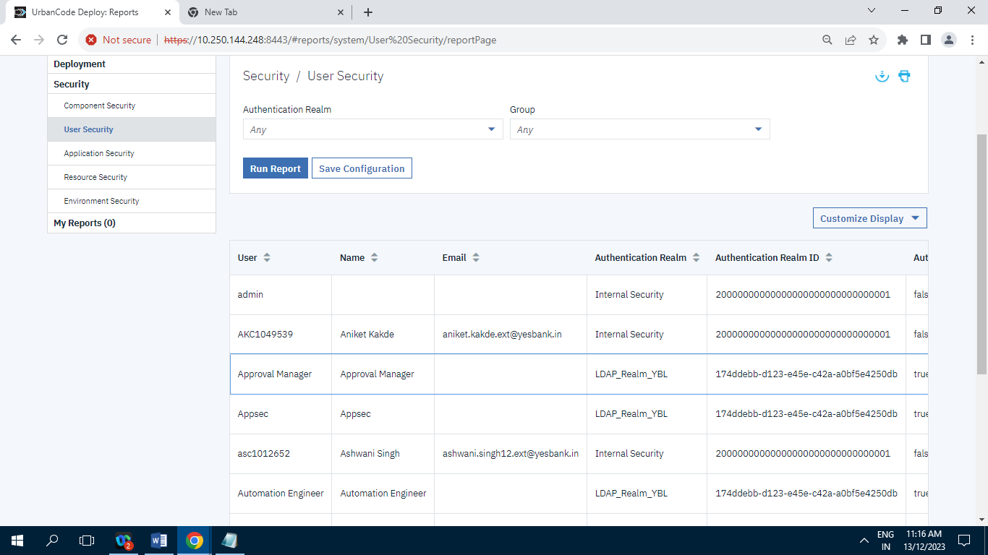

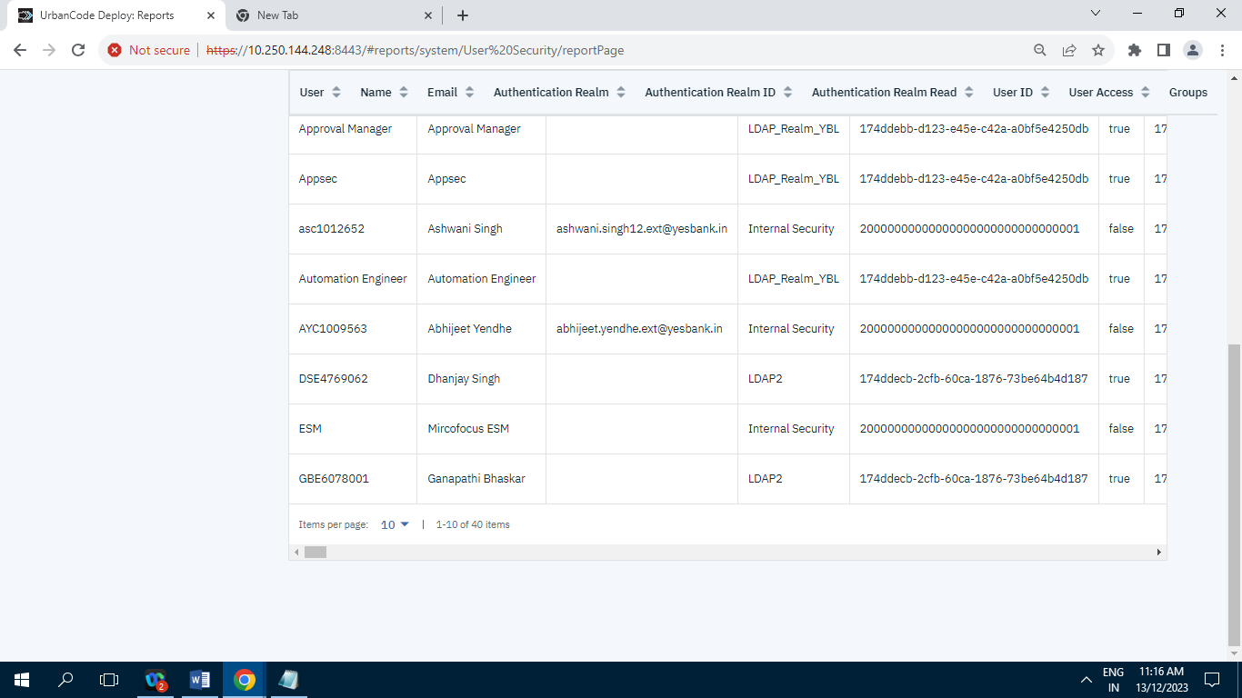

Screenshot of User Security having 40 Records/Items.

**9.2.3] Application Security :**

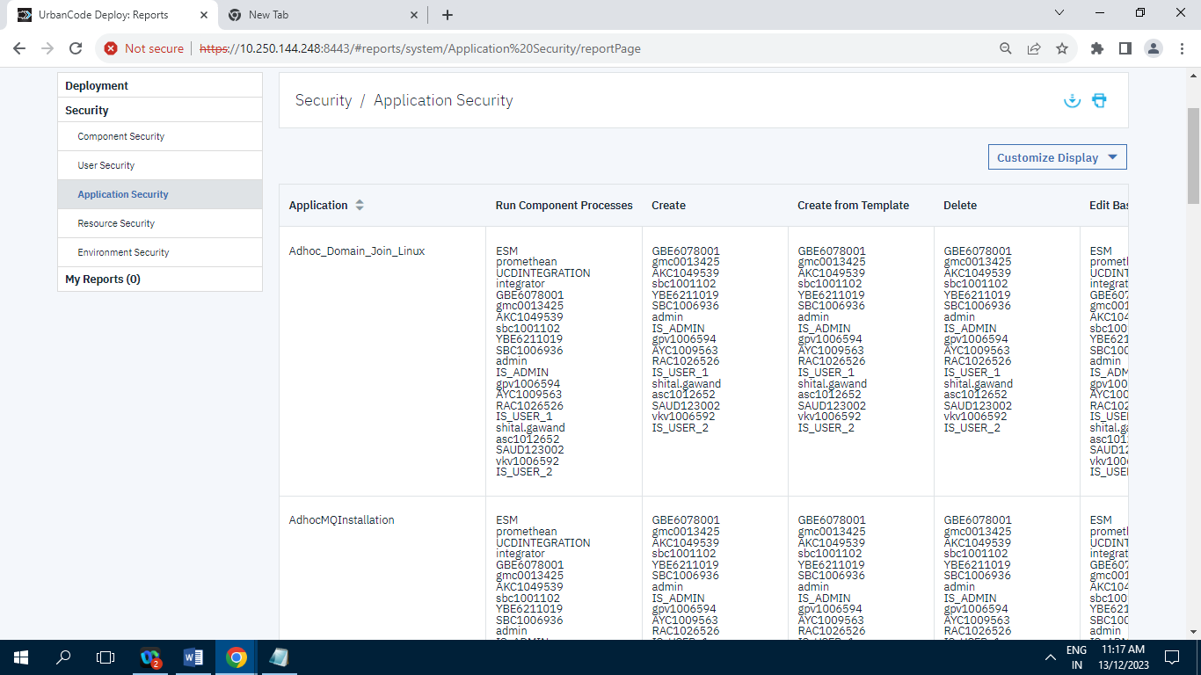

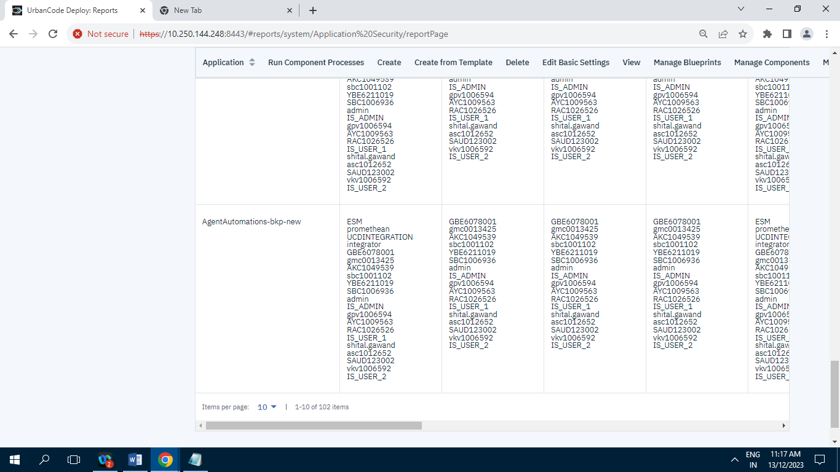

Screenshot of Application Security having 102 Records/Items.

**9.2.4] Resource Security :**

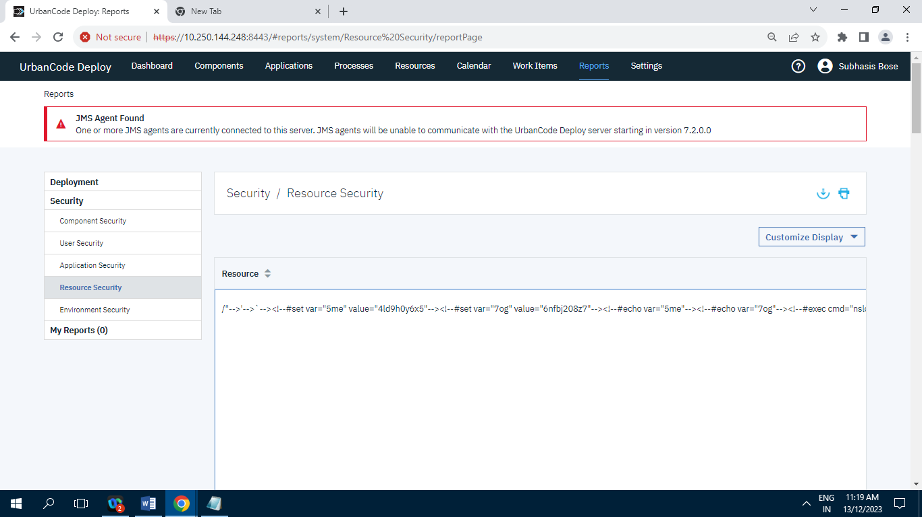

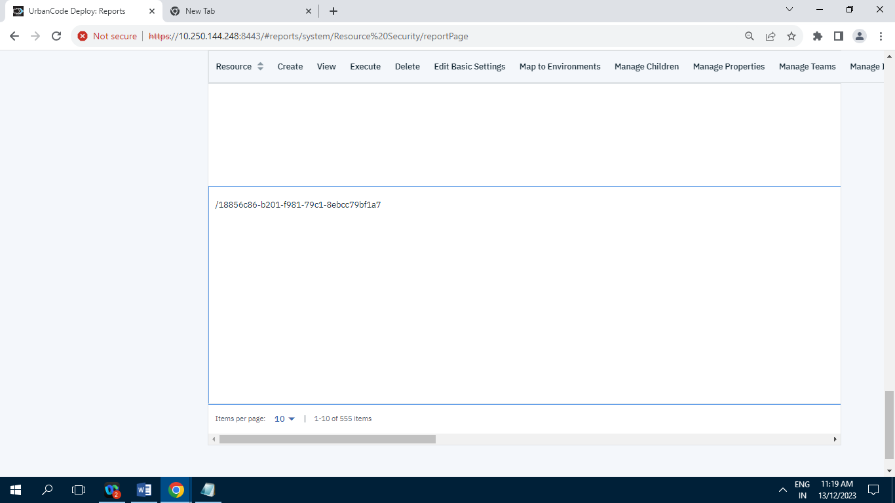

Screenshot of Resource Security having 555 Records/Items.

**9.2.5] Environment Security :**

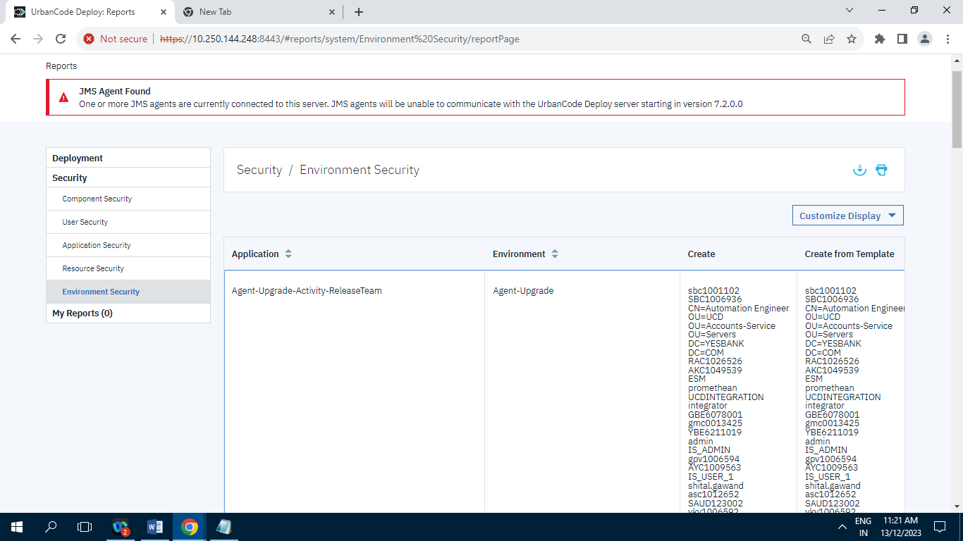

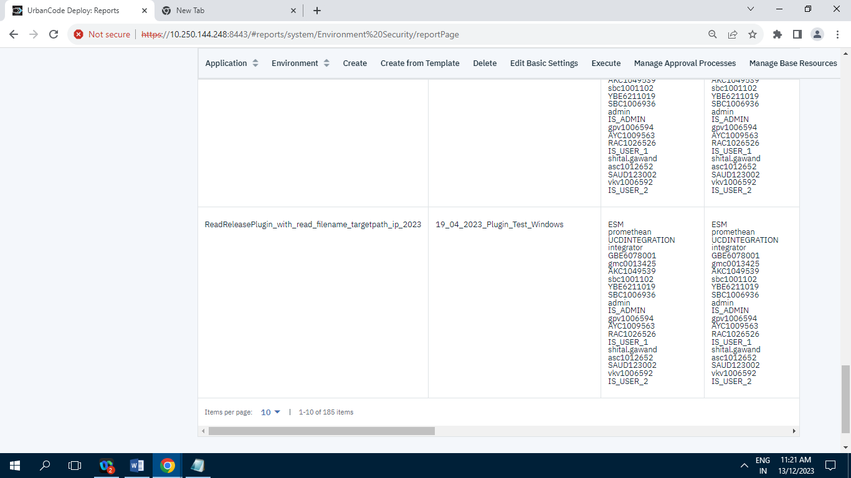

Screenshot of Environment Security having 185 Records/Items.

**9.3] My Reports :** Having Zero Record.

**10] Settings:**

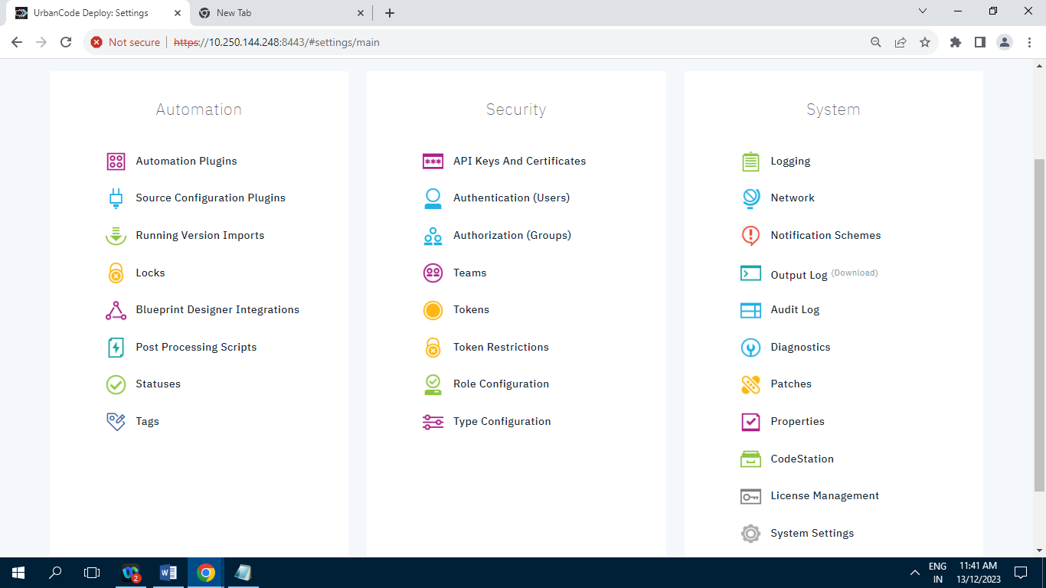

**10.1] Automation :**

**10.1.1] Automation Plugins :**

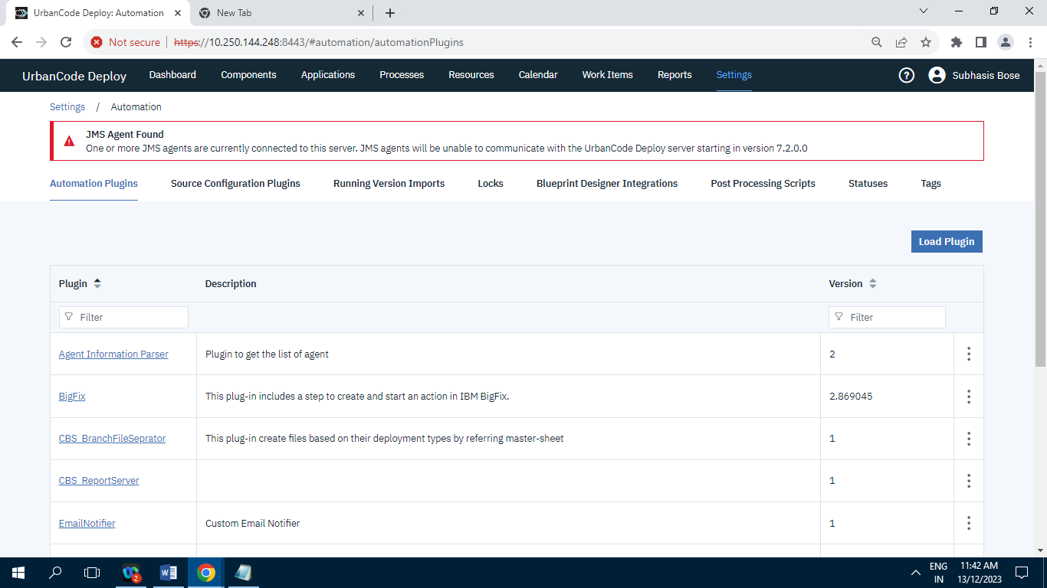

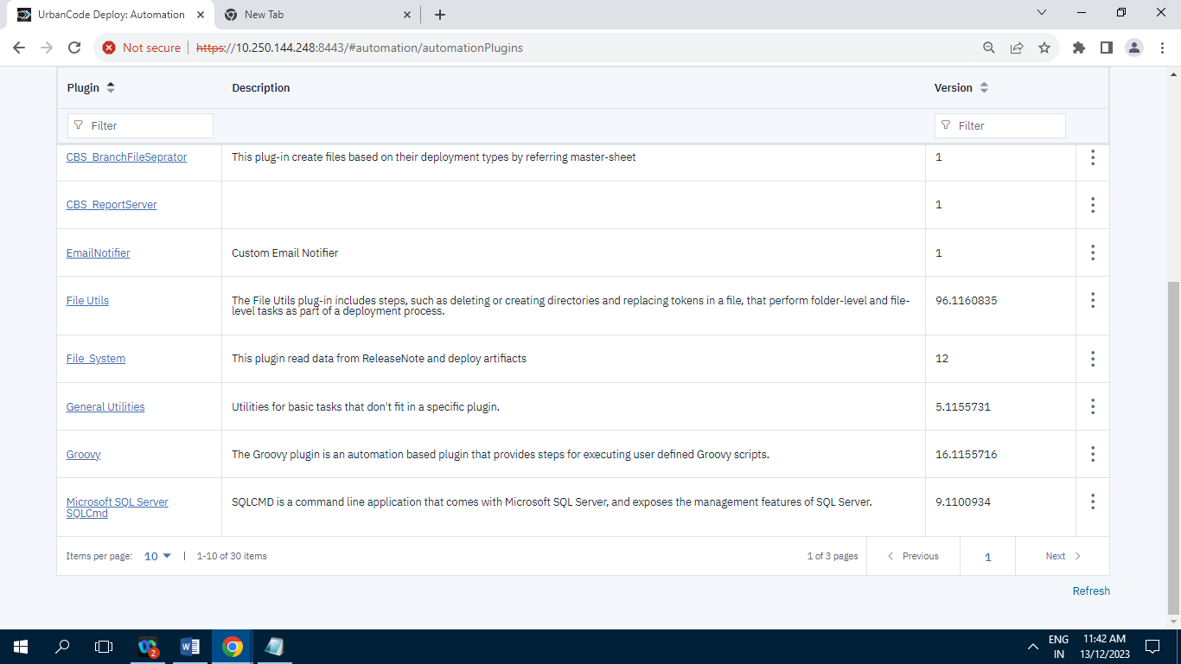

Screenshot of Automation Plugins having 30 Records/Items.

**10.1.2] Source Configuration Plugins :**

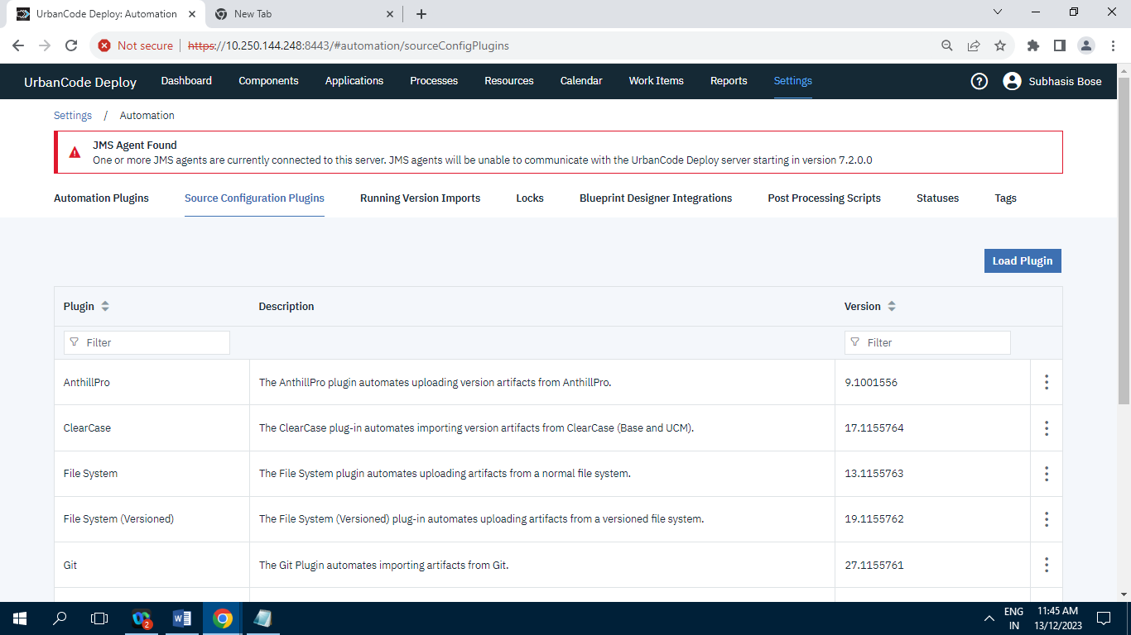

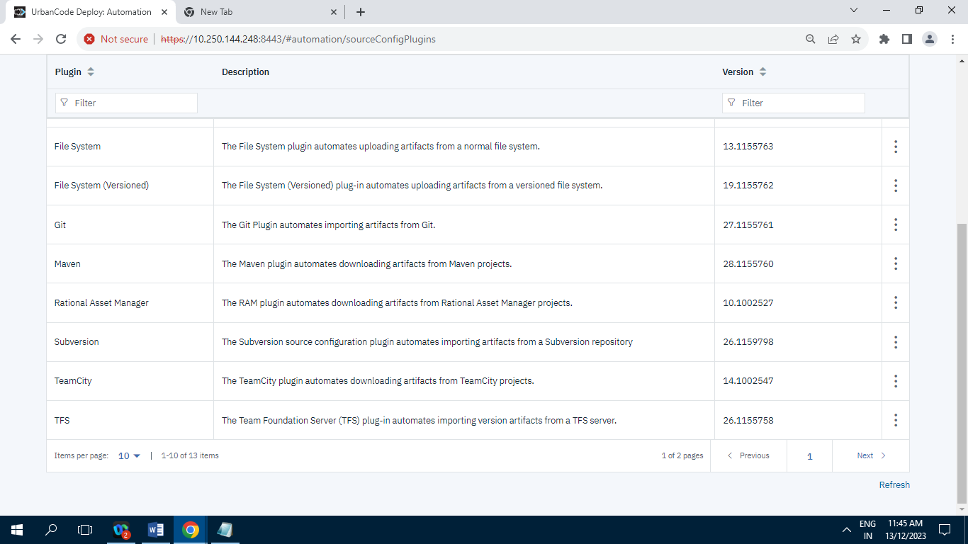

Screenshot of Source Configuration Plugins having 13 Records/Items.

**10.1.3] Running Version Import :**

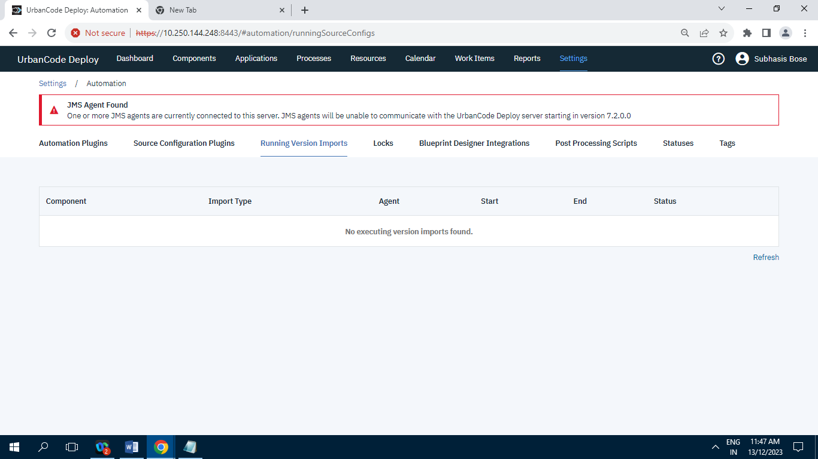

Screenshot of Running Version Import having zero Record.

**10.1.4] Locks :**

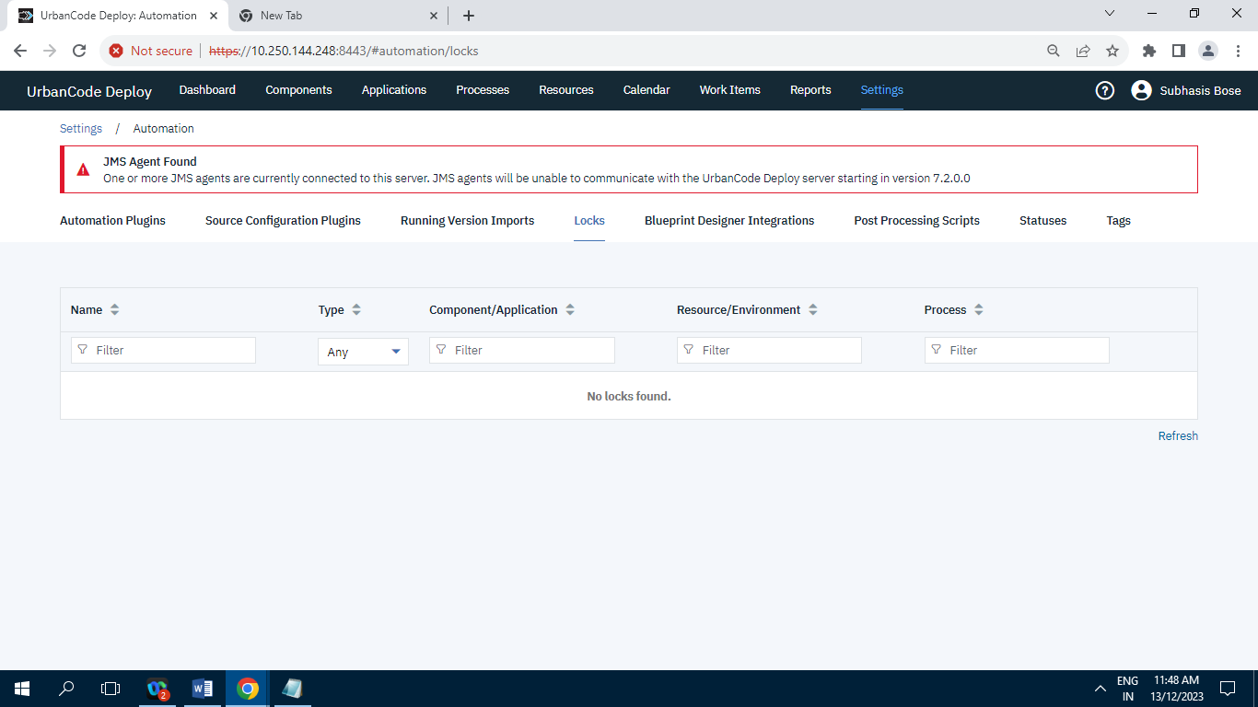

Screenshot of Locks having Zero Record.

**10.1.5] Blueprint Designer Integration :**

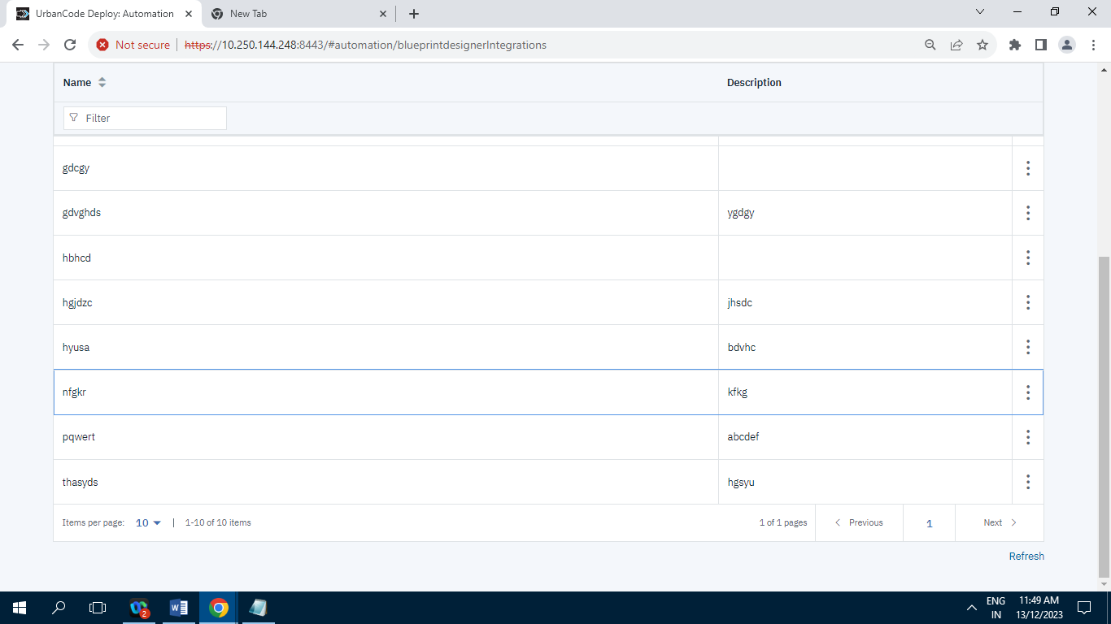

Screenshot of Blueprint Designer Integration Having 10 Records/Items.

**10.1.6] Post Processing Script :**

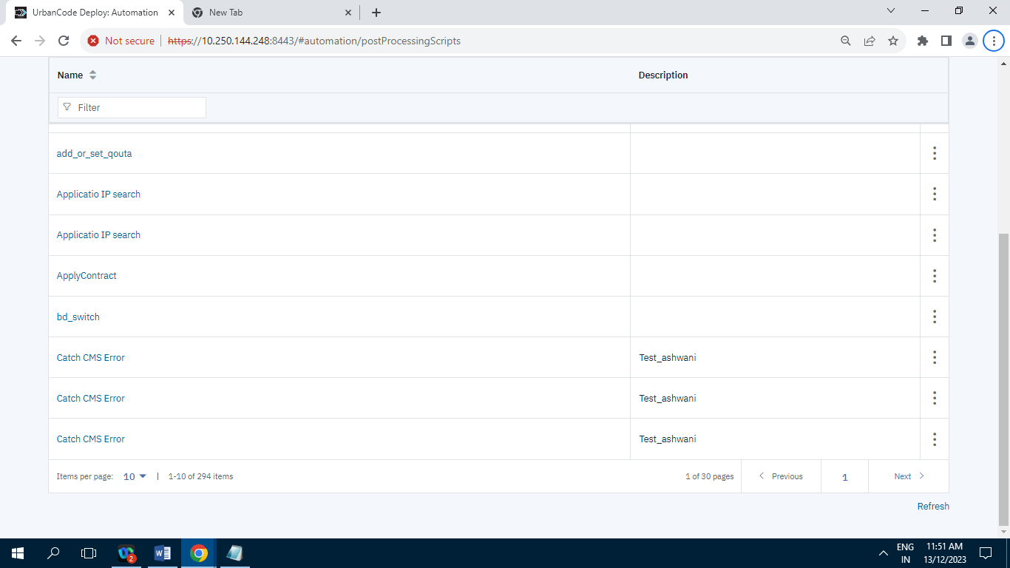

Screenshot of Post Processing Script having 294 Records/Items.

**10.1.7] Statuses :**

**10.1.7.1] Inventory Statuses :**

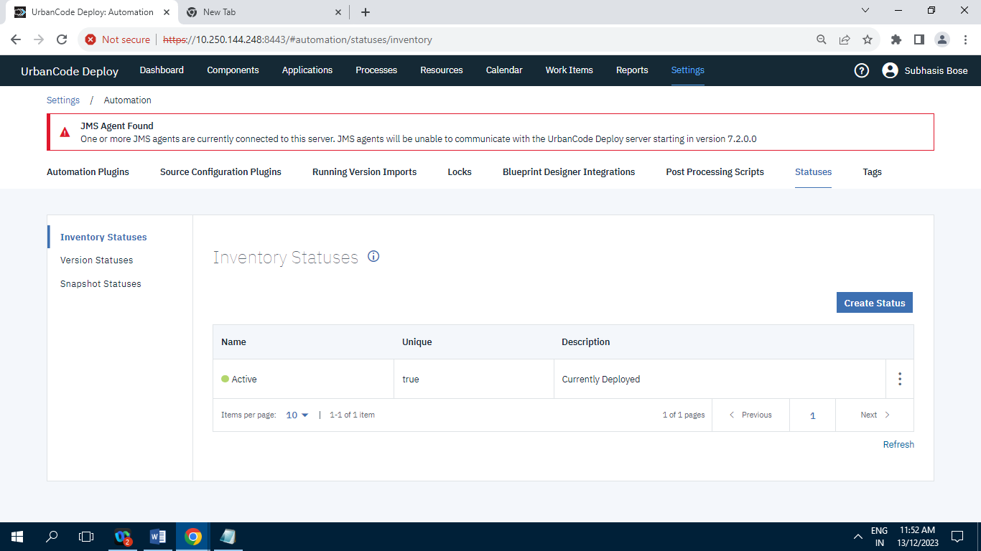

Screenshot of Inventory Statuses having 1 Record/Item.

**10.1.7.2] Version Statuses :**

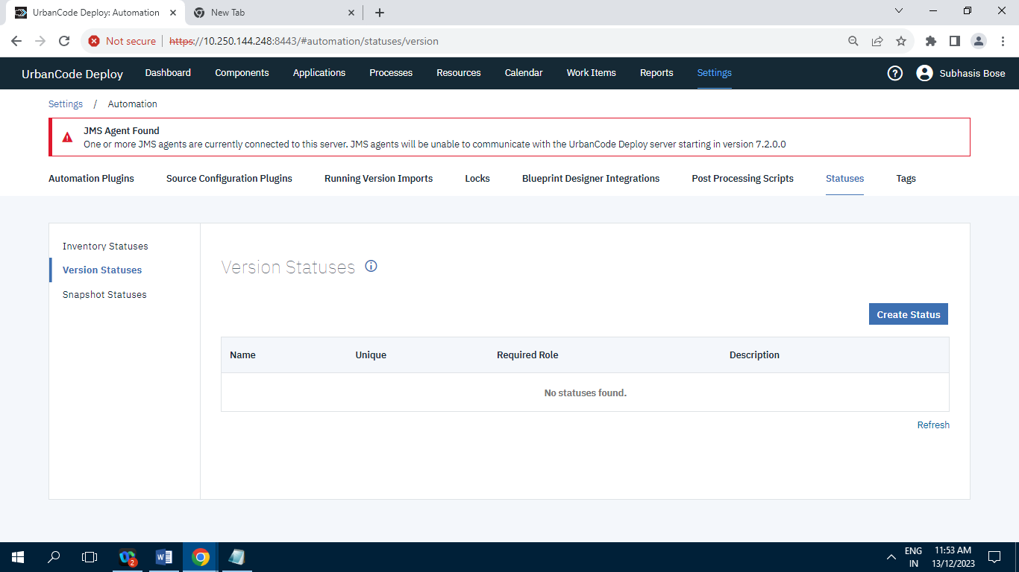

Screenshot of Version Statuses having zero Record.

**10.1.7.3] Snapshot Statuses :**

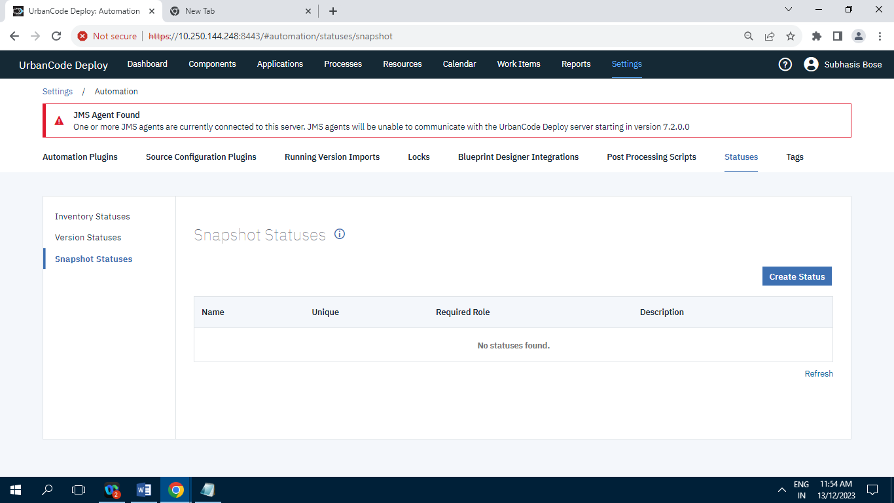

Screenshot of Snapshot Statuses having zero Record.

**10.1.8] Tags :**

**10.1.8.1] Agent Tags :**

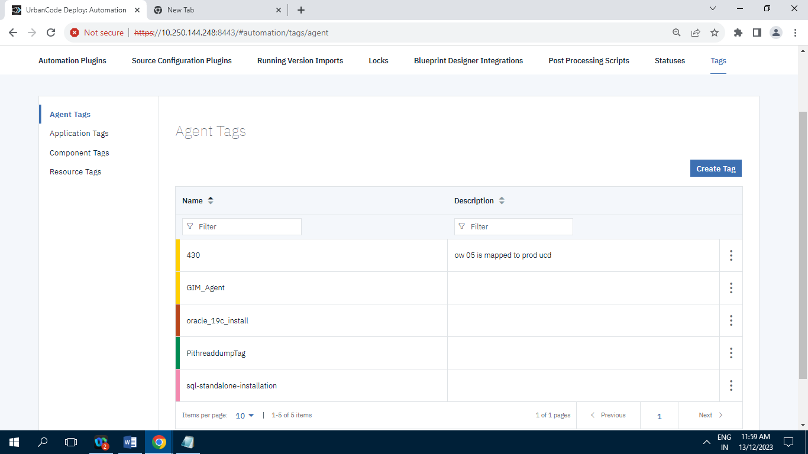

Screenshot of Agent Tags having 5 Records/Items.

**10.1.8.2] Application Tags :**

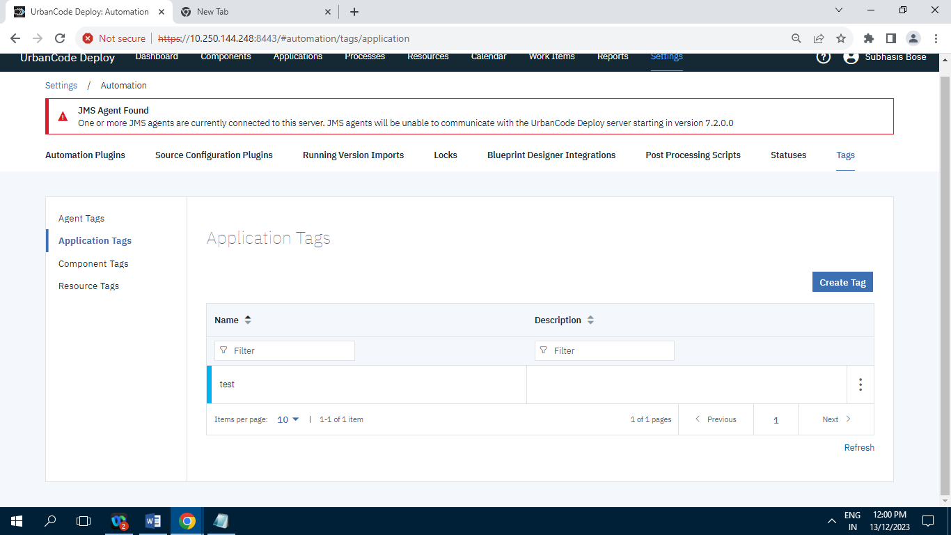

Screenshot of Application tags having 1 Record.

**10.1.8.3] Component Tags :**

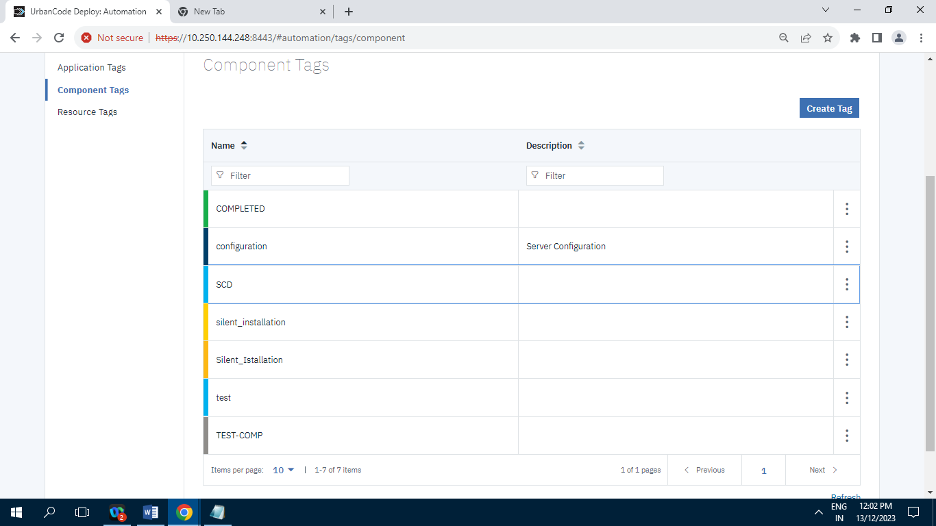

Screenshot of Component Tags having 7 Records/Items.

**10.1.8.4] Resource Tags :**

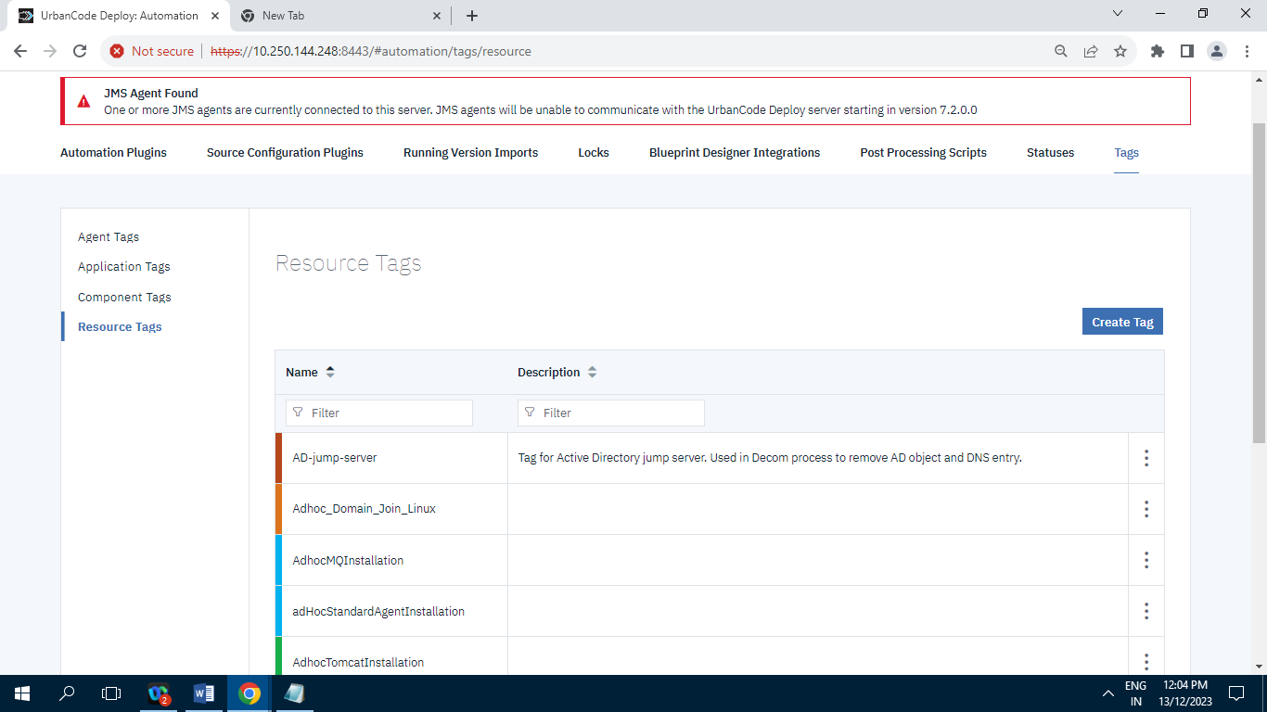

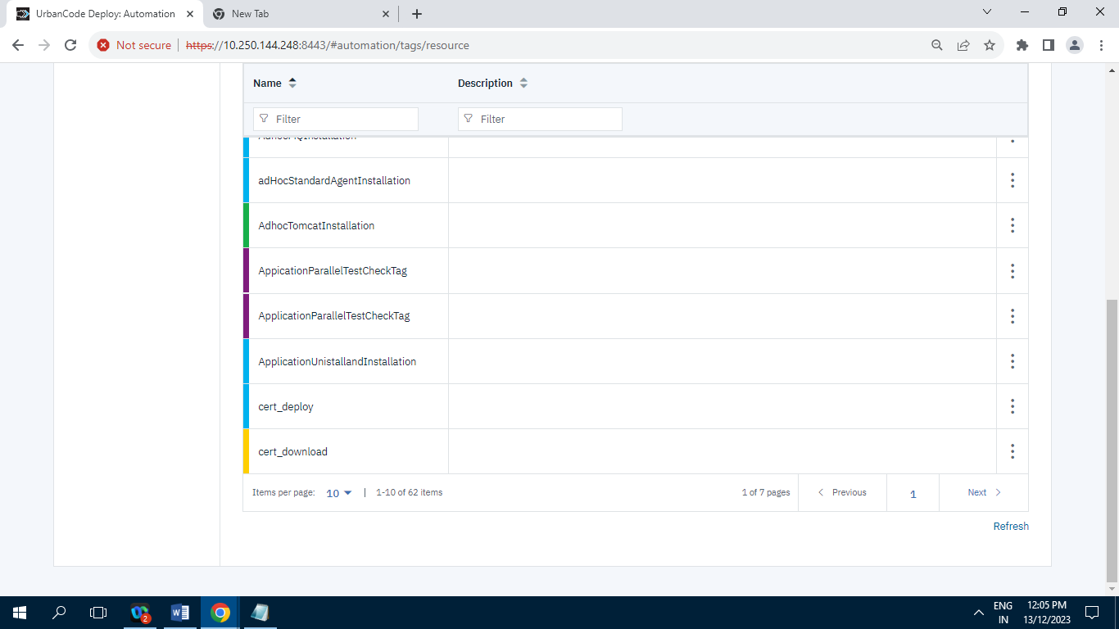

Screenshot of Resource Tags having 62 Records/Items.

**10.2] Security :**

**10.2.1] API Keys And Certificates :**

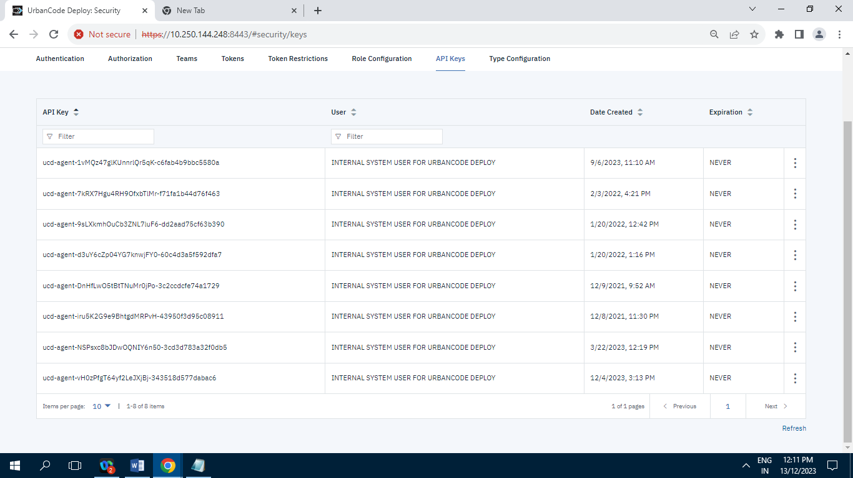

Screenshot of API Keys having 8 Records/Items.

**10.2.2] Authentication (Users) :**

**10.2.2.1] Internal Security :**

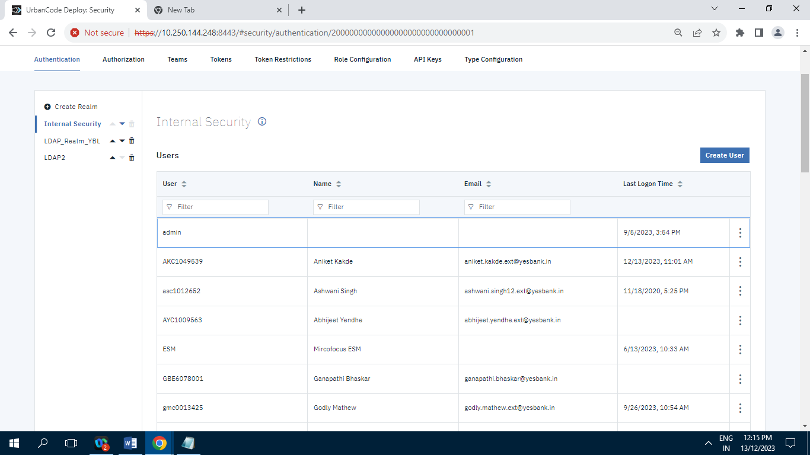

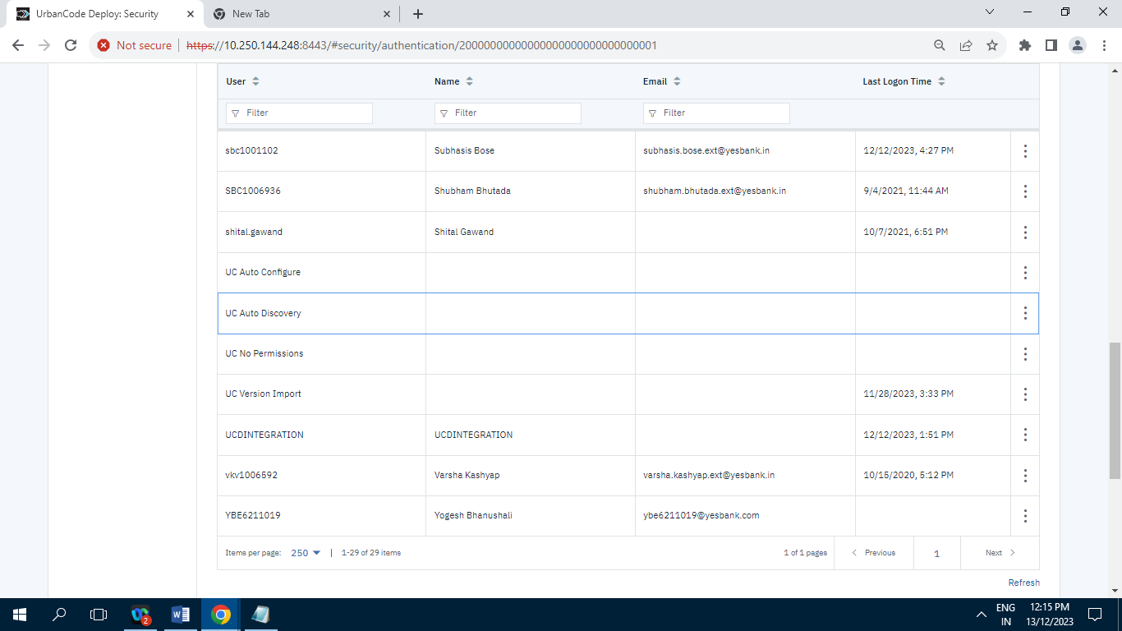

**Records = 29**

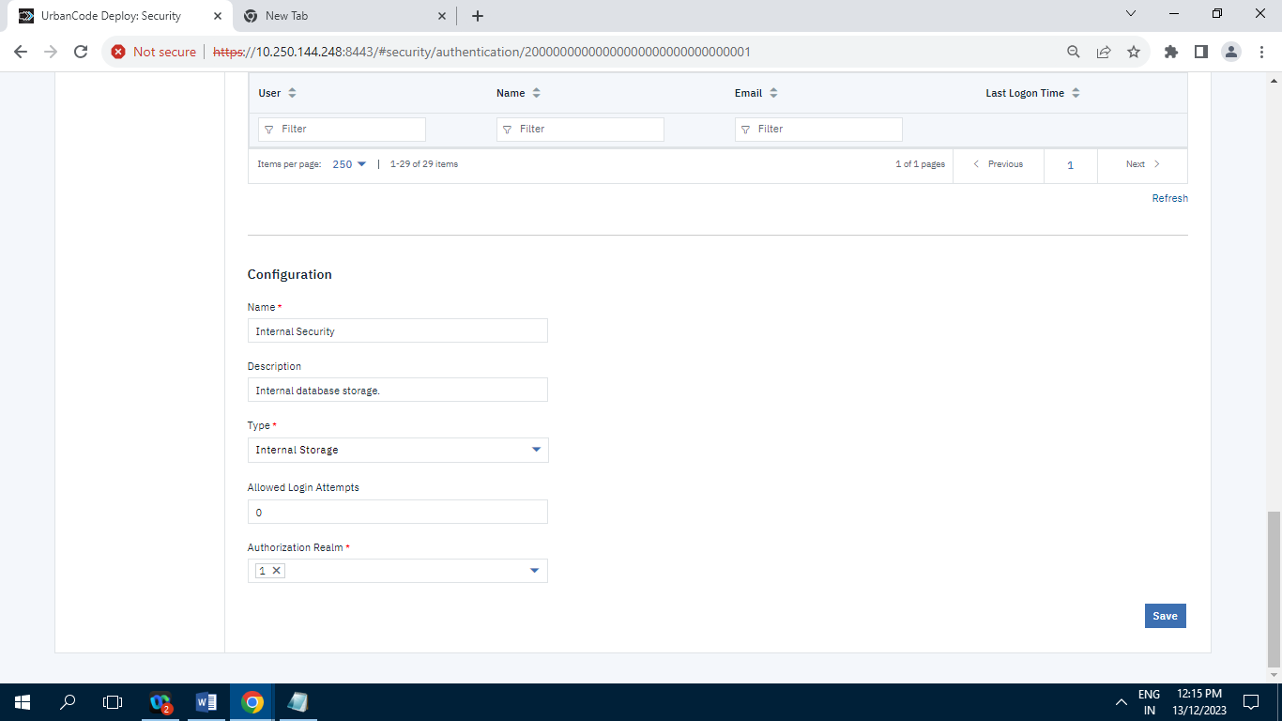

**10.2.2.2] LDAP_Realm_YBL :**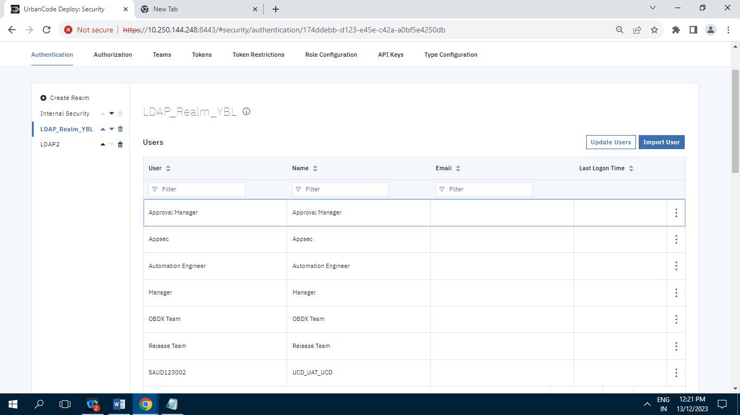

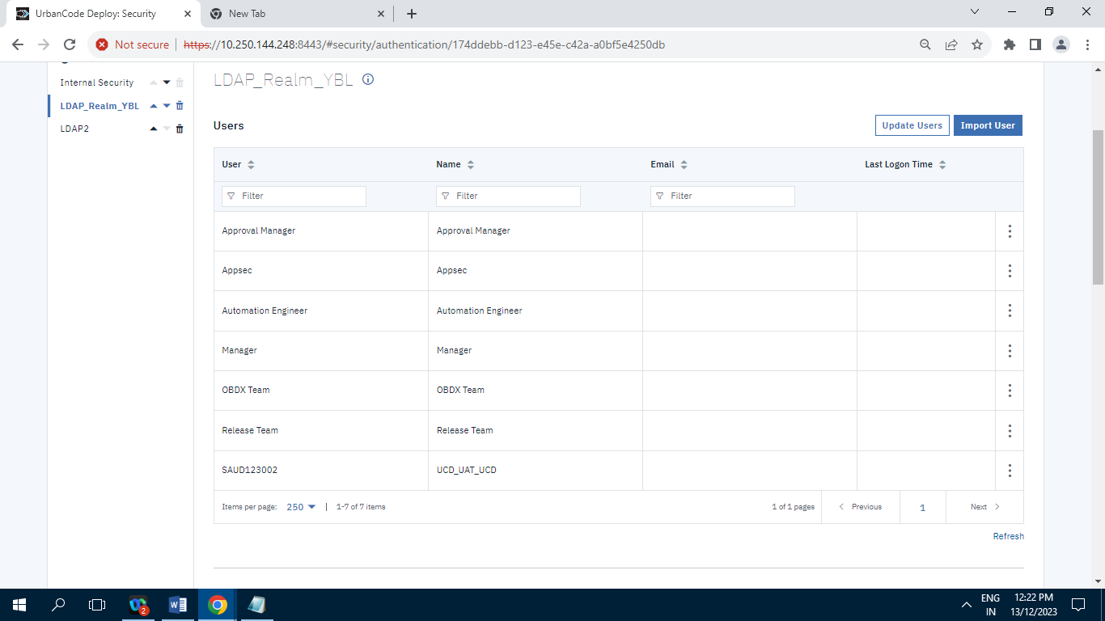

Screenshot of LDAP_Realm_YBL having 7 Records/Items.

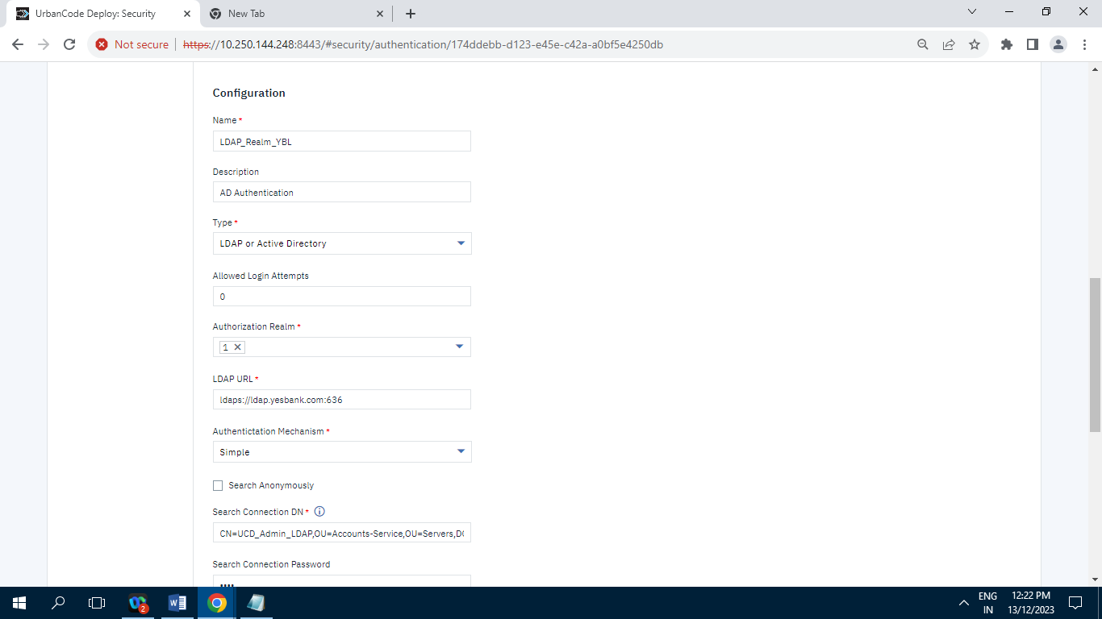

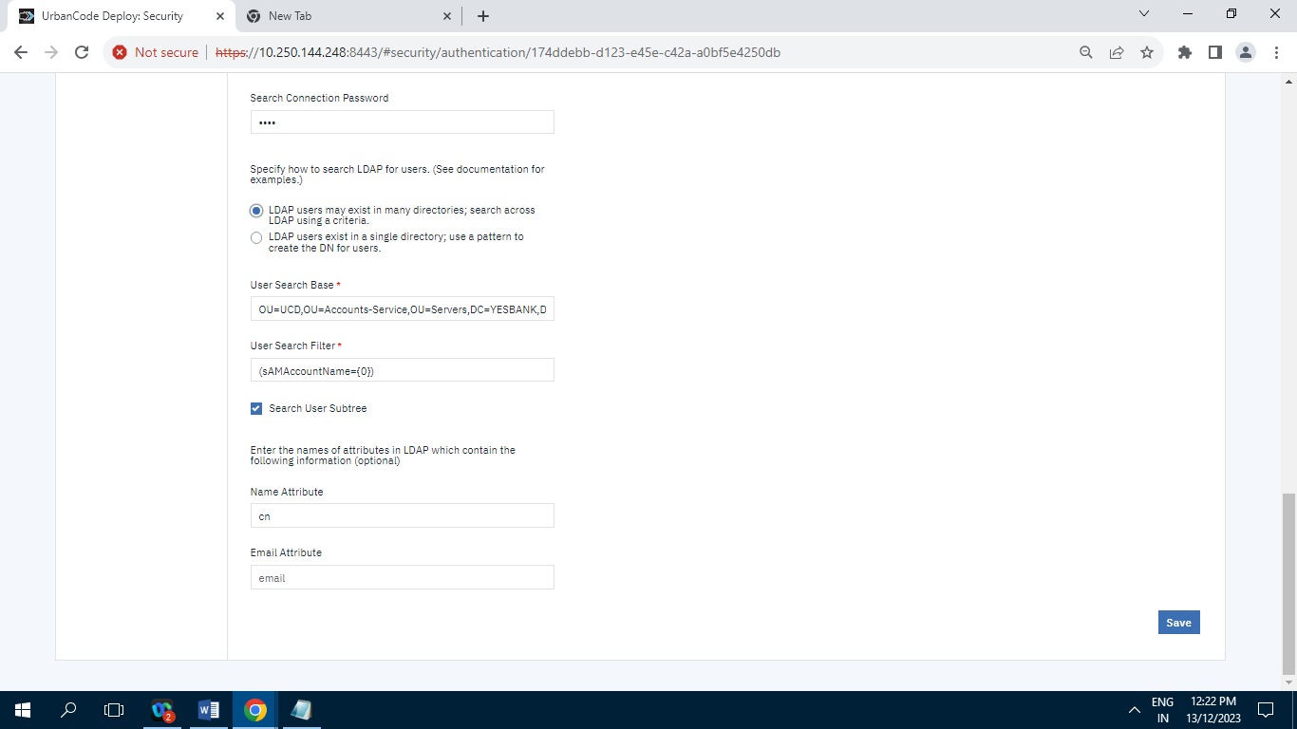

**10.2.2.3] LDAP2 :**

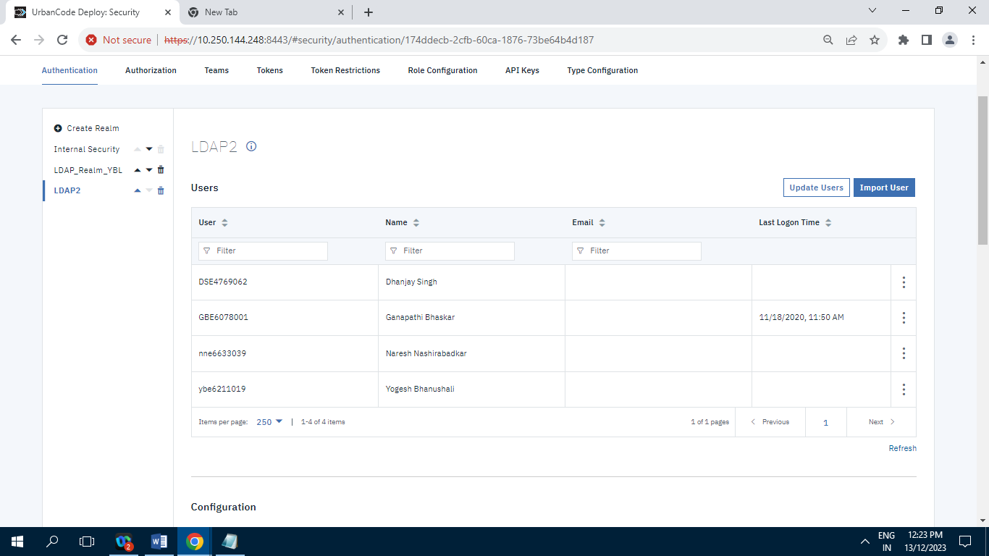

Screenshot of LDAP2 having 4 Records/Items.

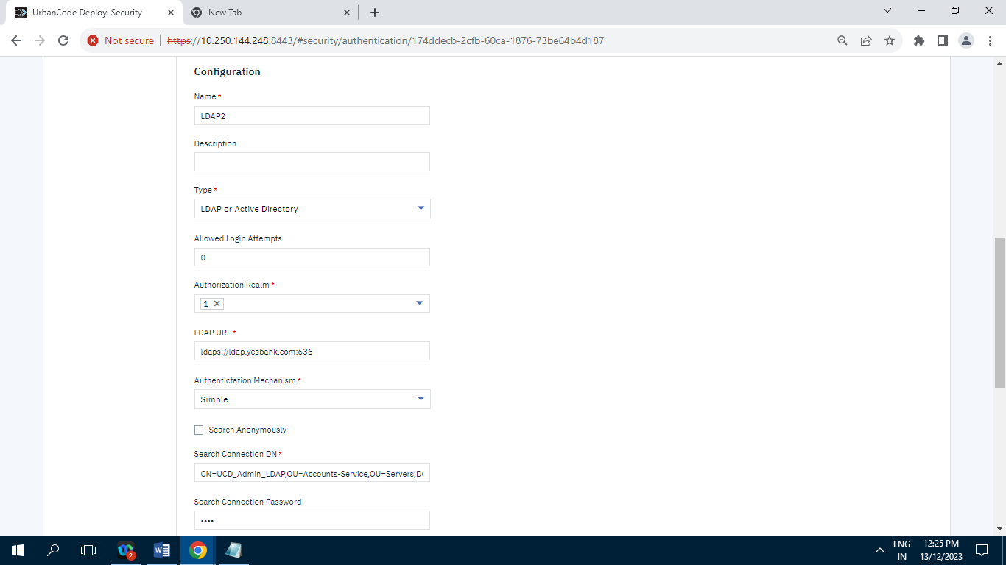

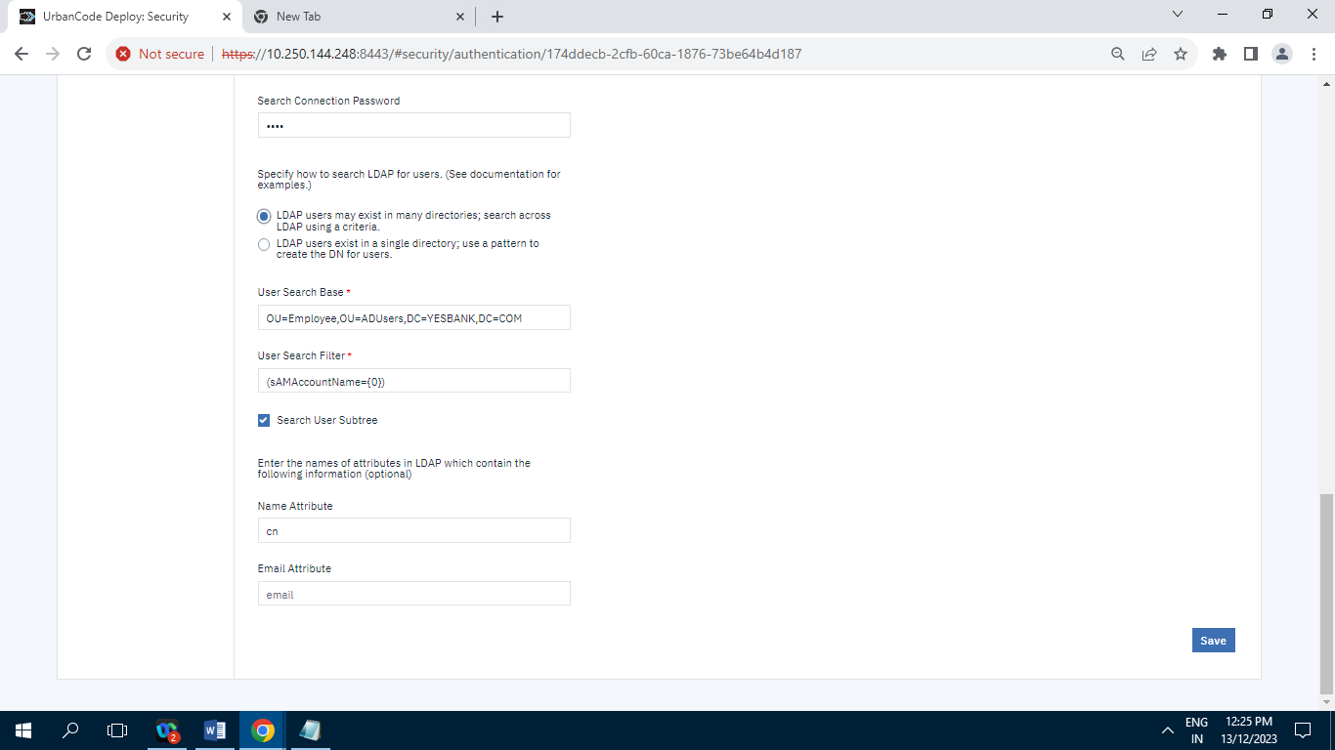

**10.2.3] Authorization (Groups) :**

**10.2.3.1] Authorization Realms :**

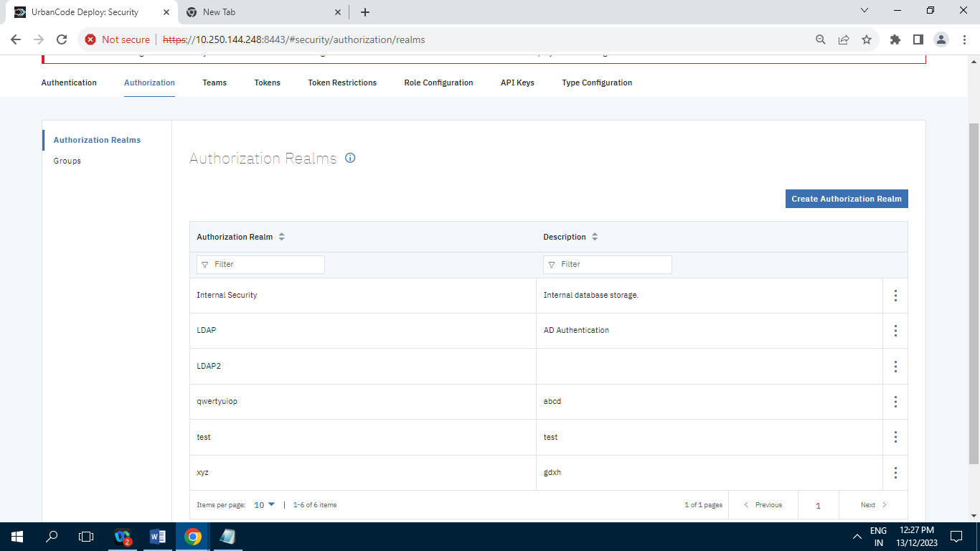

**Records= 6**

**10.2.3.2] Groups :**

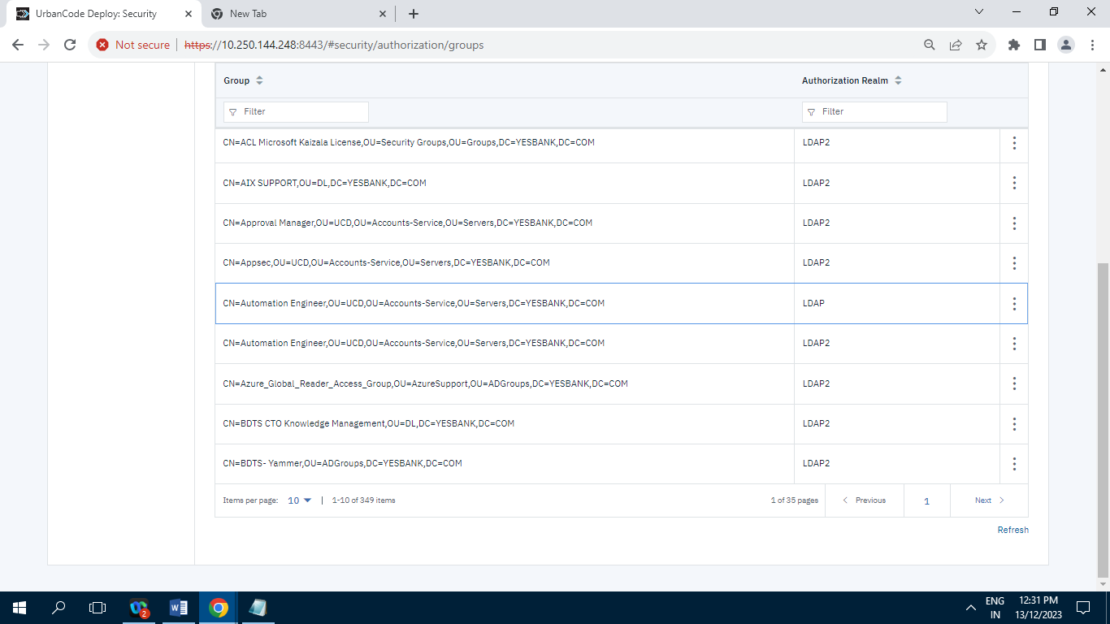

**Records= 349**

**10.2.4] Teams :**

**10.2.4.1] Approval Manager :**

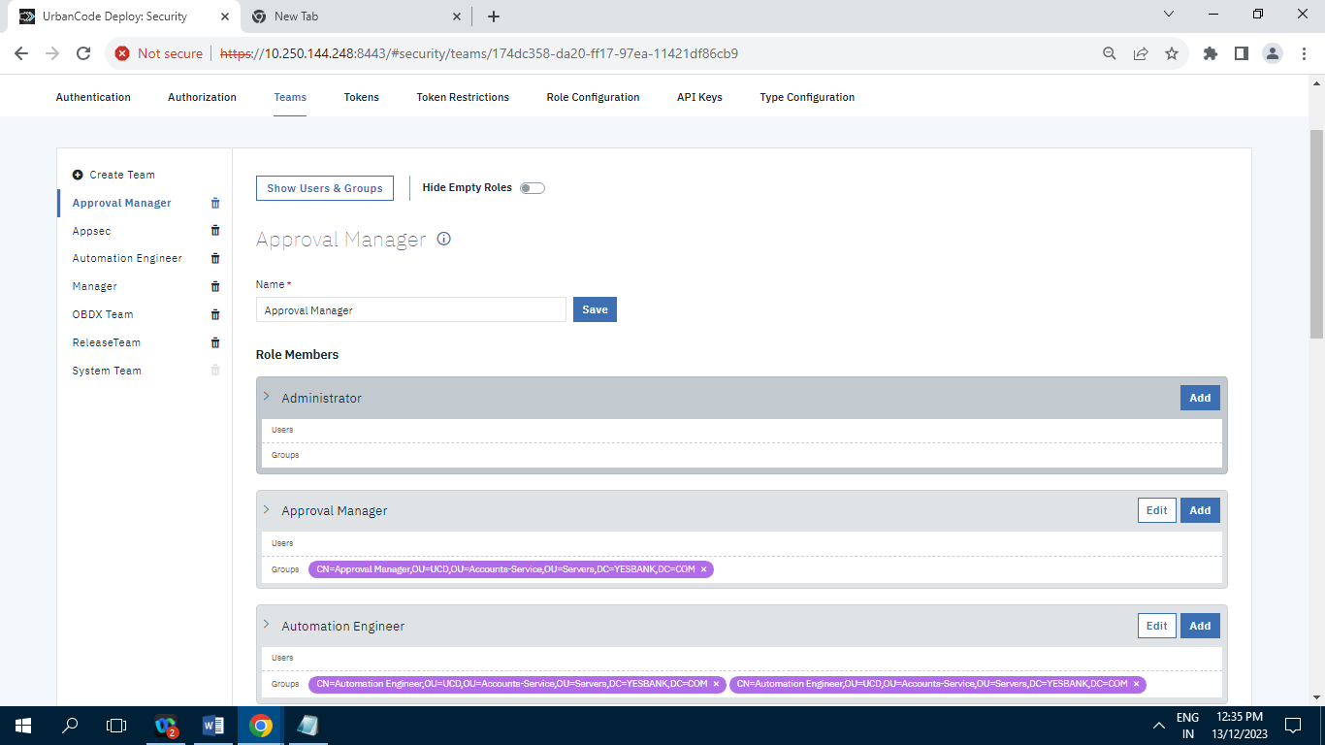

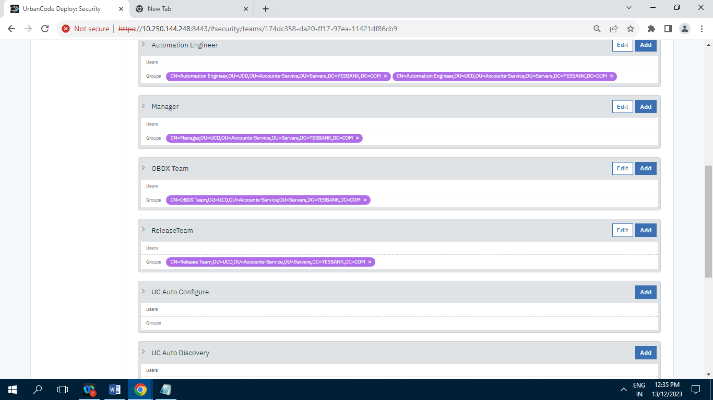

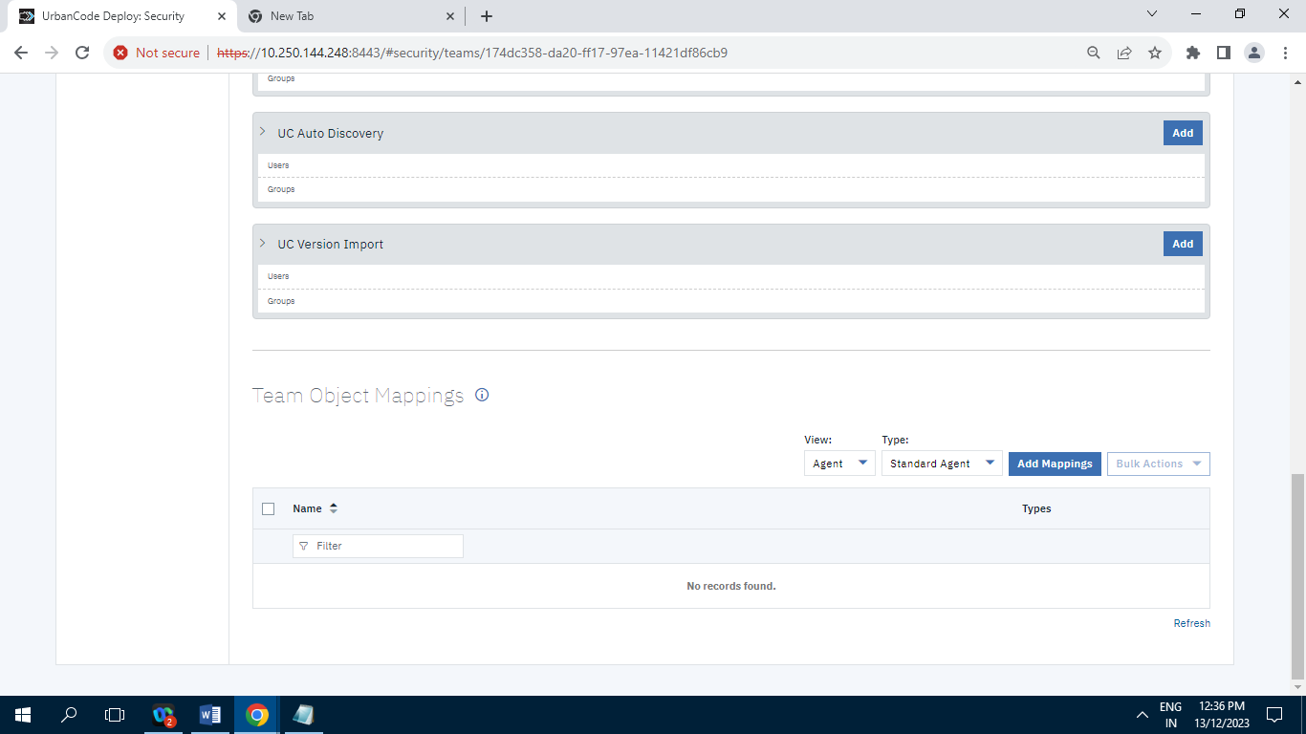

**10.2.4.2] Appsec :**

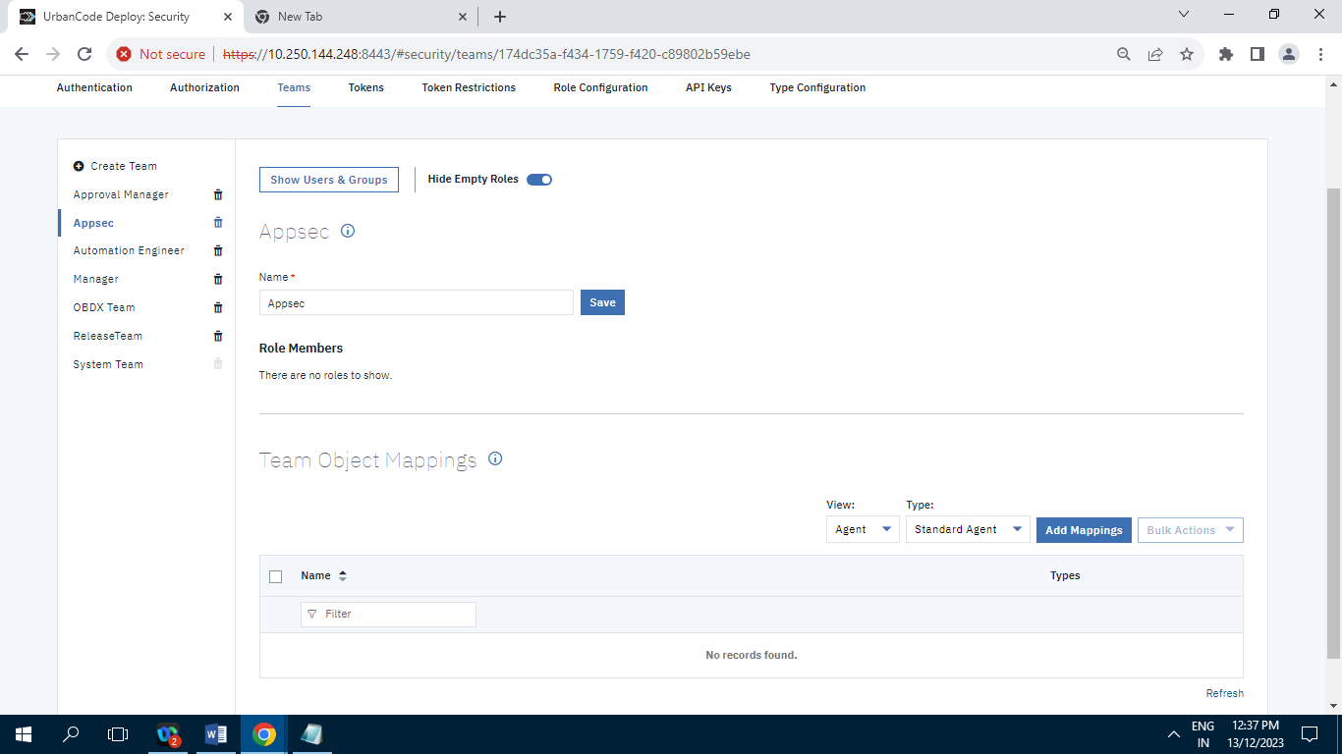

**10.2.4.3] Automation Engineer :**

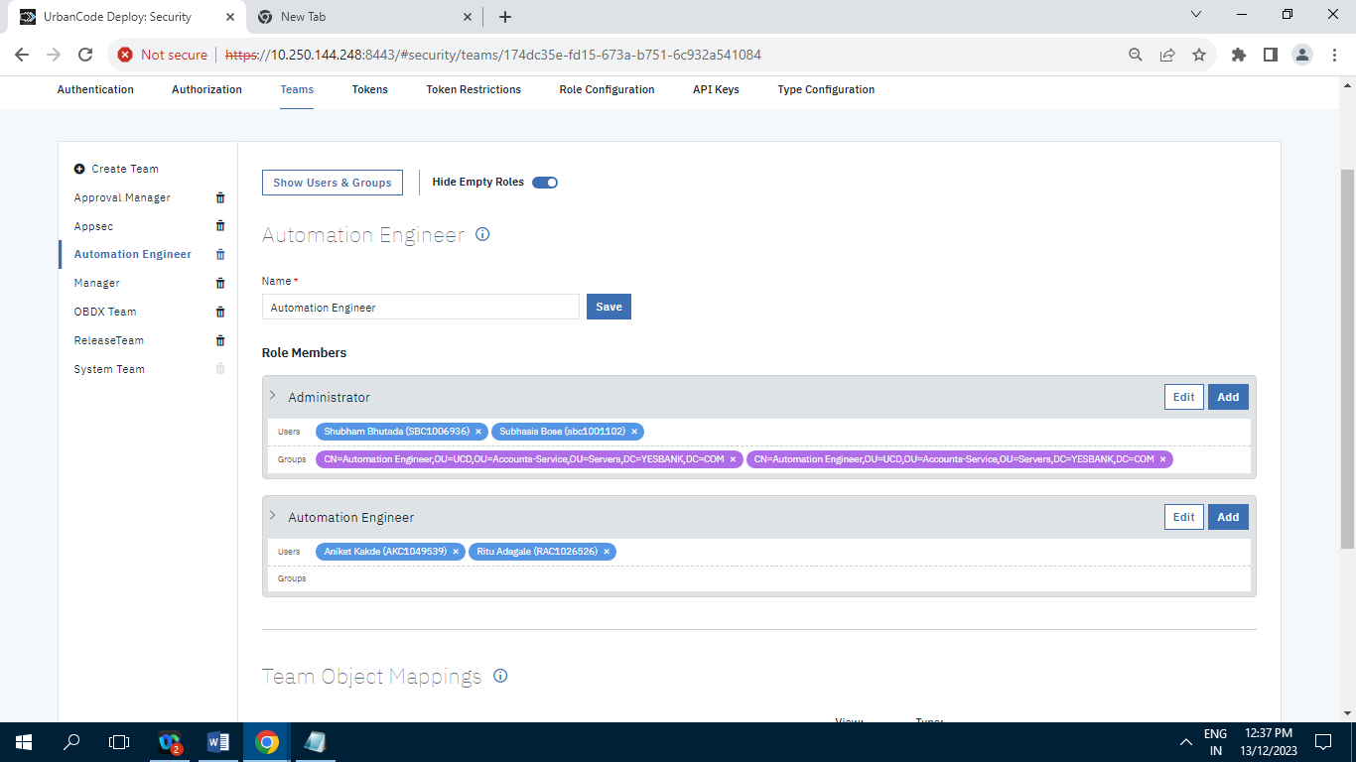

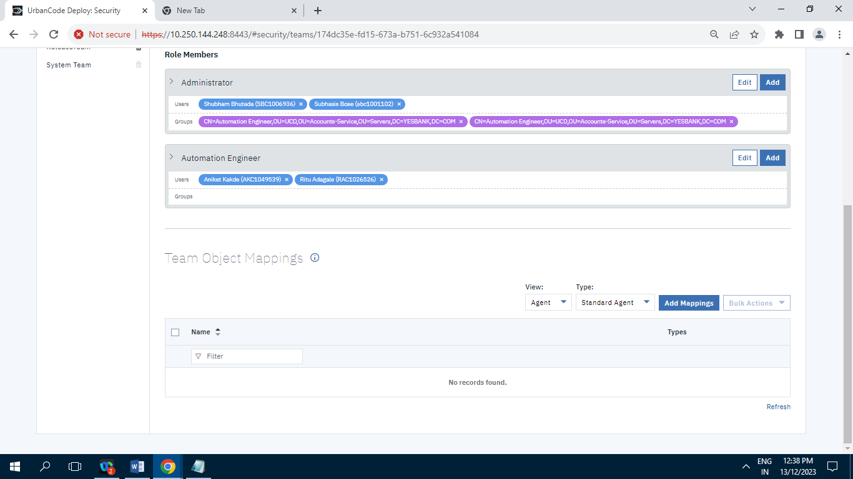

**10.2.4.4] Manager :**

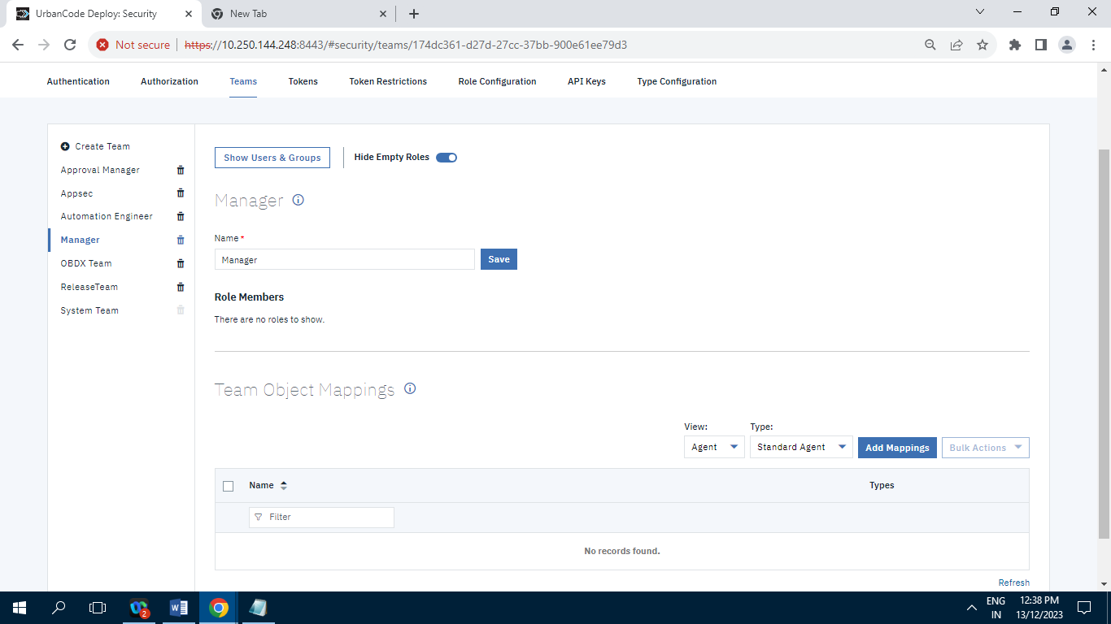

**10.2.4.5] OBDX Team :**

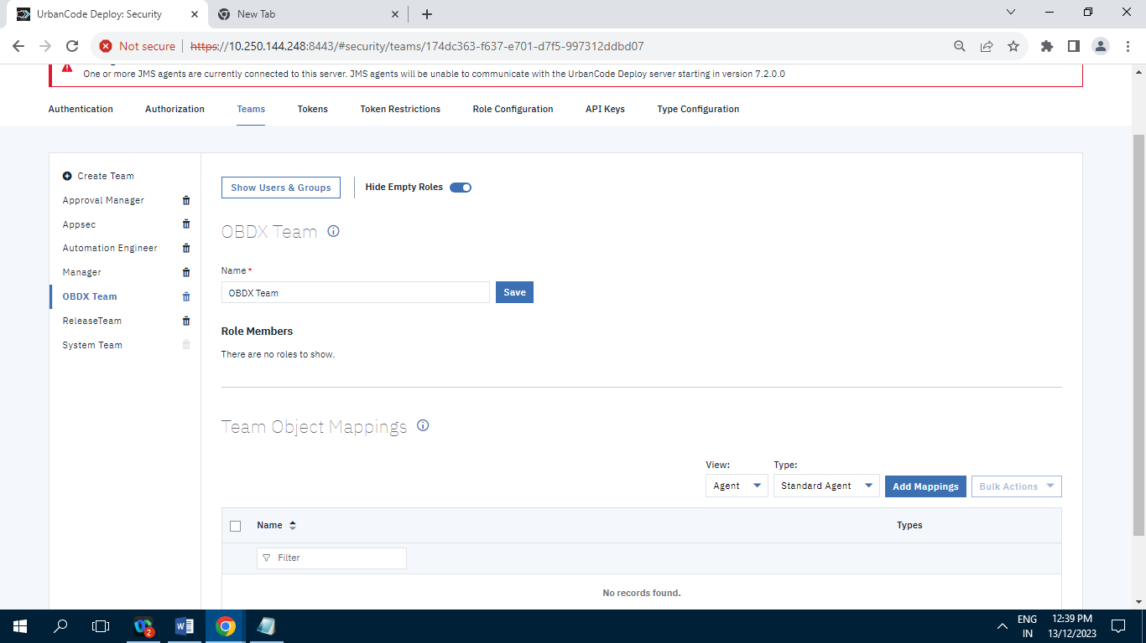

**10.2.4.6] Release Team :**

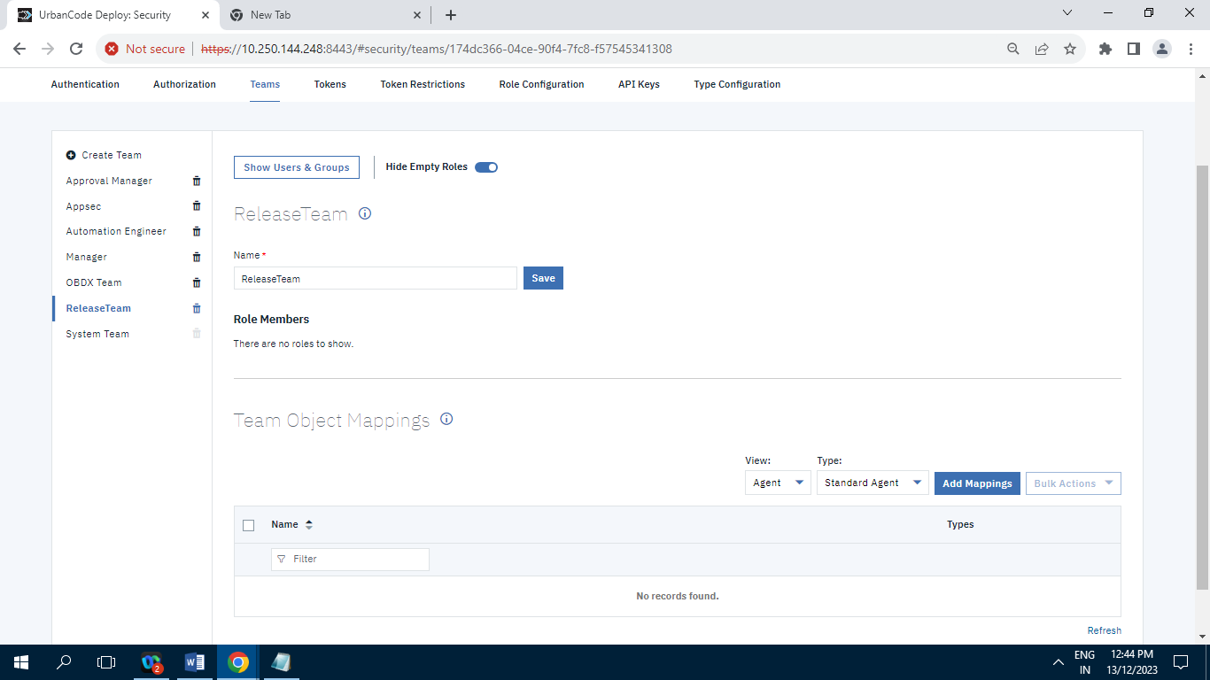

**10.2.4.7] System Team :**

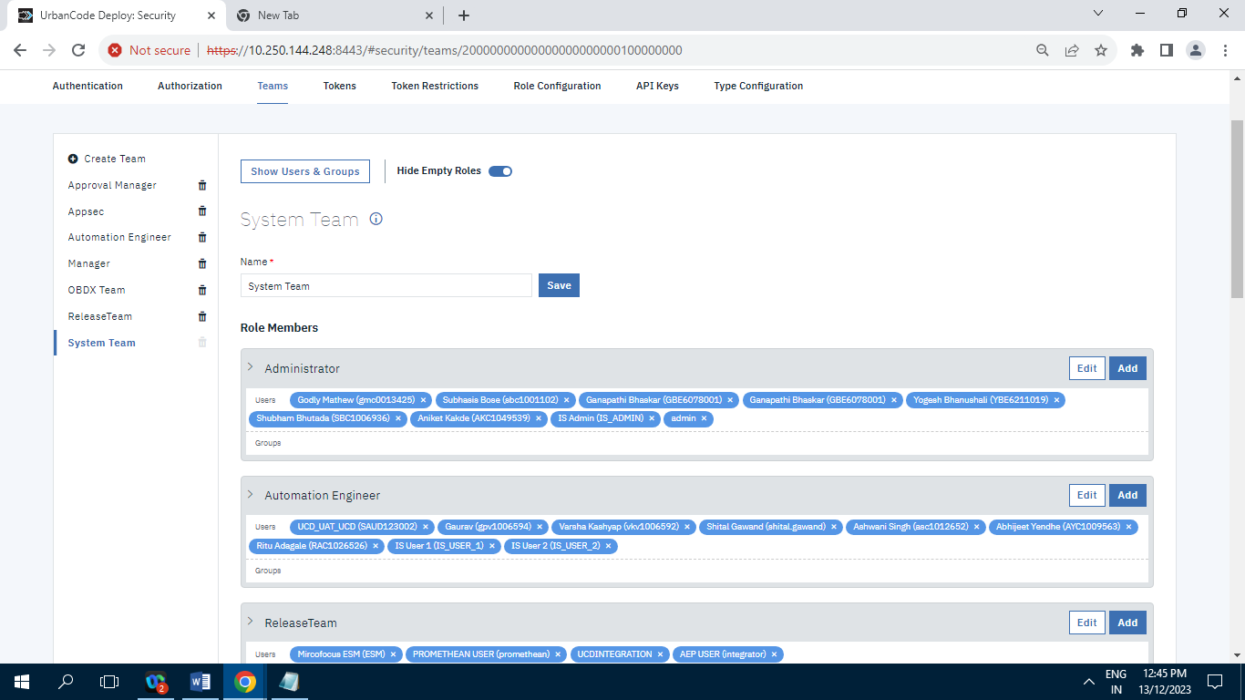

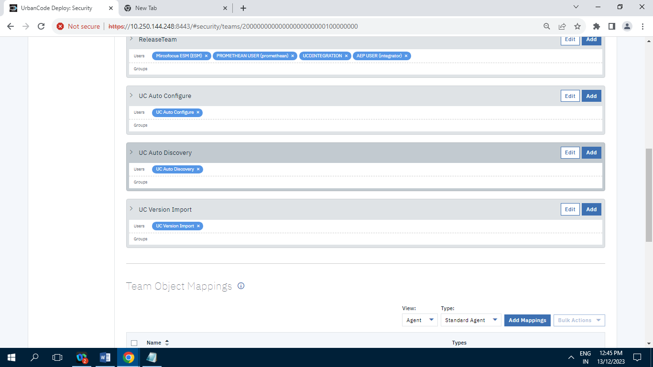

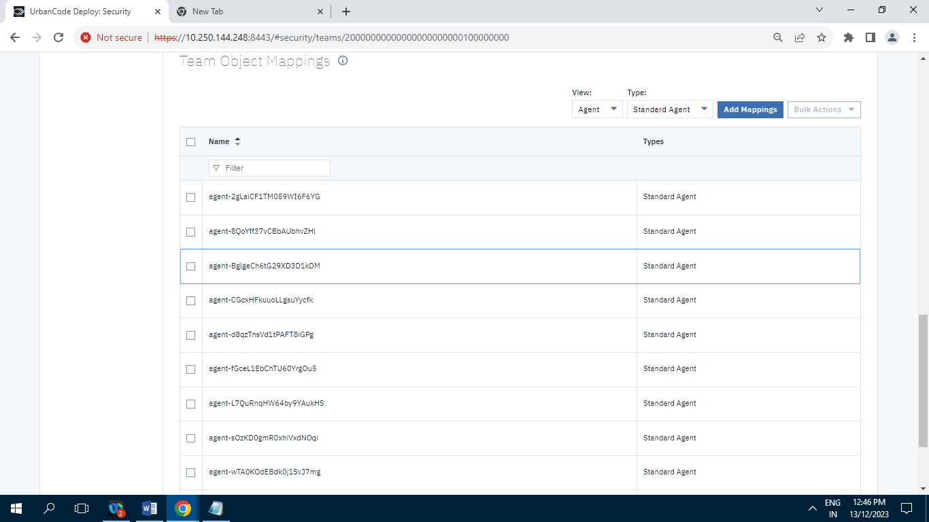

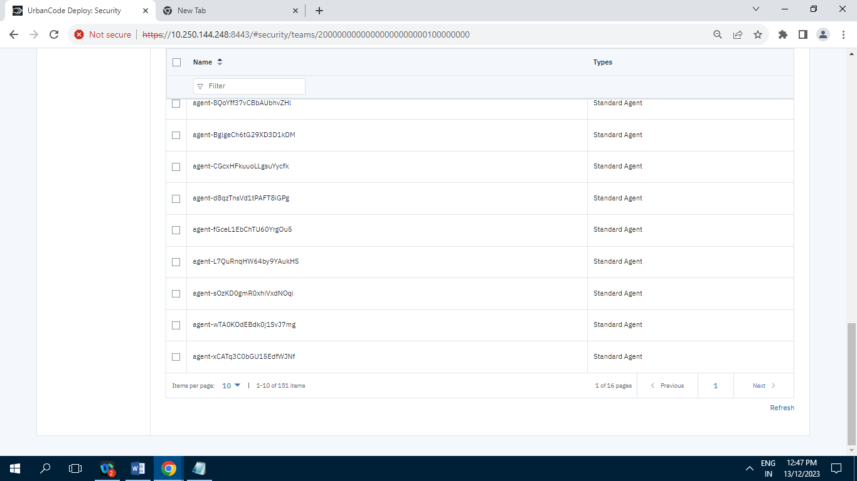

Records= 151

**10.2.5] Tokens :**

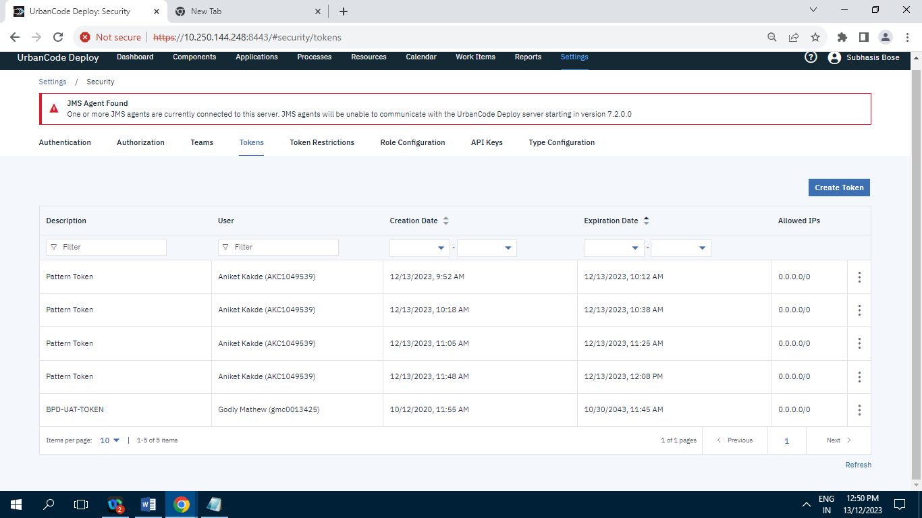

**Record=5**

**10.2.6] Token Restrictions :**

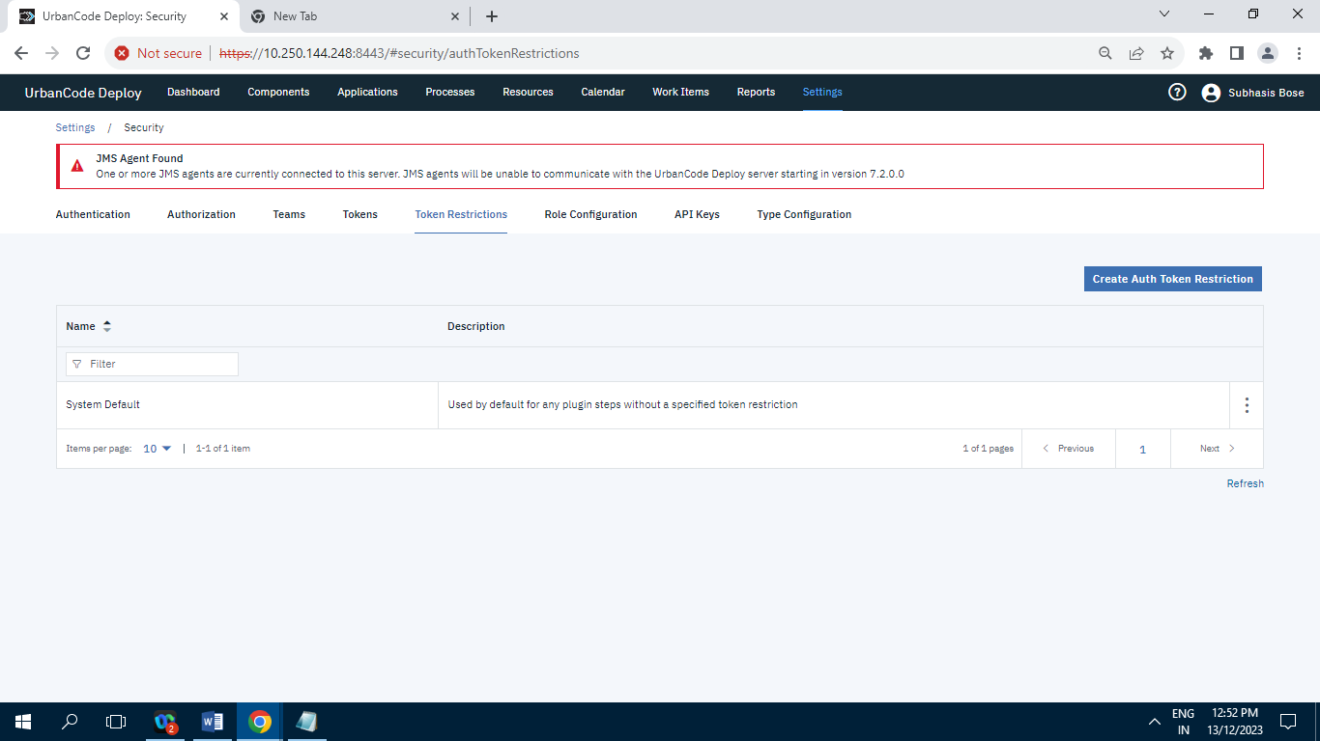

Record= 1

**10.2.7] Role Configuration :**

**10.2.7.1] Administrator**

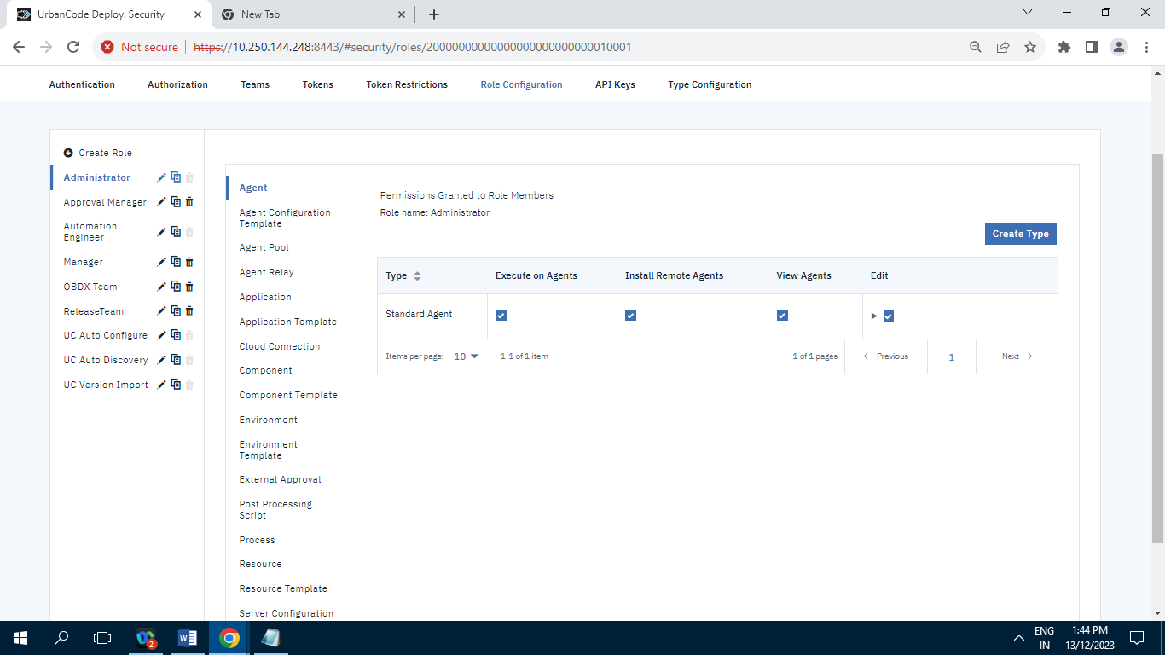

**10.2.7.2]Approval Manager**

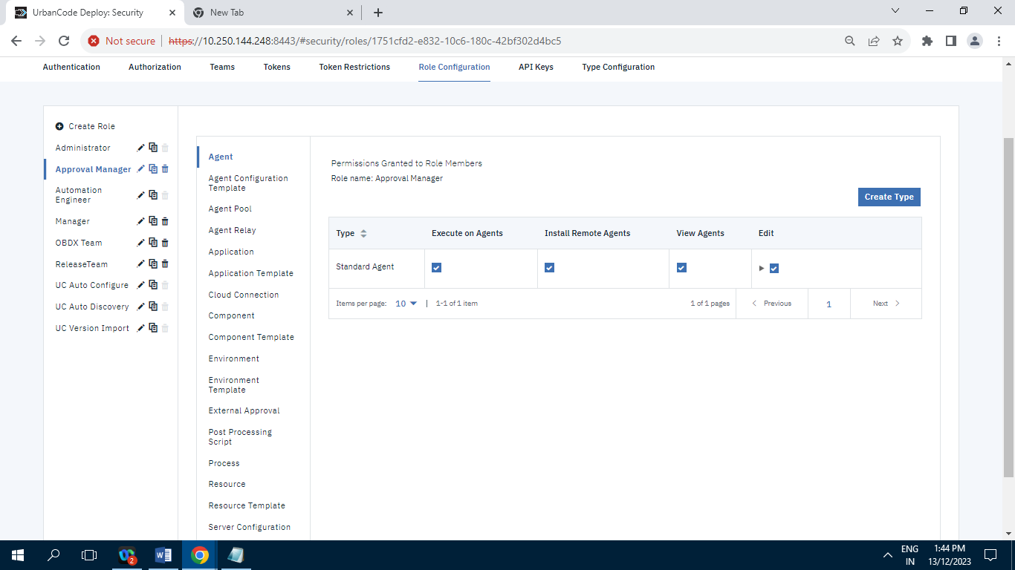

**10.2.7.3]Automation Engineer**

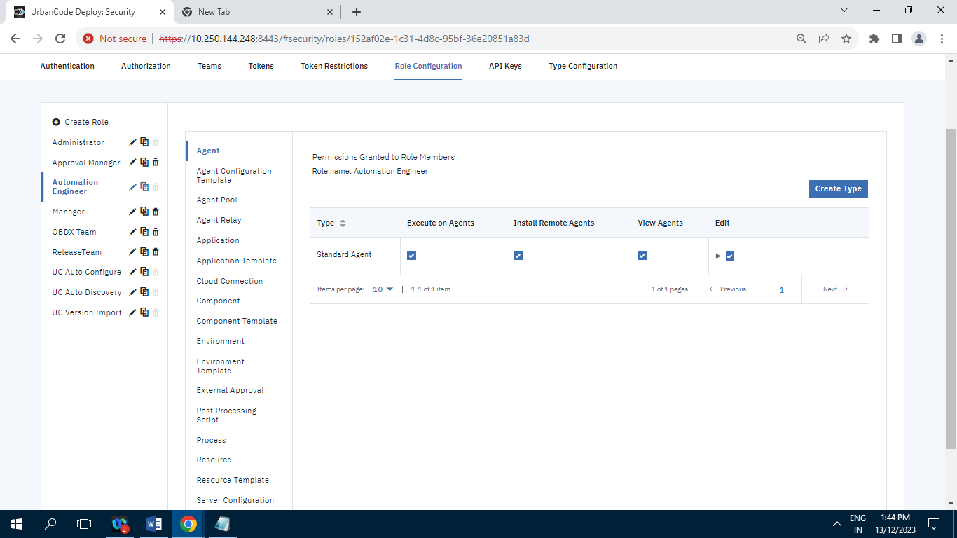

**10.2.7.4]Manager**

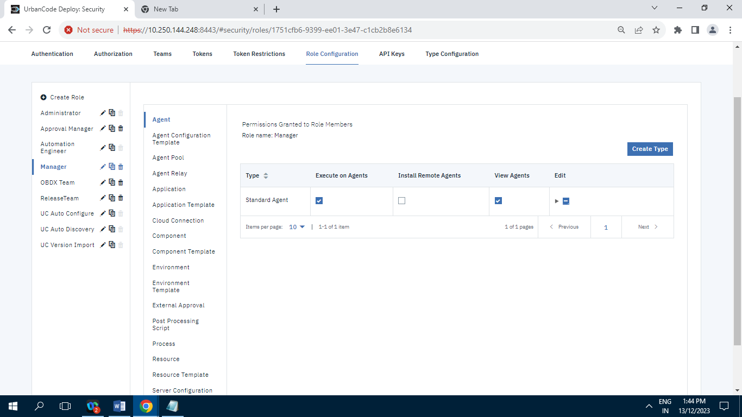

**10.2.7.5]OBDX Team**

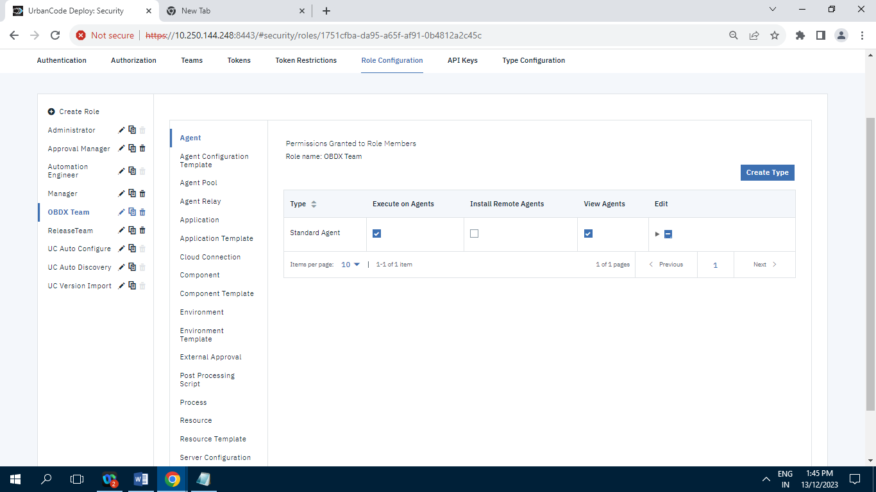

**10.2.7.6]Release Team**

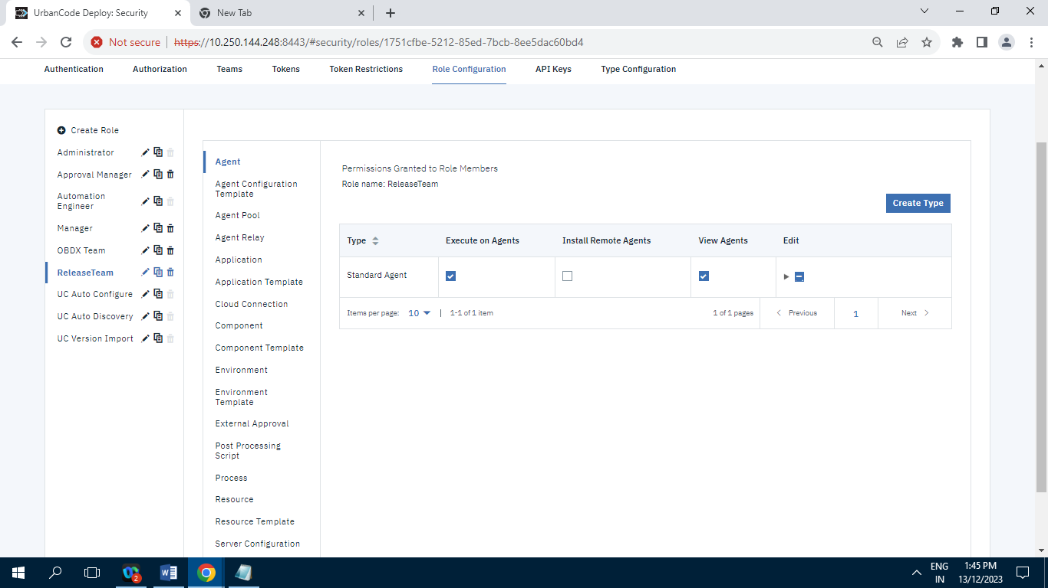

**10.2.7.7]UC Auto Configure**

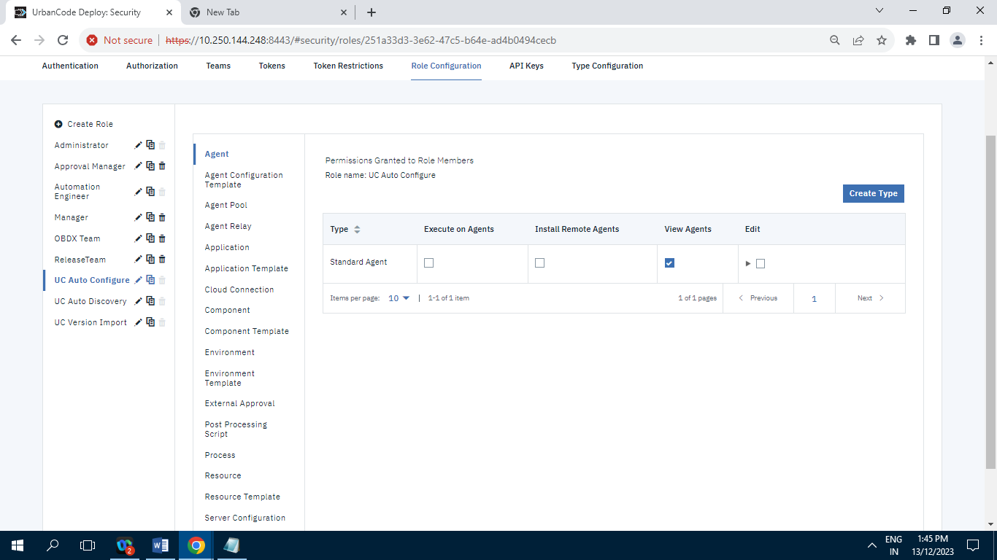

**10.2.7.8]UC Auto Discovery**

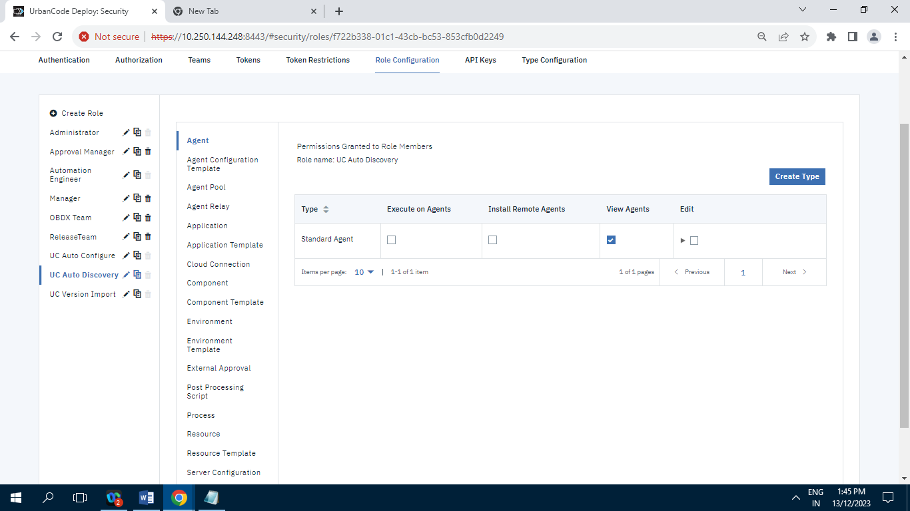

**10.2.7.9]UC Version Import**

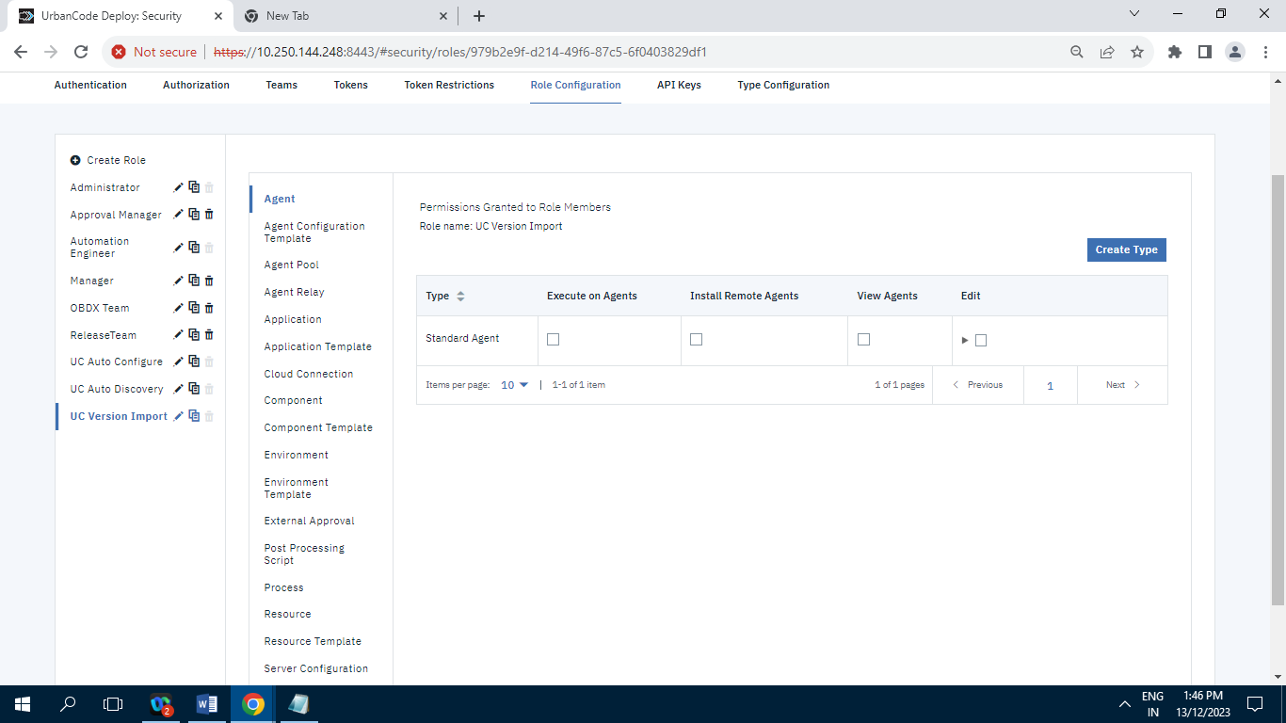

**10.2.8] Type Configuration :**

**10.2.8.1]Agent**

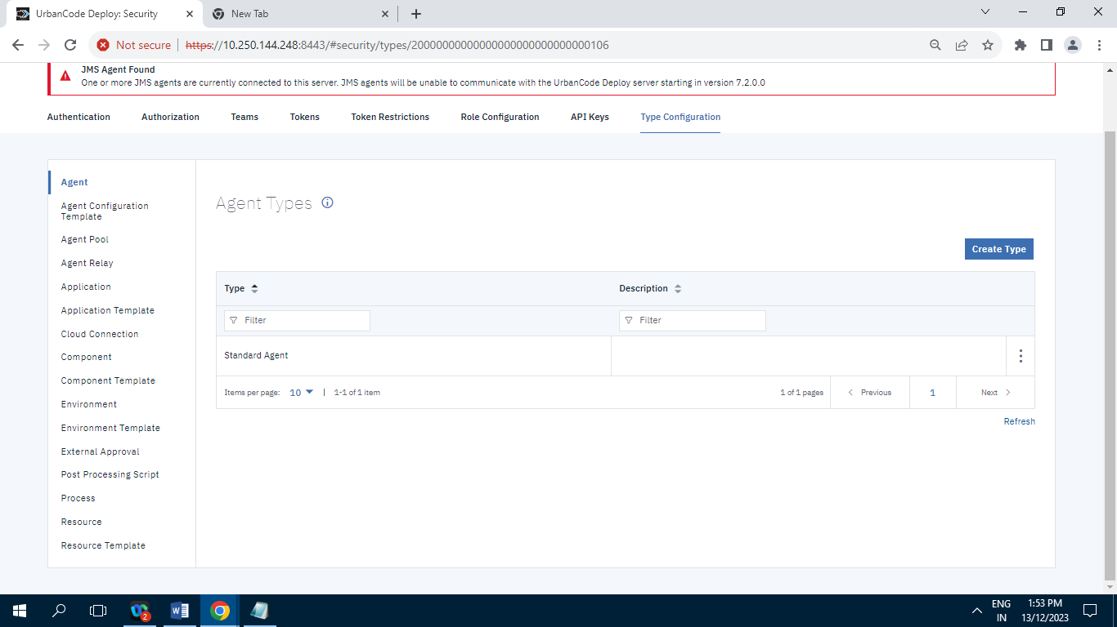

**Record=1**

**10.2.8.2]Agent Configuration Template**

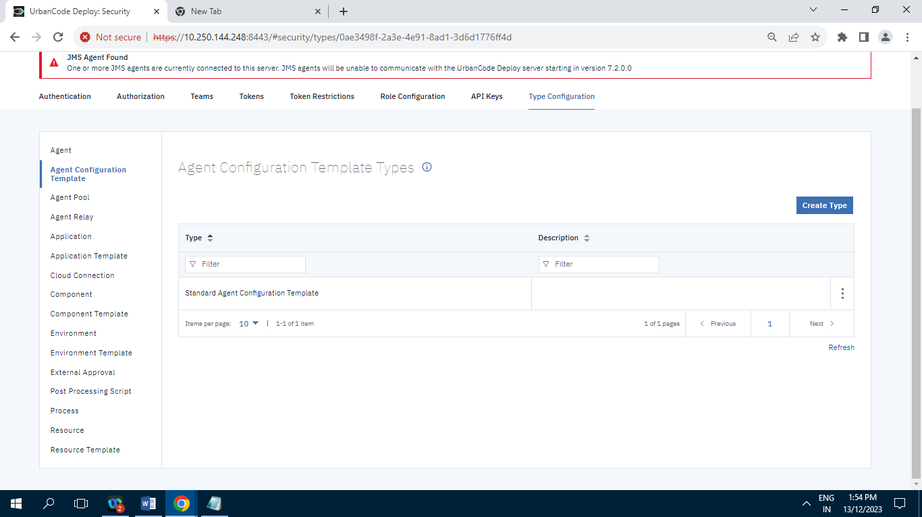

**Record=1**

**10.2.8.3]Agent Pool**

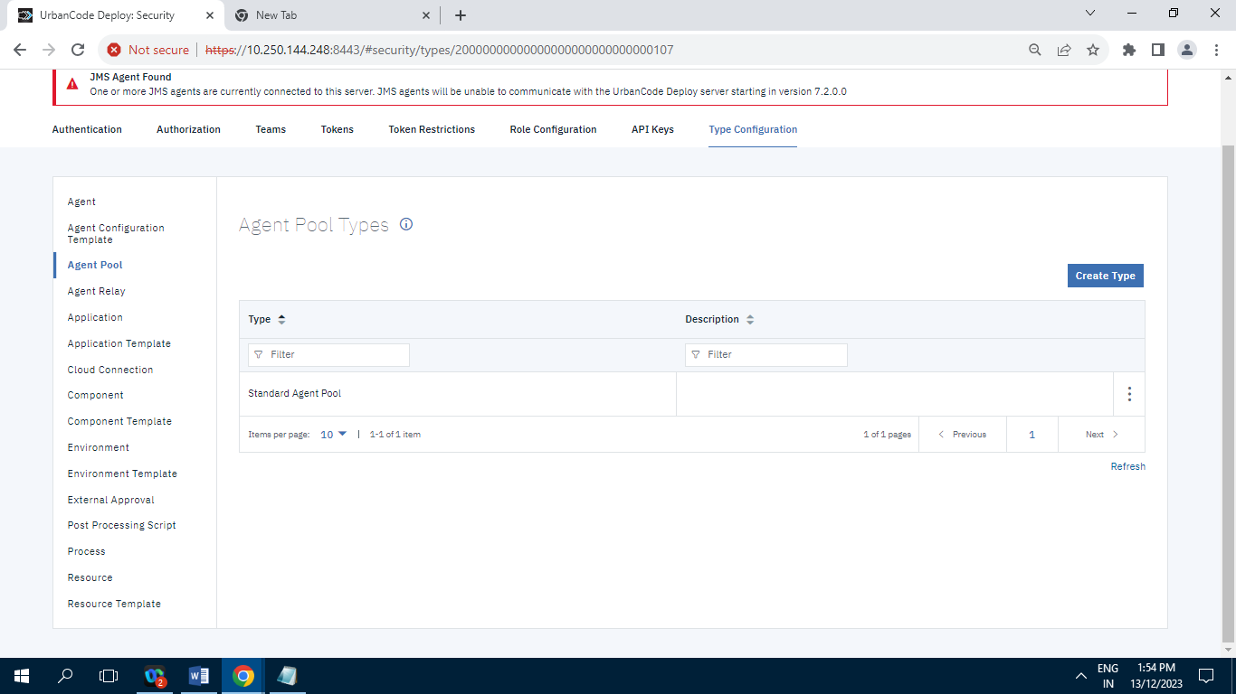

**Records=1**

**10.2.8.4] Agent Relay**

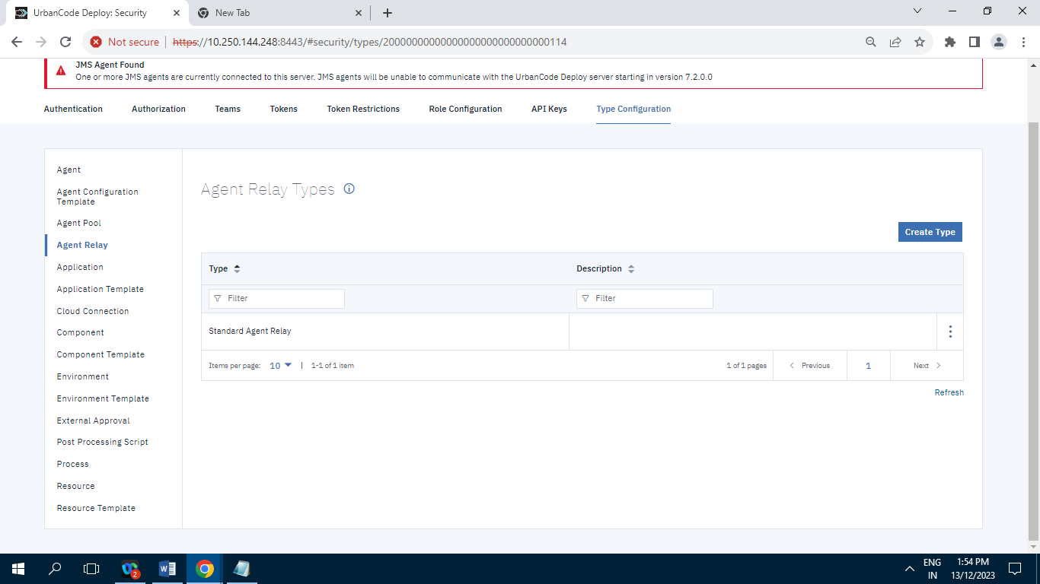

**Record=1**

**10.2.8.5]Application**

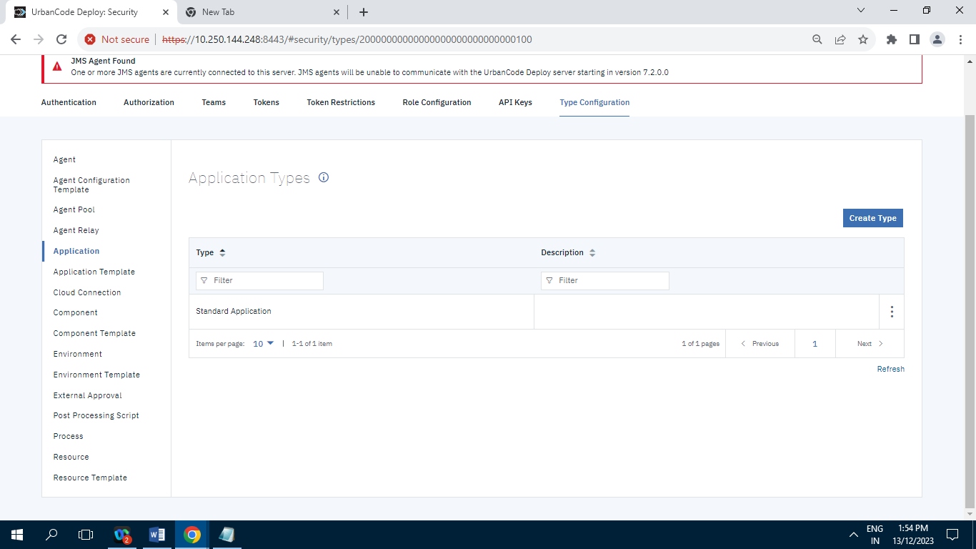

**Record=1**

**10.2.8.6]Application Template**

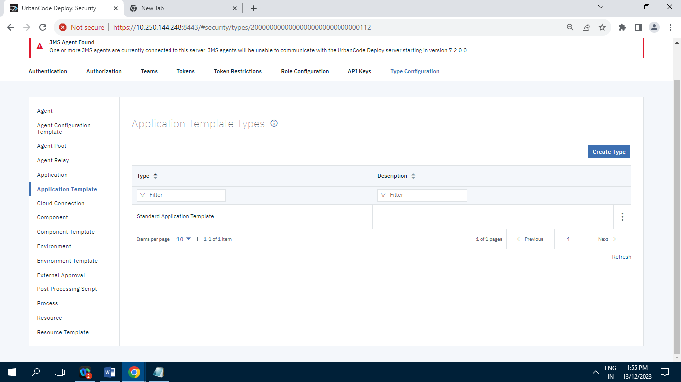

**Record=1**

**10.2.8.7]Cloud Connection**

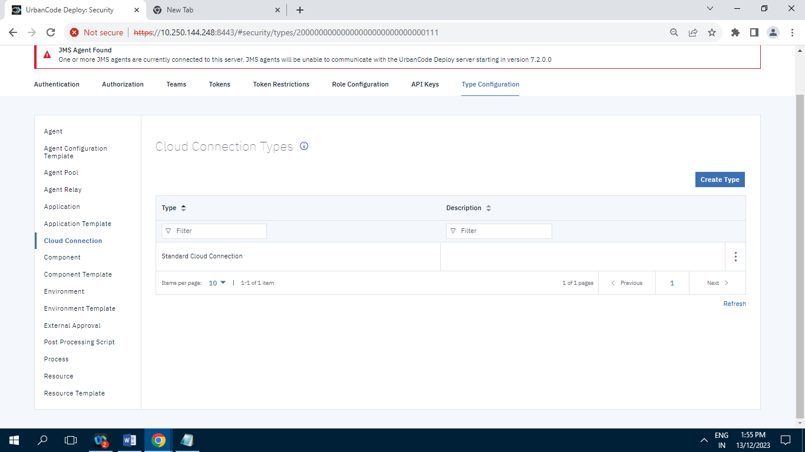

**Record=1**

**10.2.8.8]Component**

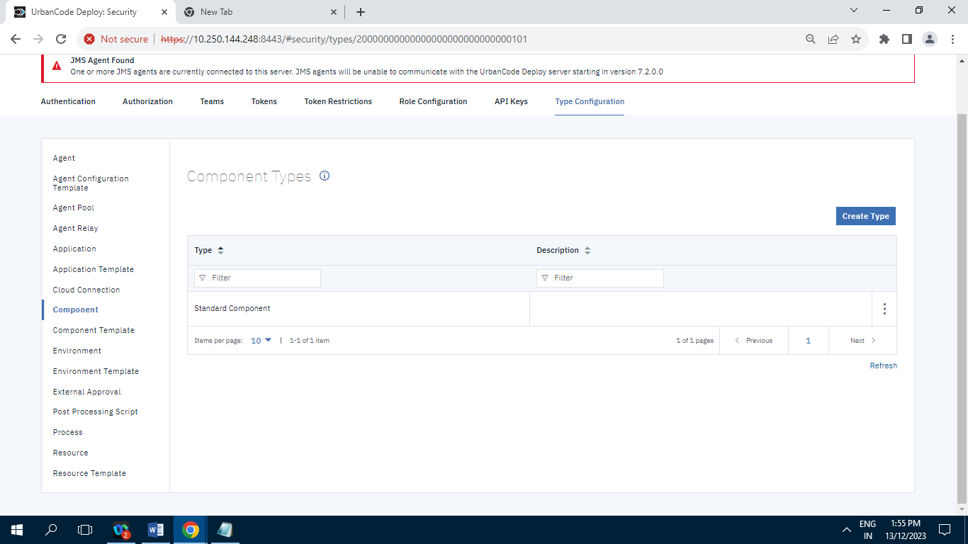

**Record=1**

**10.2.8.9]Component Template**

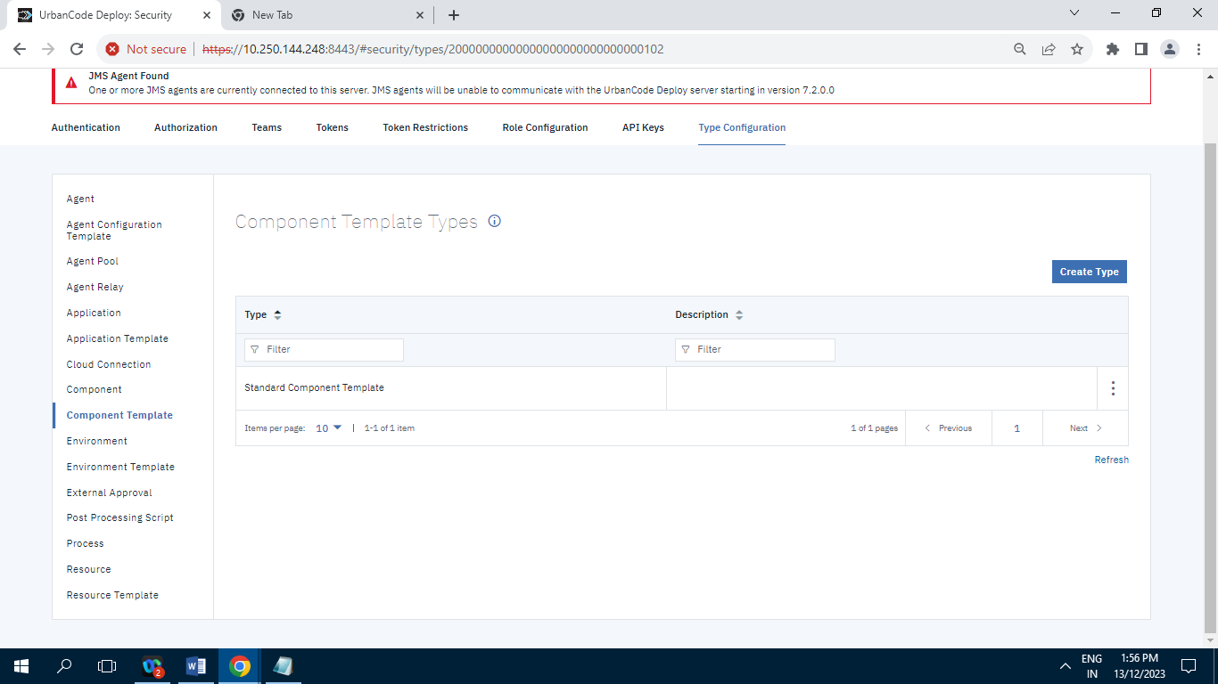

**Record=1**

**10.2.8.10]Environment**

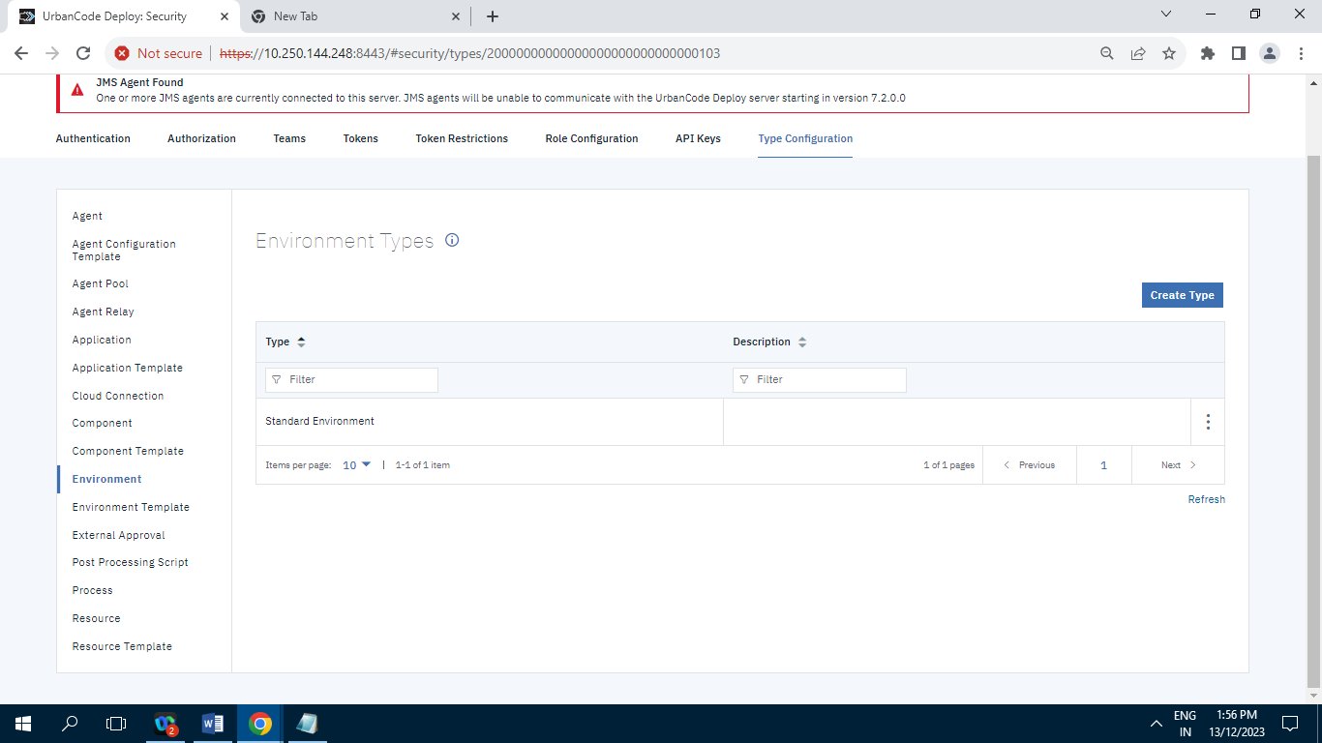

**Record=1**

**10.2.8.11]Environment Template**

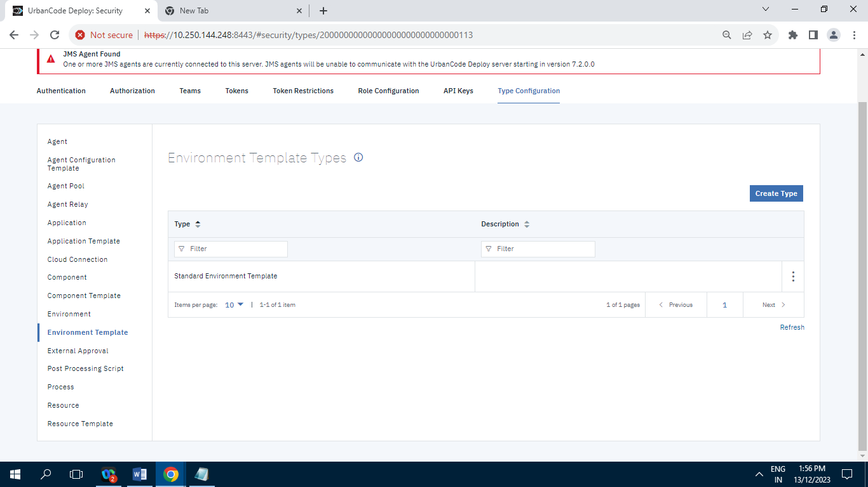

**Record=1**

**10.2.8.12]External Approval**

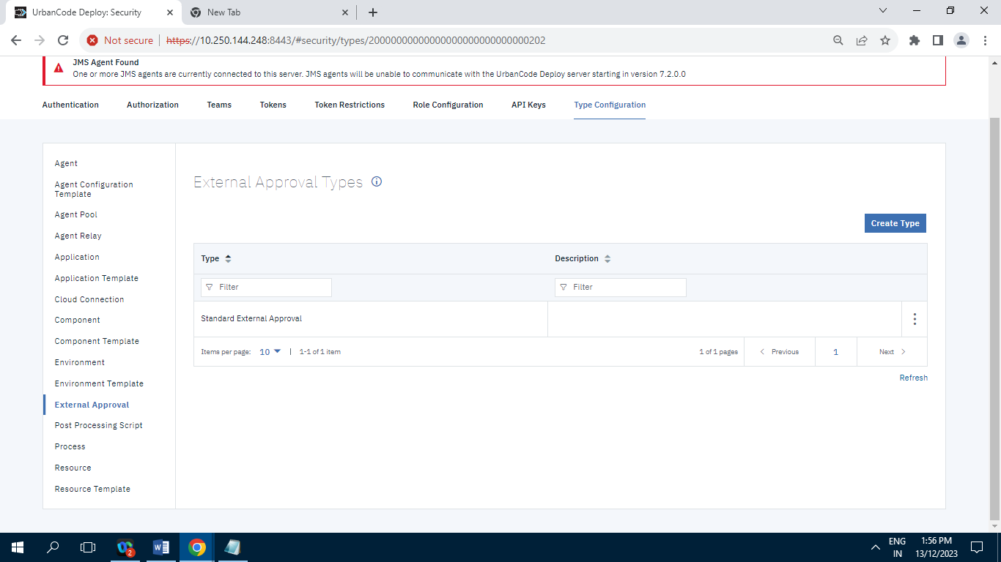

**Record=1**

**10.2.8.13]Post Processing Script**

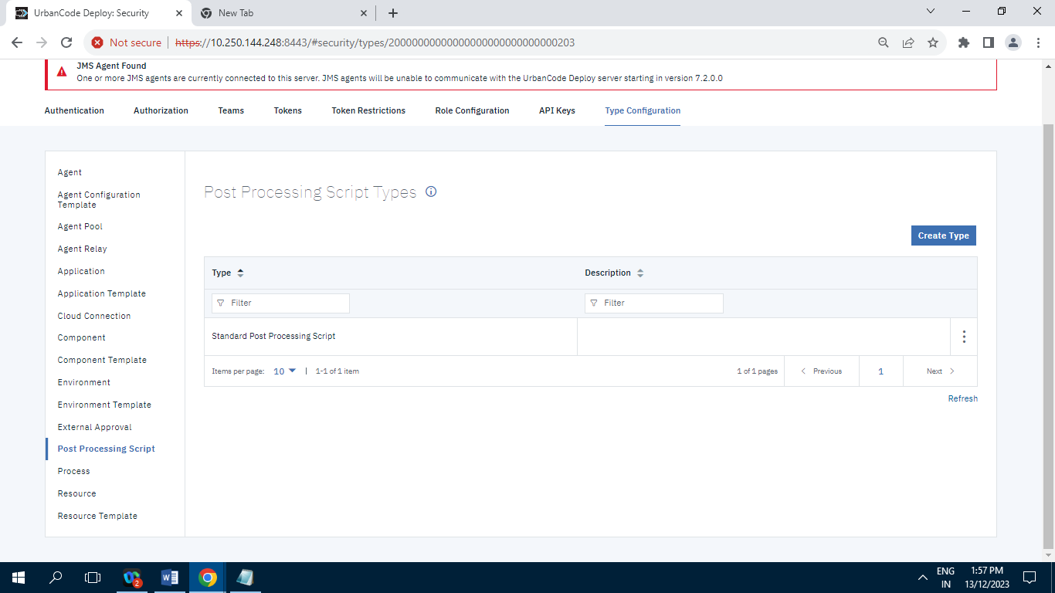

**Record=1**

**10.2.8.14]Process**

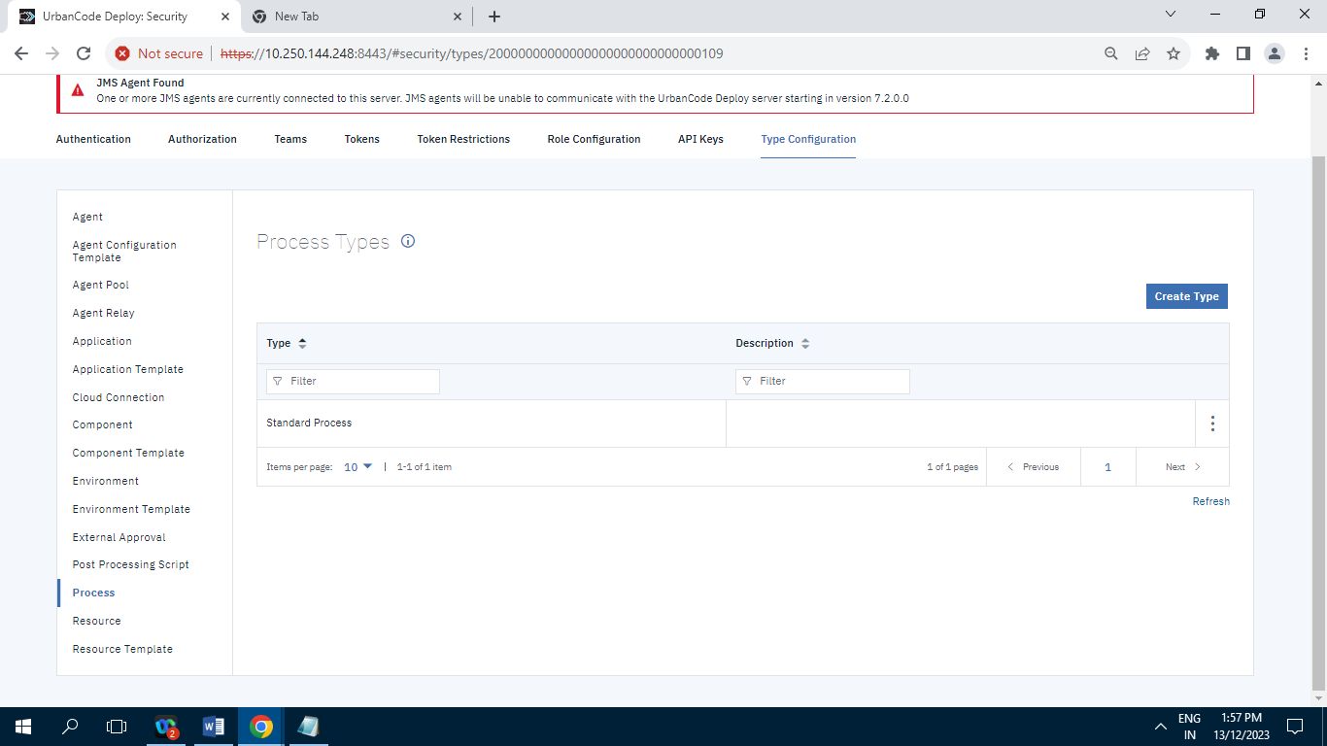

**Record=1**

**10.2.8.15]Resource**

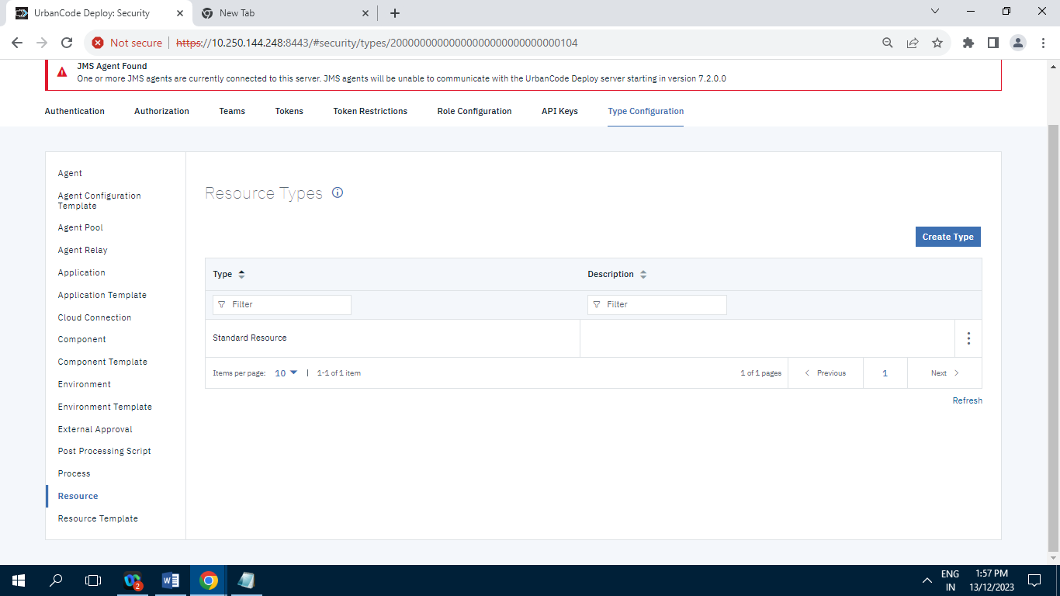

**Record=1**

**10.2.8.16]Resource Template**

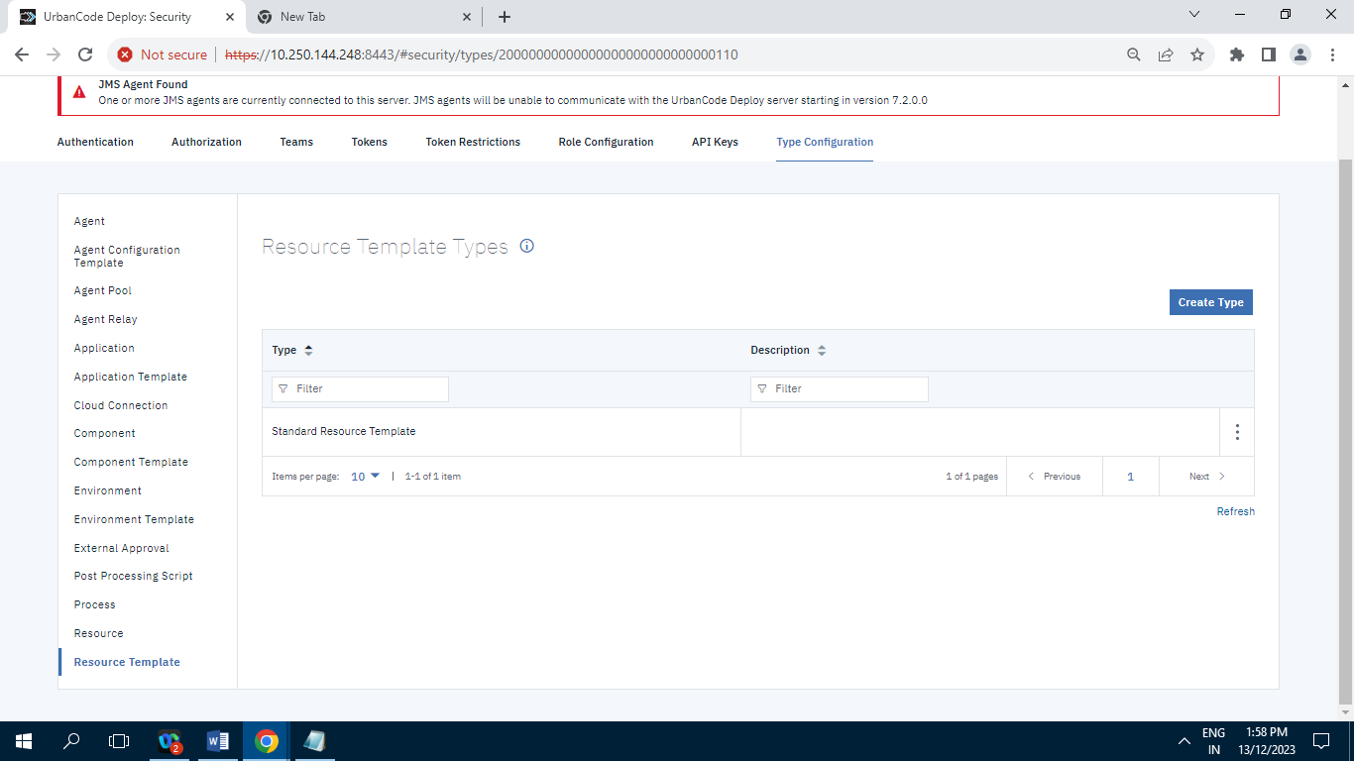

**Record=1**

**10.3] System :**

**10.3.1] Logging :**

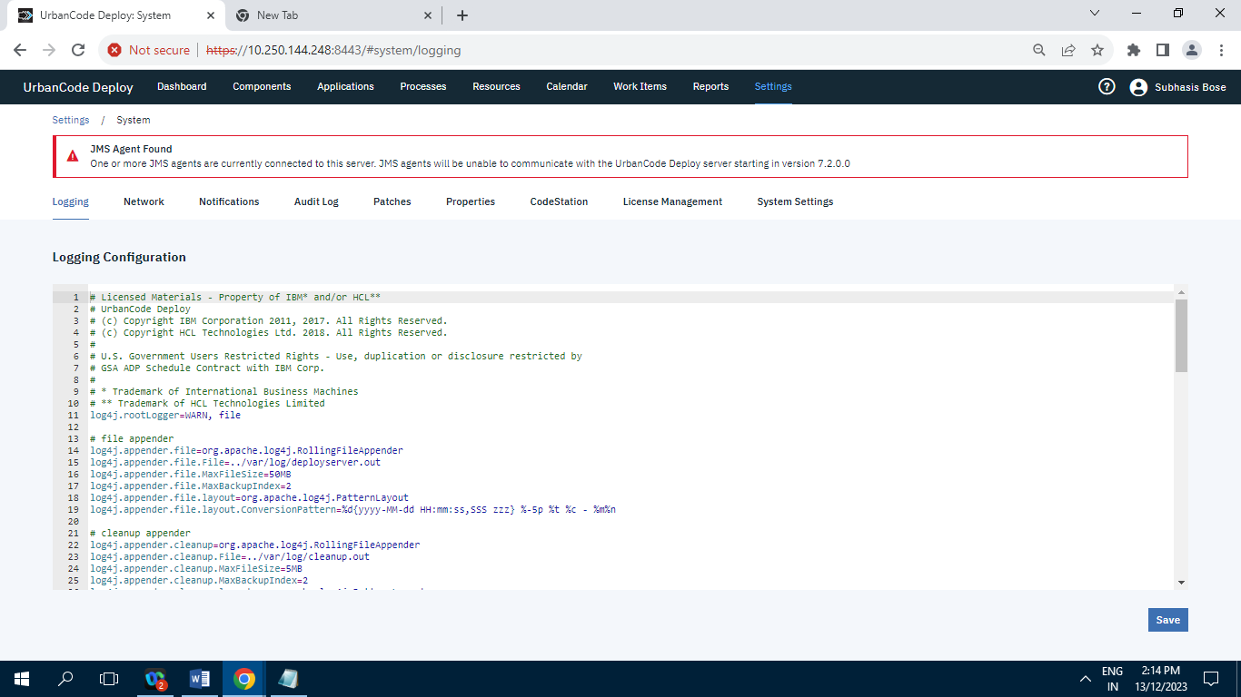

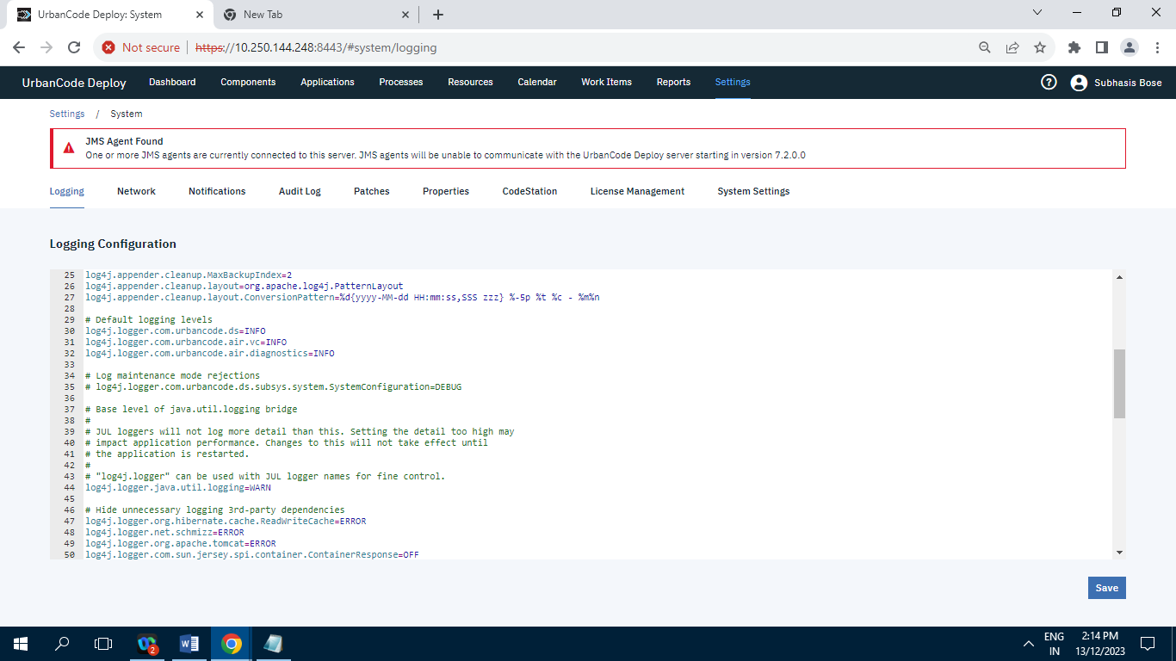

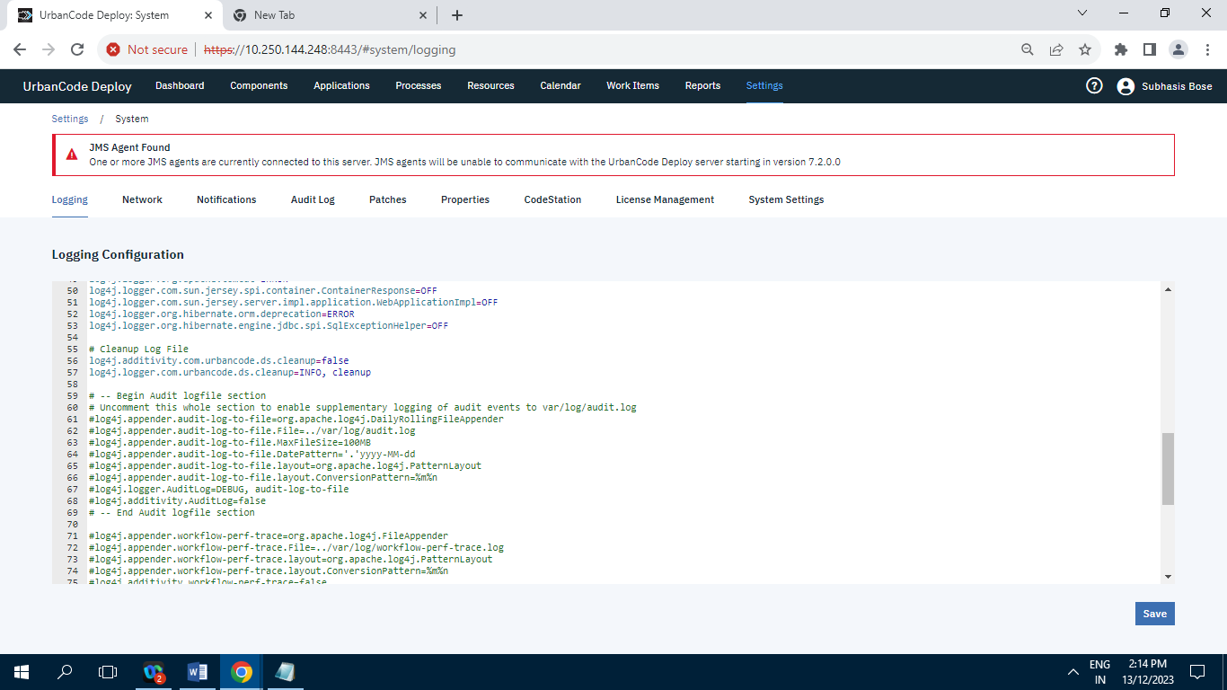

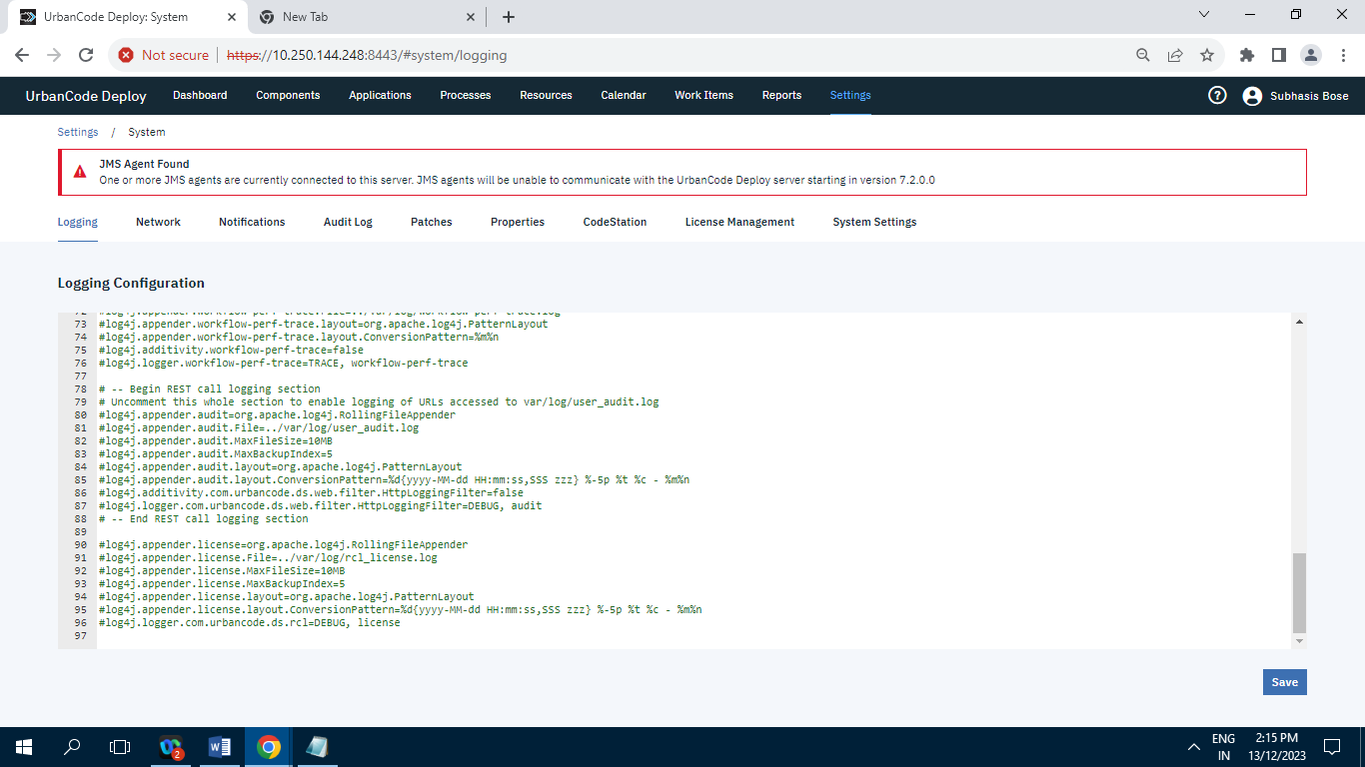

**10.3.2] Network :**

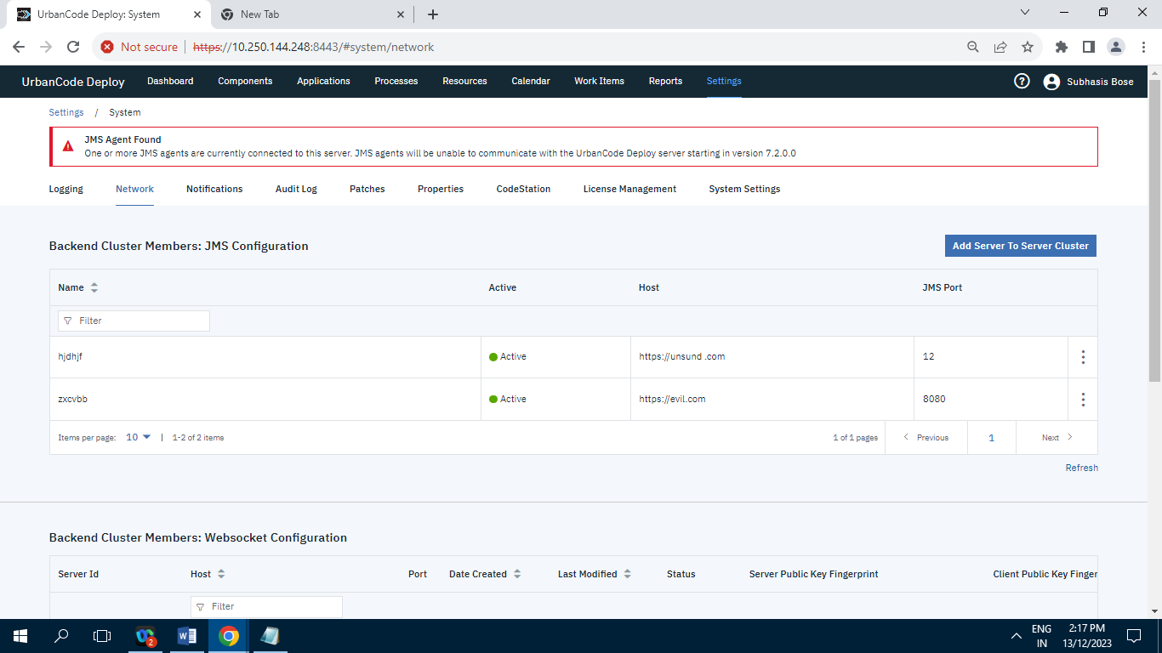

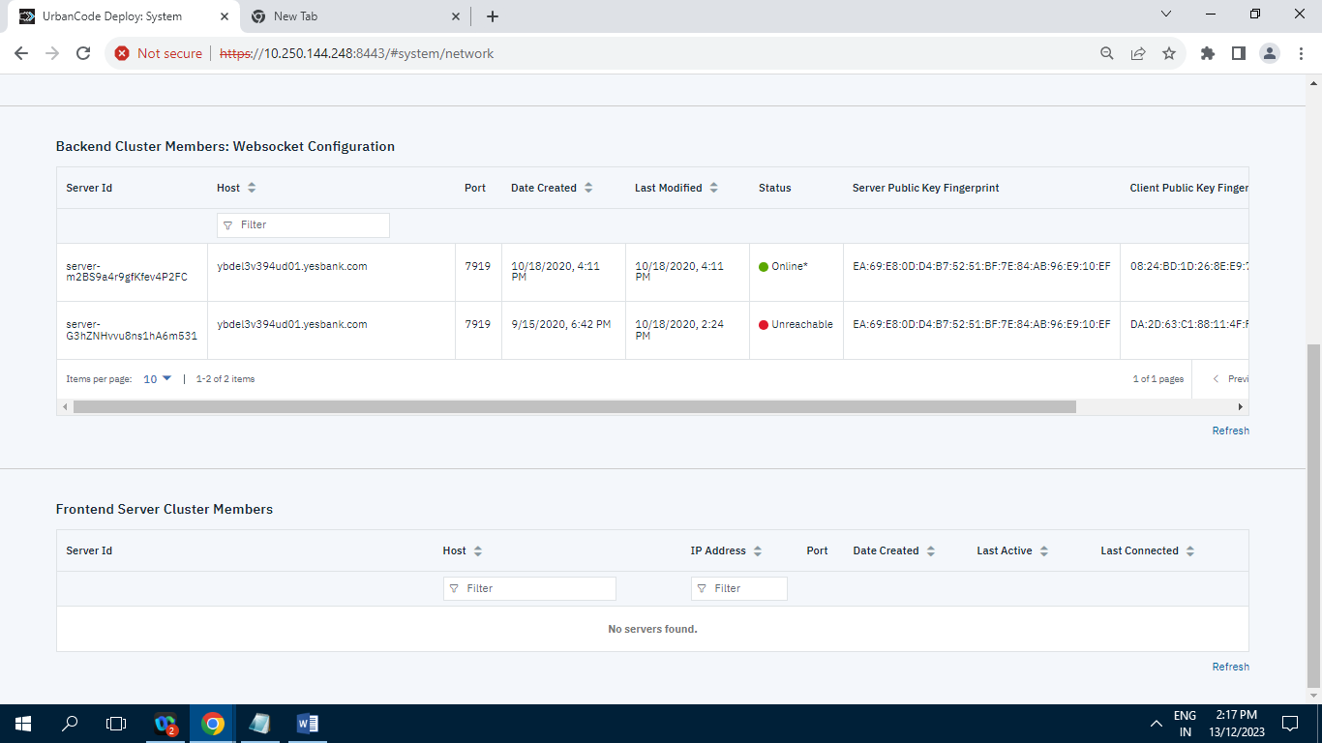

**10.3.3] Notification Scheme :**

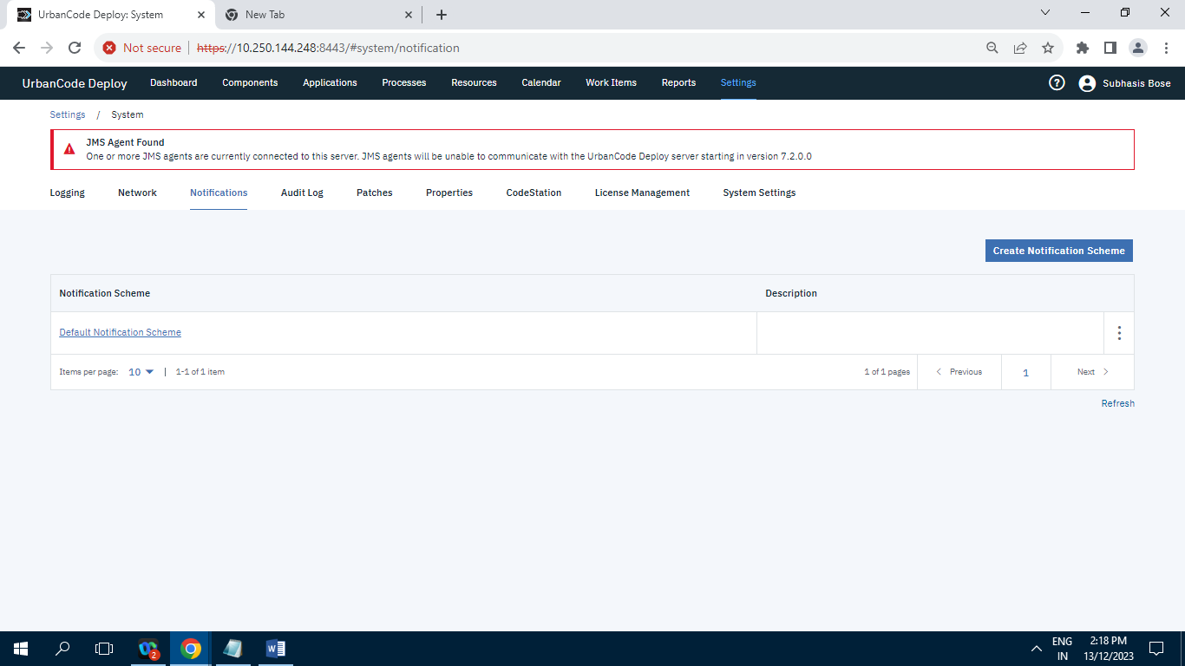

**Record=1**

**10.3.4] Audit Log :**

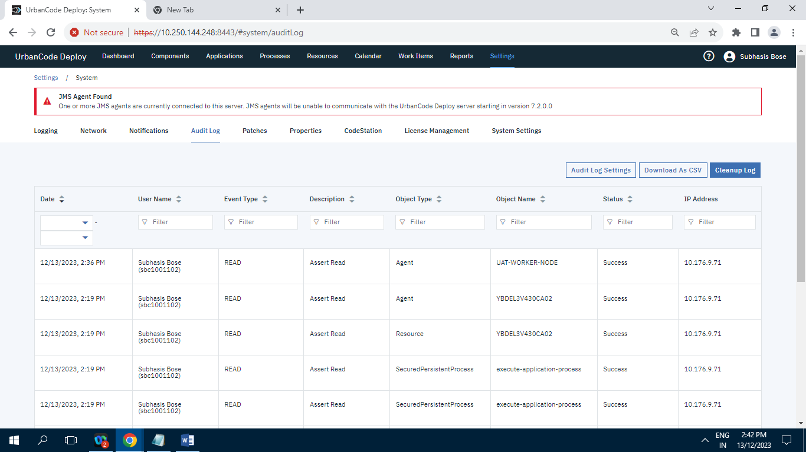

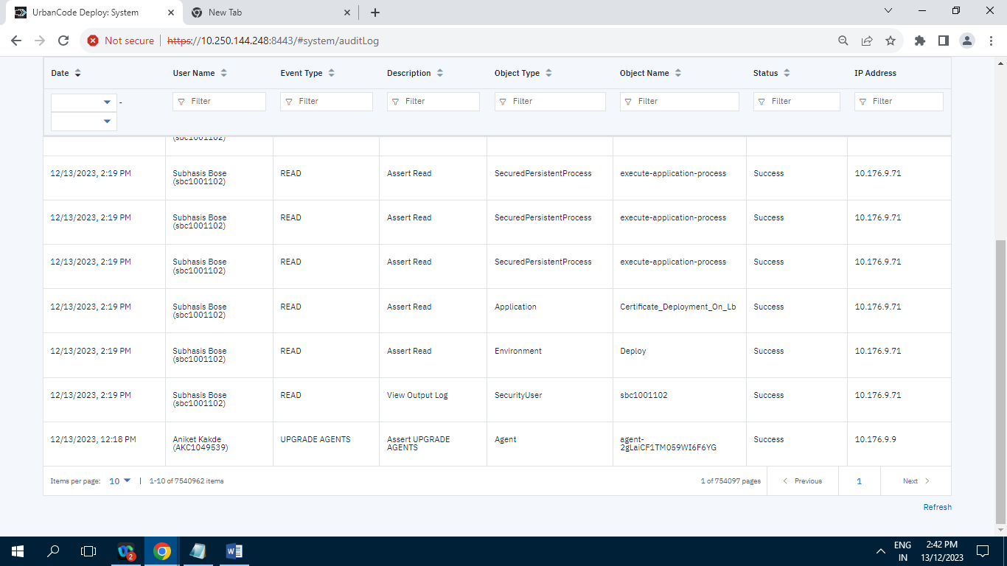

**Records= 7540962**

**10.3.5] Diagnostics :**

**10.3.5.1] Diagnostics Bundle :**

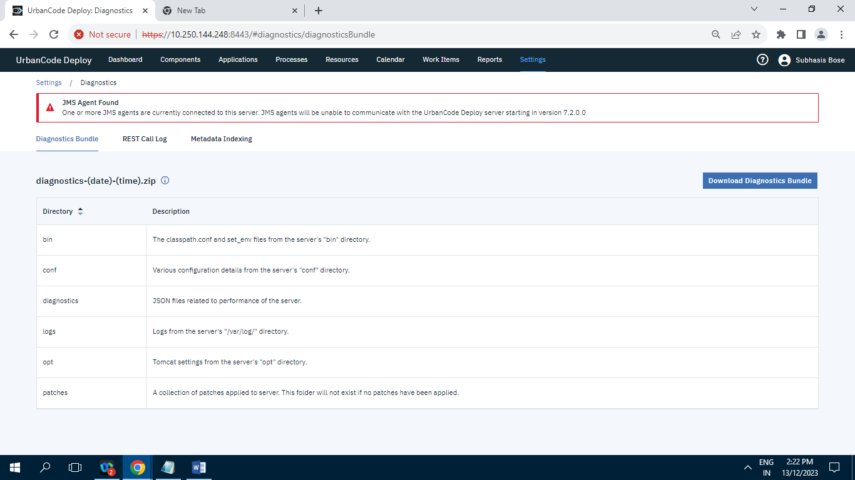

**10.3.5.2] REST Call Log :**

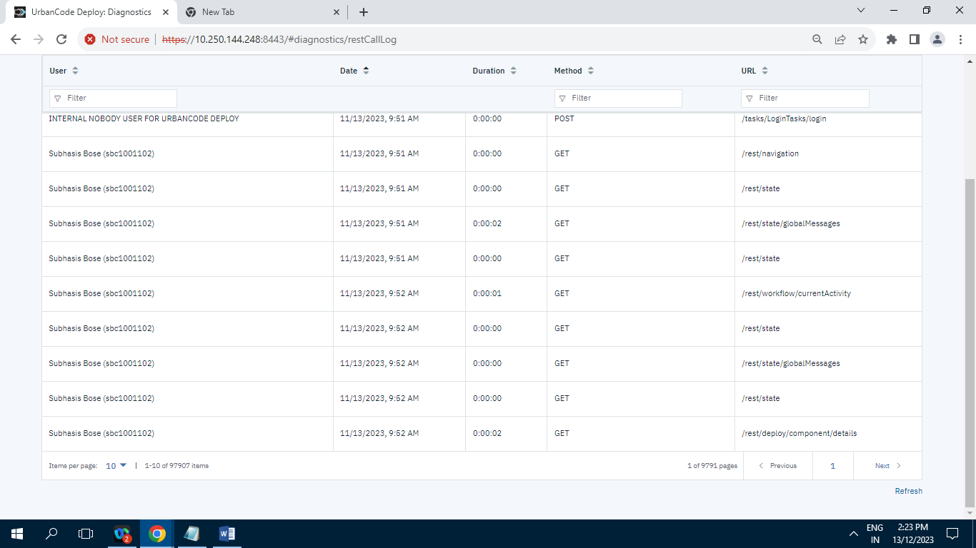

**Records= 97907**

**10.3.5.3] Metadata Indexing :**

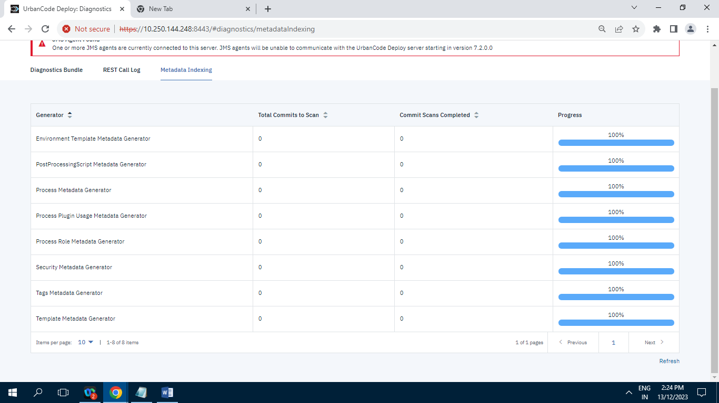

**Records=8**

**10.3.6] Patches :**

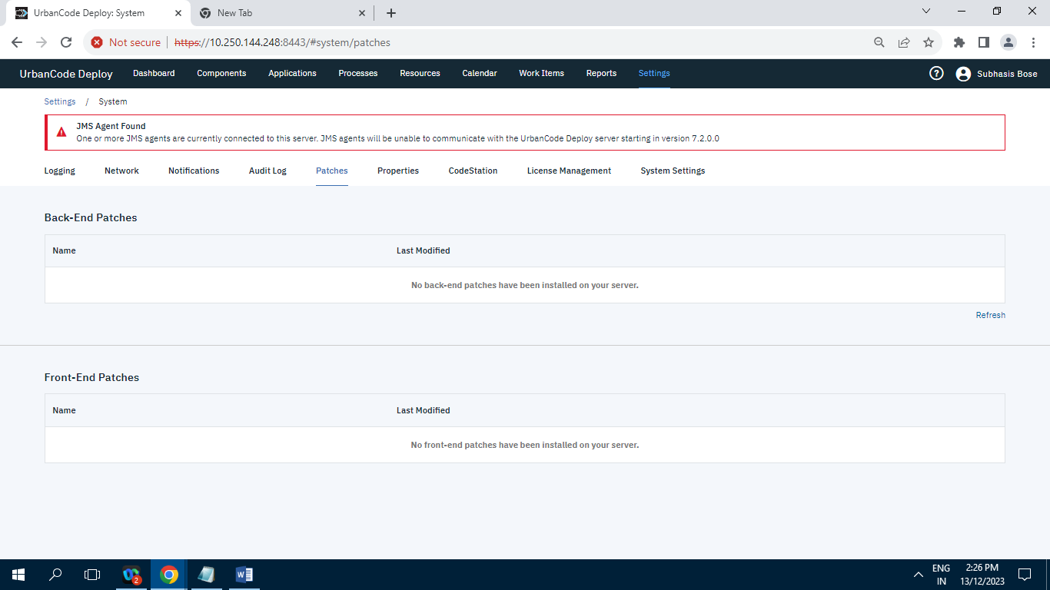

**10.3.7] Properties :**

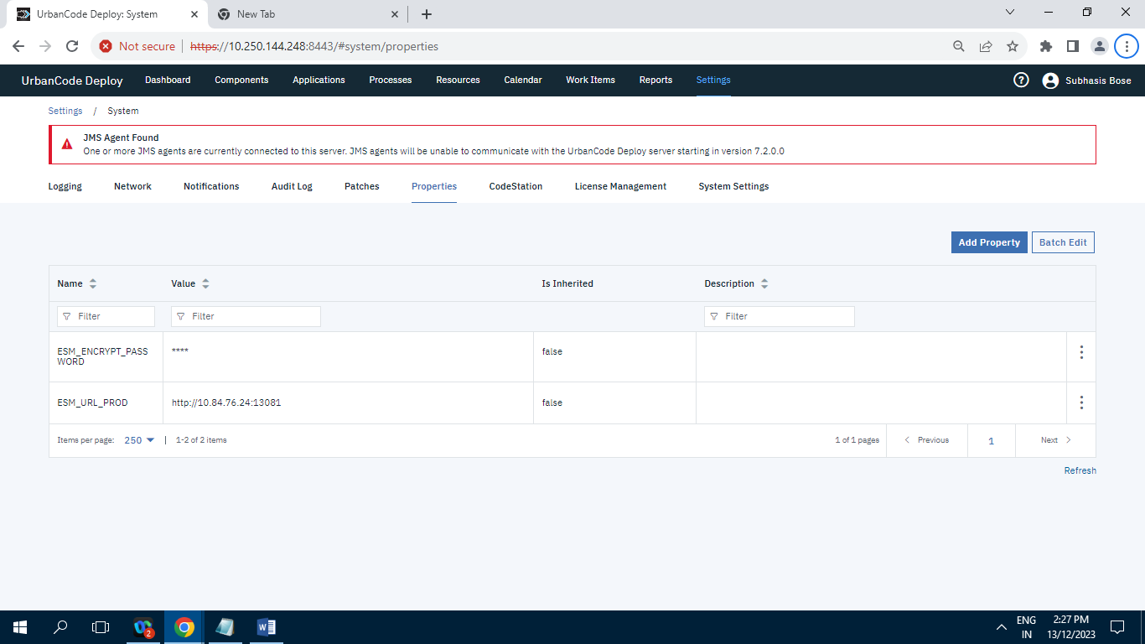

**Record=2  
10.3.8] CodeStation :**

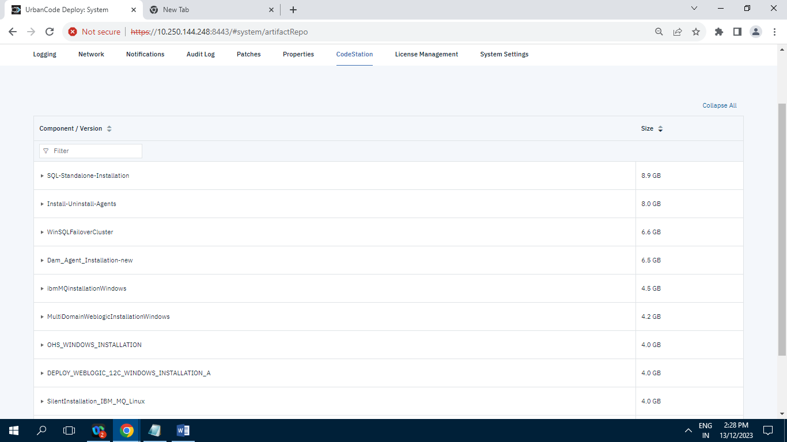

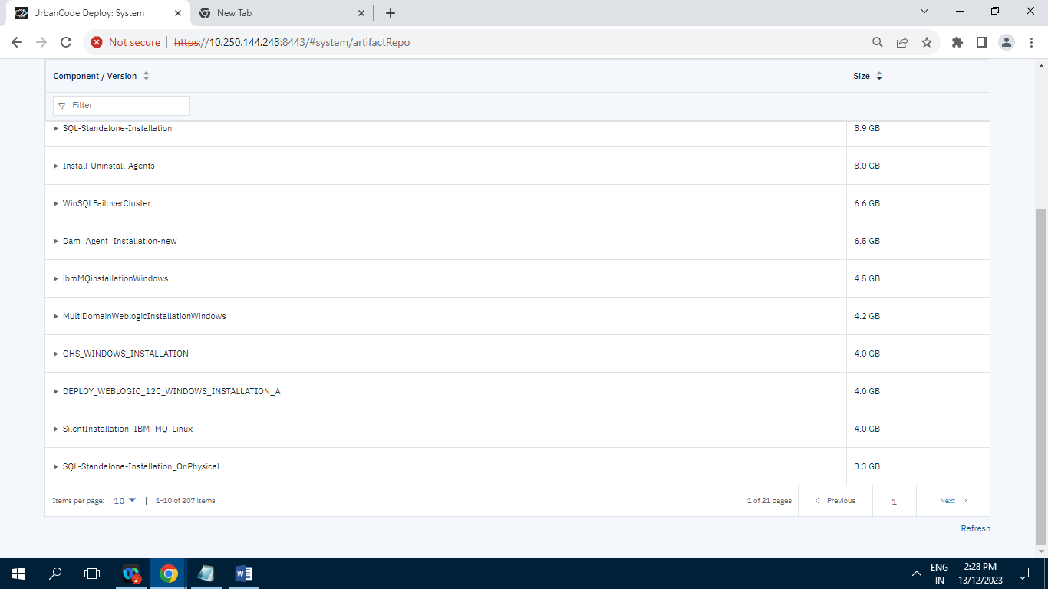

**Record=207**

**10.3.9] License Management :**

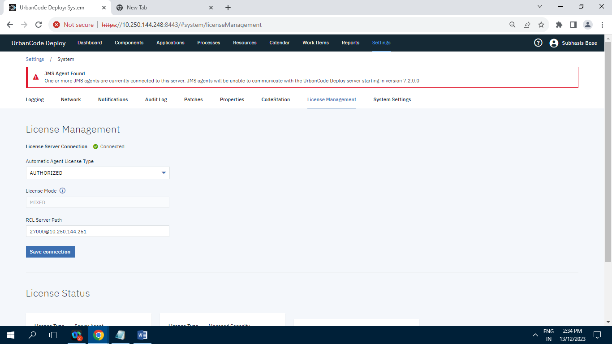

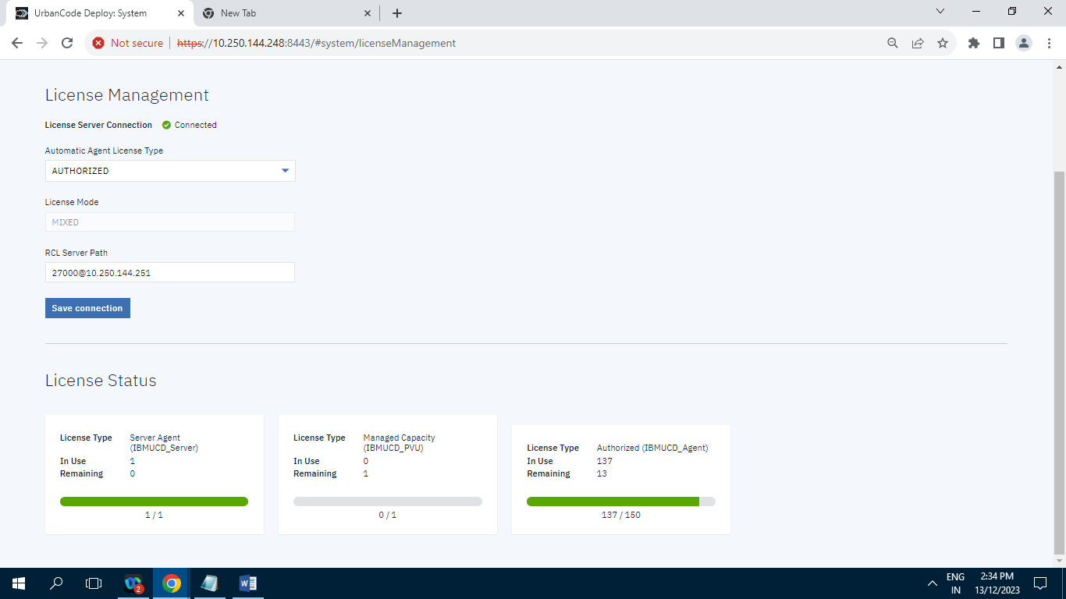

**10.3.10] System Settings :**

